# Introduction

## What is Katalon?

Katalon is an automated functional and regression testing platform that provides the user ability to implement full automated testing solutions for their application projects with reduced and minimal engineering and programming skill requirements.

## Who is Katalon for?

Katalon is right for you if:

* You want to do automated testing for your software products.
* You want to leverage non-scripting skilled testers to do automation.

## Audience

This user guide is designed for Software Testing Professionals with a need to understand the Katalon Studio in enough detail along with its simple overview, and practical examples. This tutorial will give you enough ingredients to start with Katalon Studio from where you can take yourself at higher level of expertise.

# Setup

## System Requirements

Same as the one in <http://katalon.kms-technology.com/#/user_guide/page/11>

## Browser Support

Same as the one in <http://katalon.kms-technology.com/#/user_guide/page/12>

## Setup Environment

Same as the one in <http://katalon.kms-technology.com/#/user_guide/page/8>

## Installation

Same as the one in <http://katalon.kms-technology.com/#/user_guide/page/7>

# Getting Started

## Starting Katalon Studio

To start Katalon Studio, double-click the katalon.exe (Microsoft Windows) or katalon (Linux / Mac) file in the directory where you unpacked Katalon. For example:

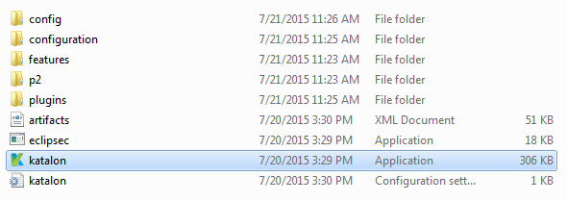

Once started, the application should look similar to the following screenshot.

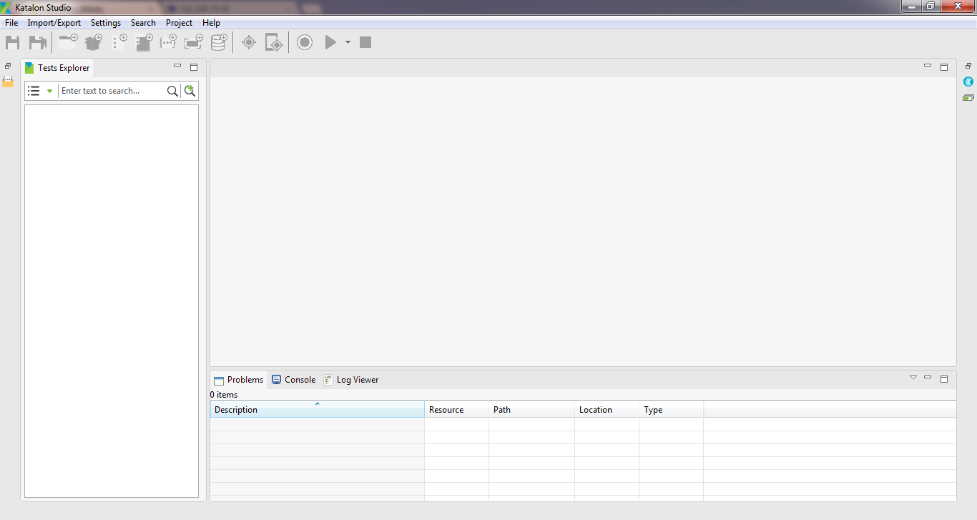

## Studio’s GUI

### Toolbar

The application toolbar contains actions which you typically perform, e.g., creating testing resources or executing test case/suite.



### Tests Explorer View

The *Tests Explorer* view allows you to browse the structure of your projects and to open the detailed view of an object in an editor via a double-click on the object.

It is also used to change the structure of your project. For example, you can rename objects or move objects and folders via drag and drop. A right-click on an object or folder shows you the available options.

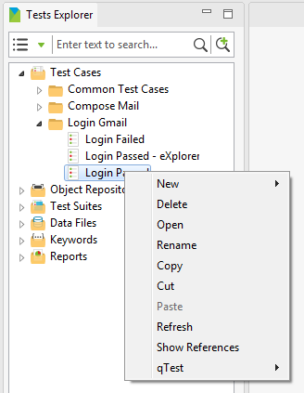

### Keywords Browser View

The *Keywords Browser* view allows you to browse the list of available keywords supported in your Katalon Studio.

The Keywords Browser view is minimized by default when the Katalon Studio is launched.

You can have a quick access to this view as following:

* Click on the “Keywords Browser” icon on the left side of Katalon Studio:

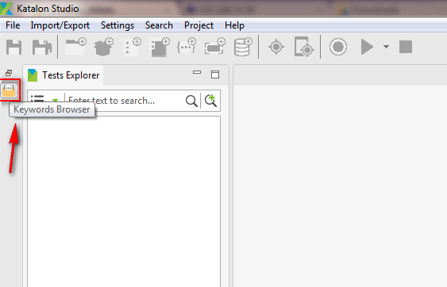

* The Keywords Browser view will be visible as following:

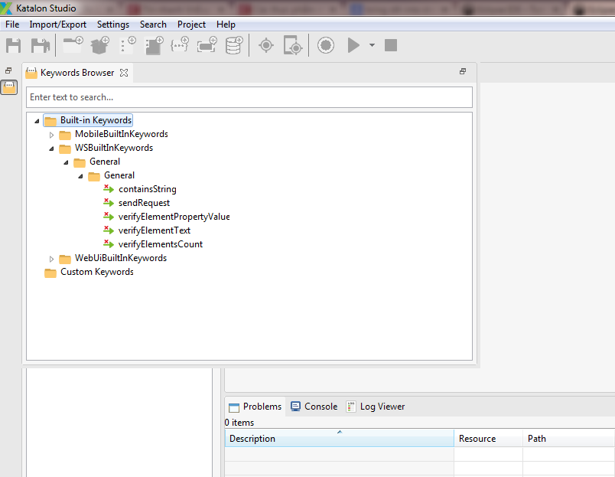

Or you can also restore it to bring it out for viewing, as following:

* Click on the “Restore” icon on the left side of Katalon Studio:

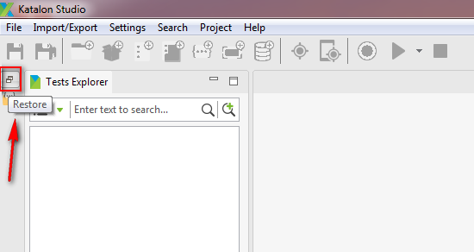

* The *Keywords Browser* view will be displayed right below the *Tests Explorer* view:

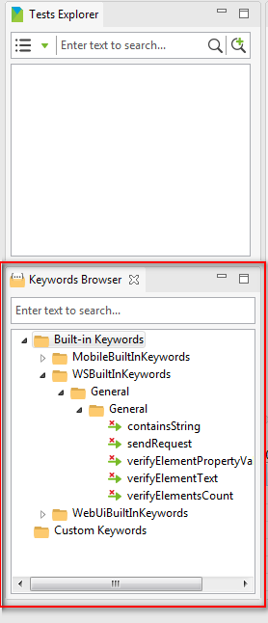

For more information on the Keywords Browser view, see ???

### Editor

The editor is used to modify the detailed information of an object. Each object is opened in a separate editor.

#### Test Case Editor

When you create a test case or choose an existing test case to edit, its detailed information will be displayed in an editor which would look like the following:

* Below is the Test Case Editor in Manual mode

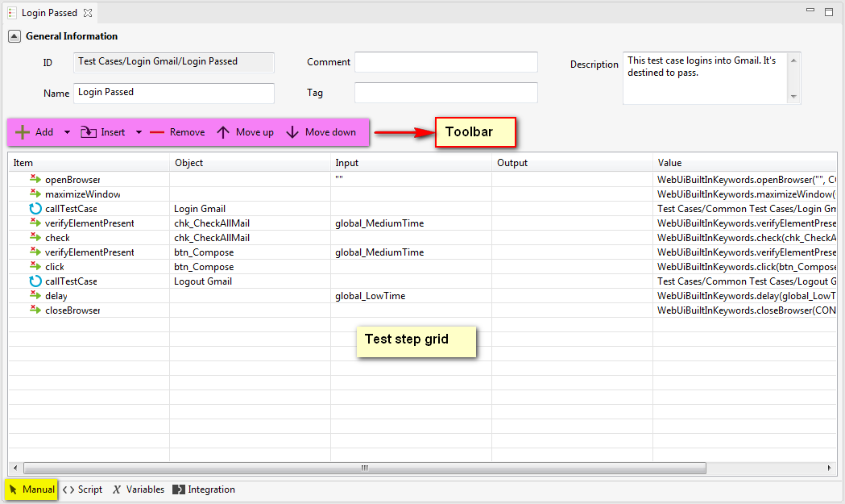

* And here’s how the Test Case Editor in Scripting mode looks like:

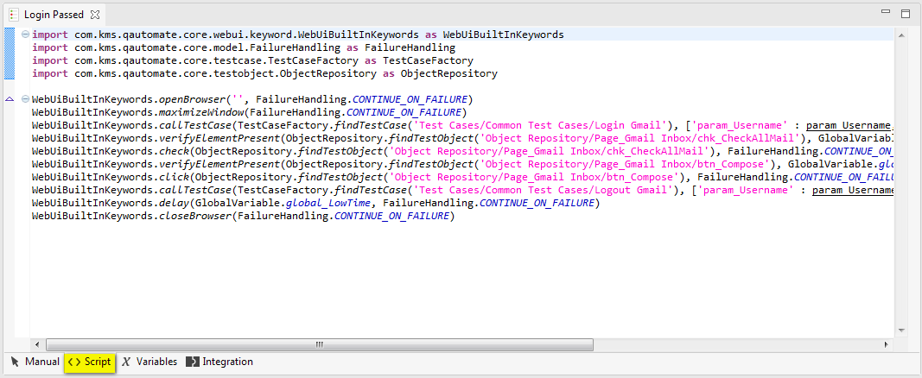

* The “Variables” tab of the Test Case Editor:

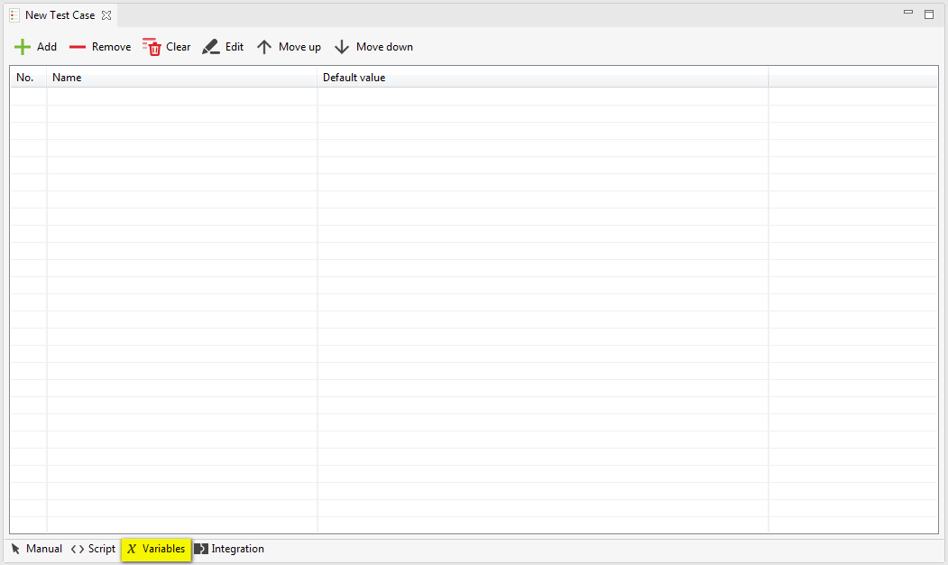

* The “Integration” tab of the Test Case Editor:

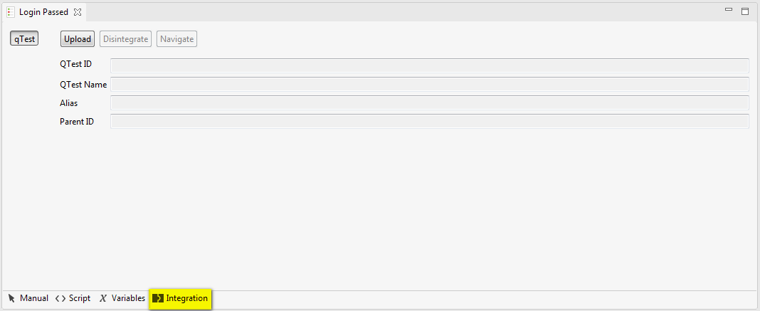

#### Test Object Editor

When you create a test object or choose an existing test object to edit, its detailed information will be displayed in an editor which would look like the following:

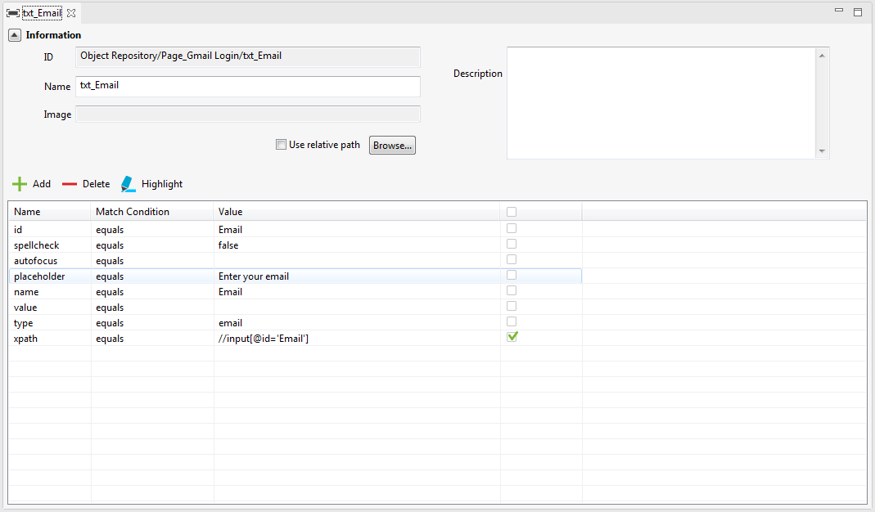

#### Web Service Request Object Editor

##### RESTful Request Object Editor

When you create a RESTful request object or choose an existing RESTful request object to edit, its detailed information will be displayed in an editor which would look like the following:

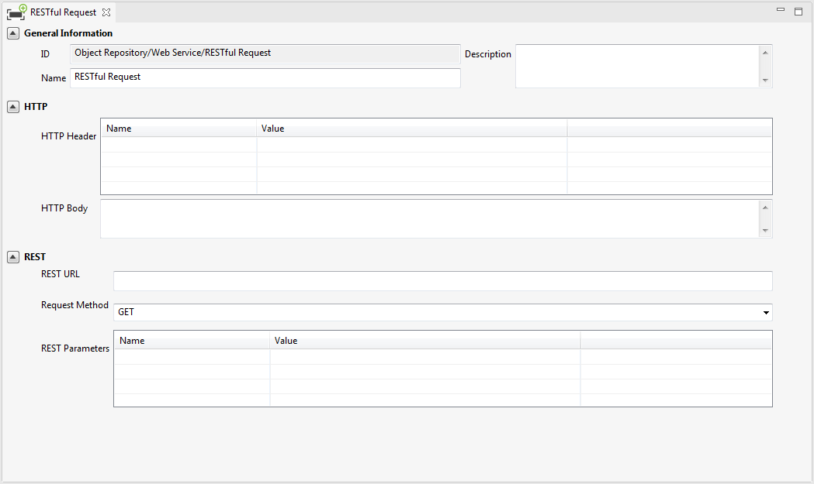

##### SOAP Request Object Editor

When you create a SOAP request object or choose an existing SOAP request object to edit, its detailed information will be displayed in an editor which would look like the following:

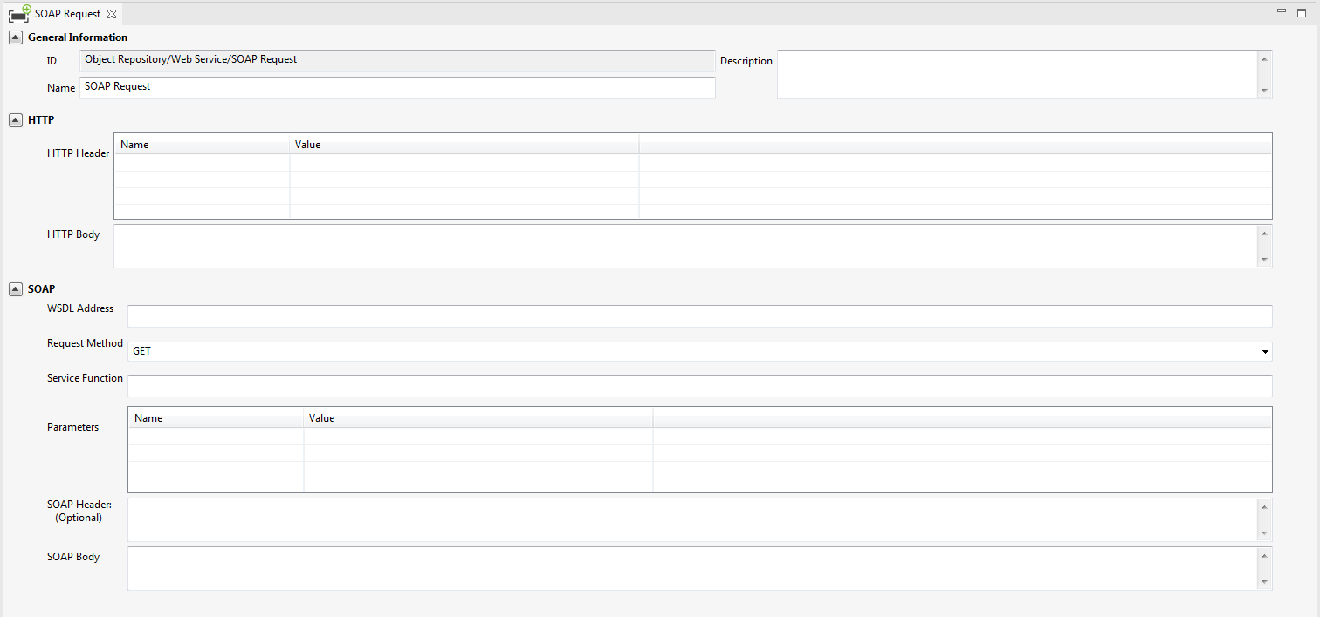

#### Test Suite Editor

When you create a test suite or choose an existing test suite to edit, its detailed information will be displayed in an editor which would look like the following:

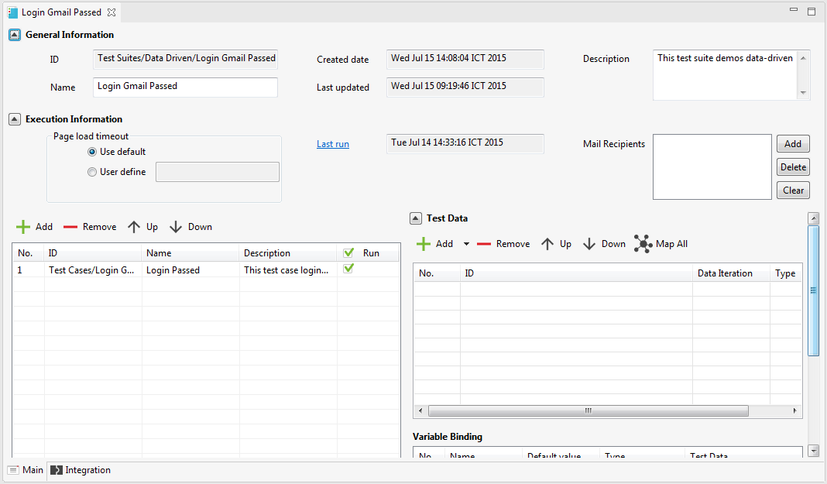

#### Data File Editor

When you create a data file object or choose an existing data file object to edit, its detailed information will be displayed in an editor which would look like the following:

* If the test data is from an Excel file:

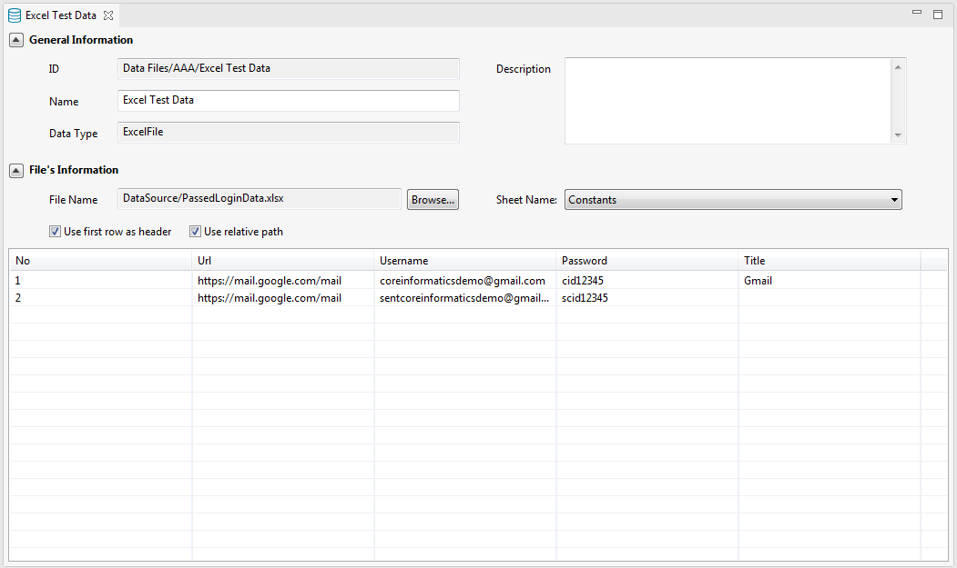

* If the test data is from a CSV file:

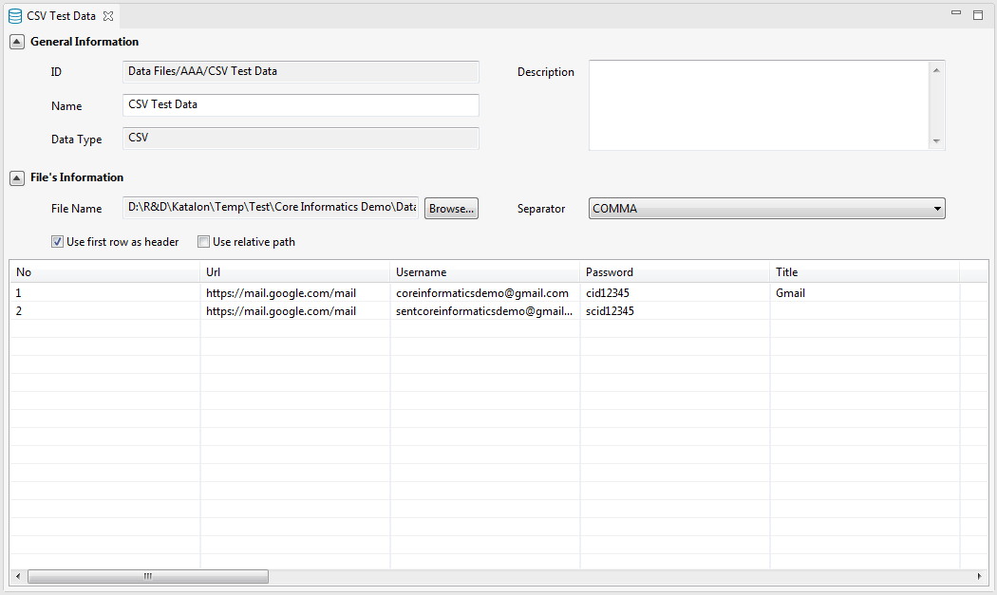

* If the test data is defined internally inside your test project:

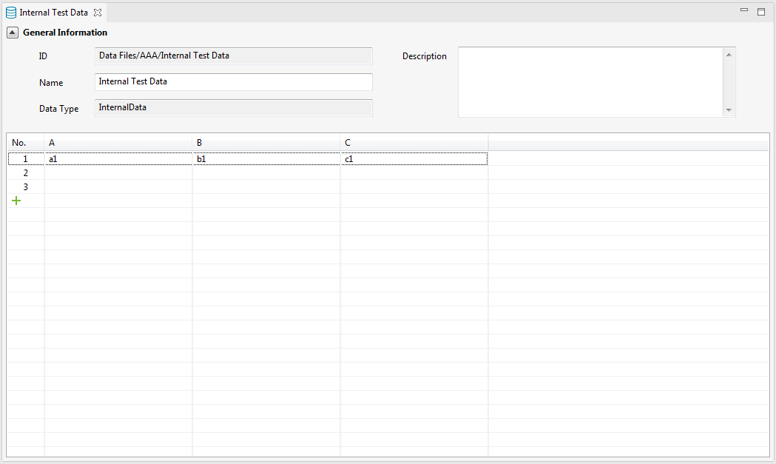

#### Keyword Editor

When you create a custom keyword or choose an existing custom keyword to edit, its detailed information will be displayed in an editor which would look like the following:

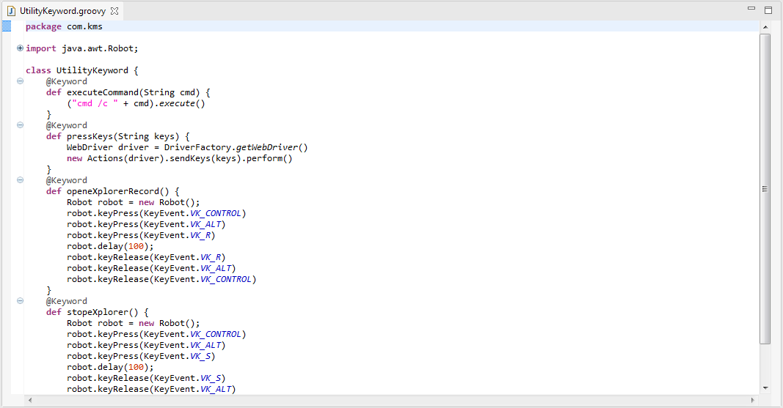

### Global Variables View

The *Global Variables* view allows you to browse the list of available global variables defined in your project. A global variable is a variable that can be referenced / used from anywhere in your project.

The Global Variables view is minimized by default when the Katalon Studio is launched.

You can have a quick access to this view as following:

* Click on the “Global Variables” icon on the right side of Katalon Studio:

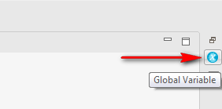

* The Global Variables view will be visible as following:

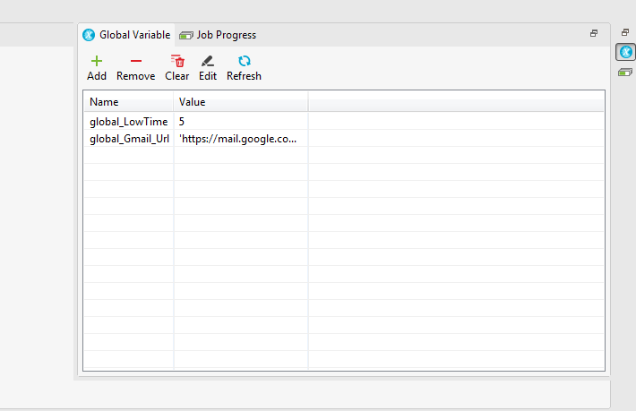

### Job Progress View

The *Job Progress* view allows you to see the progress of test case/suite execution.

The Job Progress view is minimized by default when the Katalon Studio is launched.

You can have a quick access to this view as following:

* Click on the “Job Progress” icon on the right side of Katalon Studio:

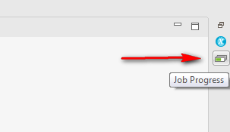

* The Job Progress view will be visible as following:

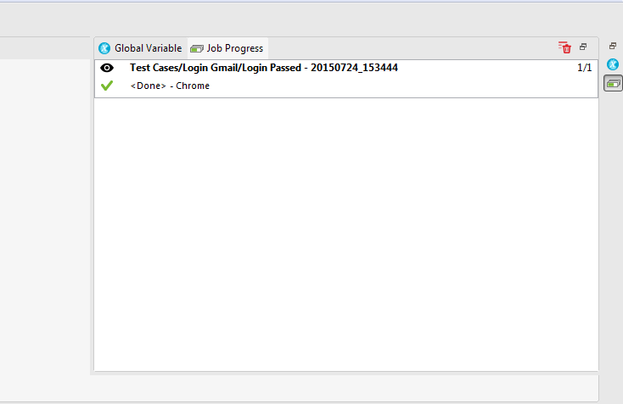

### Problems View

The *Problems* view shows errors and warning messages raised when you are setting up project or designing test case/suite/object/data. The problems will be displayed in this view as below:

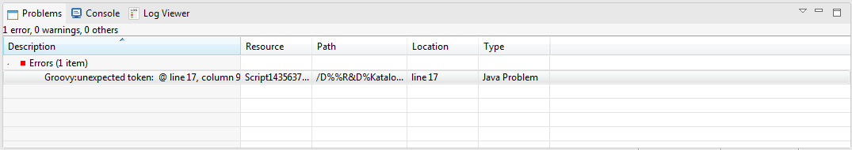

The messages which are displayed in the Problems view can be configured via the drop-down menu of the view. In fact this feature is the same as the one in Eclipse RCP.

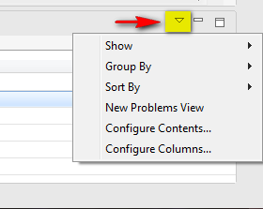

For more information on the Keywords Browser view, see ???

### Console View

The *Console* view shows the system log of those run time activities performed while the test case/suite is being executed. This is also the place to display the output if there’s any statement writing the output to console in your test script.

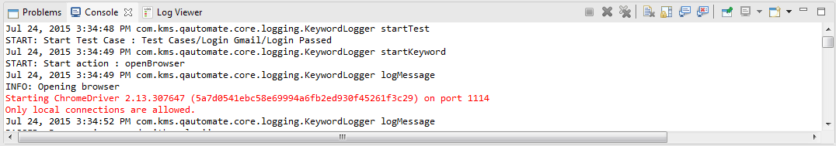

### Log Viewer View

The *Log Viewer* view shows the real time report/log of the test execution.

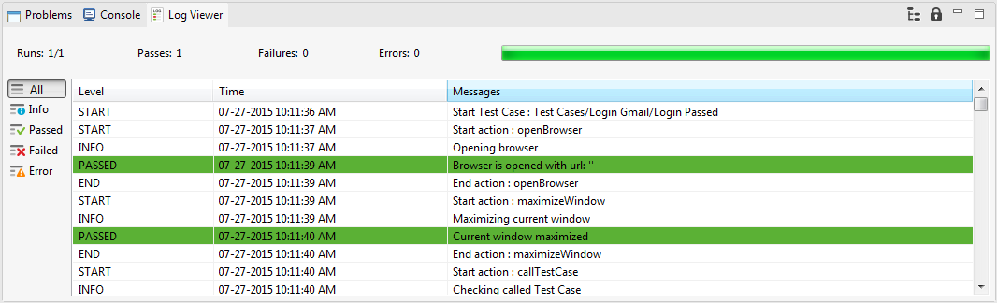

From here the user can easily determine which log messages should be displayed or hidden by using the filters provided on the left side of the Log Viewer view. The available filters which are currently supported are:

|  |  |
| --- | --- |
| **Filter** | **Description** |
| All | This is to show all the log messages. |
| Info | This is to show only the messages logged for information/reference. |
| Passed | This is to show only the log messages indicating that an action or a step is successfully executed. |
| Failed | This is to show only the log messages indicating that an action or a step is failed to execute. |
| Error | This is to show only the log messages indicating that some error has occurred at a given step/action. |

### Search View

The *Search* view shows the search results for the selected scope. You can double-click on a search entry to navigate to the corresponding position in the editor.

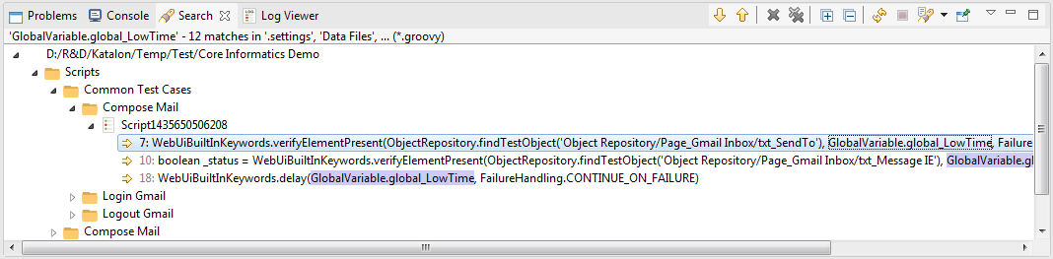

### Report View

The *Report* view allows you to view the detailed information of a historical execution report of a test suite. Typically this Report view would look like the following:

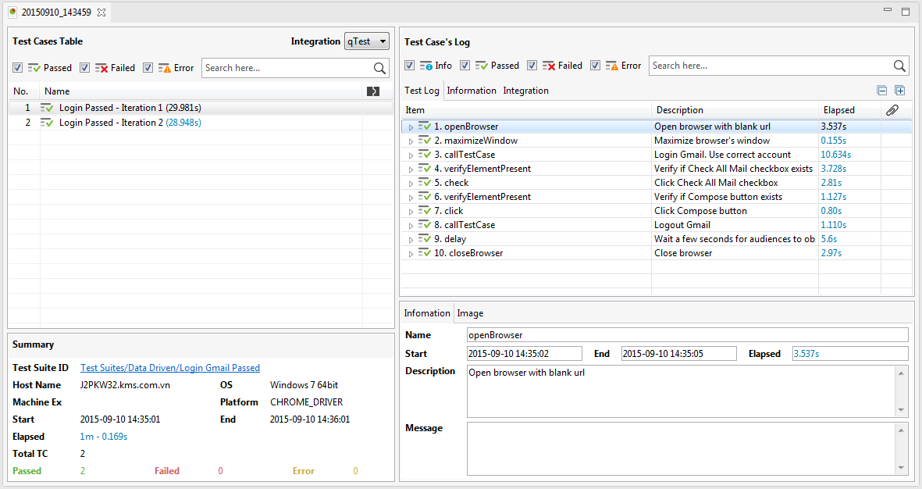

Refer to the subsequence sections for more detailed description.

#### Section “Summary”

This section is to give the summary information of the test suite:

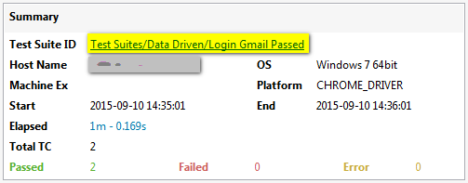

From here you can see some of the information as below:

* Test suite ID (displayed as hyperlink, and from here you can quickly open the test suite by clicking on the hyperlink provided)
* The environment where the test suite was executed
* Execution start/end date time and duration
* Total number of test cases
* The number of test cases which are passed
* The number of test cases which are failed
* Error (???)

#### Section “Test Cases Table”

This section is to give the summary information of all execution iterations done in the test suite. Each time when a test case is executed with a test data row is considered an execution iteration.

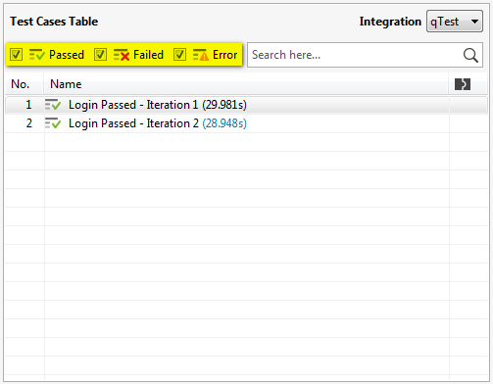

From here the user can easily determine which type of information should be displayed or hidden by using the filters provided above the result grid. The available filters which are currently supported are:

|  |  |
| --- | --- |
| **Filter** | **Description** |
| Passed | This is to show only iterations which are passed. |
| Failed | This is to show only iterations which are failed. |
| Error | ??? |

#### Section “Test Case’s Log”

This section is to give the summary information of the test case executed in the iteration selected in the “Test Cases Table” section.

##### Tab “Test Log”

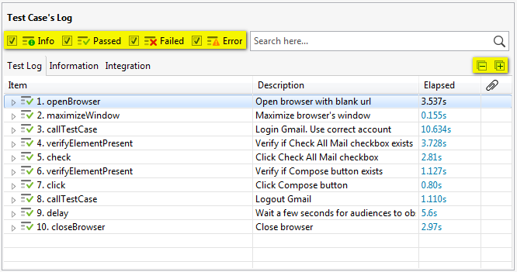

From here the user can easily determine which type of information should be displayed or hidden by using the filters provided above the result grid. The available filters which are currently supported are:

|  |  |
| --- | --- |
| **Filter** | **Description** |
| Info | This is to show only the messages logged for information/reference. |
| Passed | This is to show only the steps which are successfully executed. |
| Failed | This is to show only the steps which are failed to execute. |
| Error |  |

##### Tab “Information”

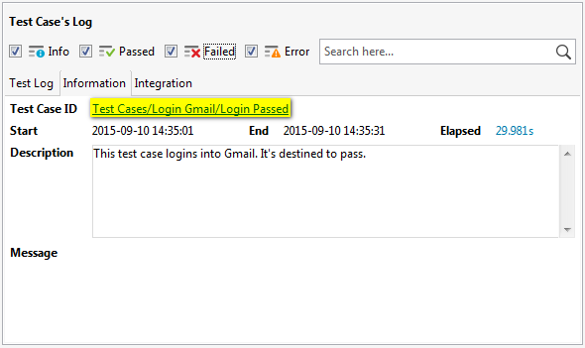

From here you can see some of the information as below:

* Test case ID (displayed as hyperlink, and from here you can quickly open the test case by clicking on the hyperlink provided)
* Execution start/end date time and duration
* The description of the test case
* Any system message raised when the test case was executed

##### Tab “Integration”

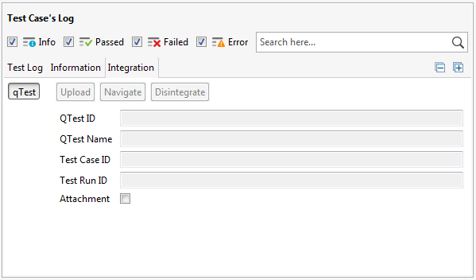

From here you can see some of the information as below:

* Test case ID of the Katalon test case
* The ID of the qTest test report if the Katalon test report is synchronized to qTest
* Attachment (???)

#### Section “Test Step’s Summary”

This section is to give the summary information of the test step selected in the “Test Case’s Log” section.

##### Tab “Information”

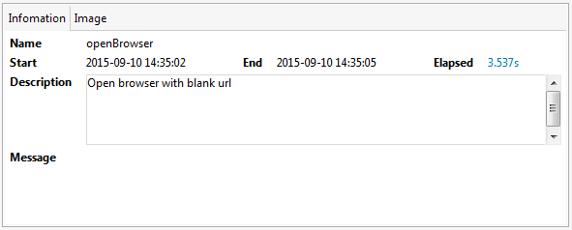

From here you can see some of the information as below:

* The name of the test step, in fact this is the name of the keyword used in the test step
* Execution start/end date time and duration
* The description of the test step
* Any system message raised when the test step was executed

##### Tab “Image”

TBD

# Value Types

While designing your test case, there are cases that you need to work with data in each test step, such as:

* Pass input parameters to a test step.
* Get the output value from a test step.

To support you to flexibly work with data in these cases, Katalon Studio provides you a wide range of value types as below:

|  |  |
| --- | --- |
| **Value Type** | **Description** |
| Constant | This is to specify that the data is a value that will not be changed over time. |
| Variable | This is to specify that the data is a value that might be changed over time. This type of data can only be referenced within the scope of the test case where it is defined. |
| Global Variable | This is to specify that the data is a value that might be changed over time. This type of data can be referenced anywhere in your test project. |
| Test Data Value | This is to specify that the data is a value coming from a test data file. |
| Binary | This is to specify that the data is a binary expression. |
| Boolean | This is to specify that the data is a Boolean value that can be evaluated from a Boolean expression. |
| Test Case | This is to specify that the data is a test case. |
| Test Data | This is to specify that the data is a test data file. |
| Test Object | This is to specify that the data is a test object. |
| Method Call | This is to specify that the data is a method call. |
| Property | This is to specify that the data is a public property value of an object. |
| List | This is to specify that the data is a list of values. |
| Map | This is to specify that the data a map where the value is identified by its corresponding key. |

# Binary Operators

TBD: Need to explain the meaning of each binary operator supported.

The following binary operators are currently supported in Katalon Studio:

|  |  |
| --- | --- |
| **Binary Operator** | **Description** |
|  |  |
|  |  |
|  |  |
|  |  |
|  |  |
|  |  |
|  |  |
|  |  |
|  |  |
|  |  |
|  |  |
|  |  |
|  |  |

# Test Project

## Create a test project

Follow the steps below in order to create a test project:

* Select *File → New → Project* from the menu. The following popup will be displayed:

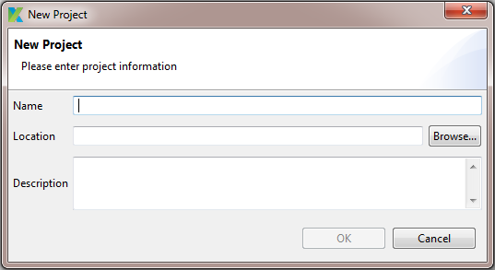

* Enter the project name and specify where it should be stored.
* You can also optionally enter the description for your project.
* Then press the “OK” button.

A new project is created and displayed immediately in Katalon Studio. If there’s any project which is currently being open in Katalon Studio, that project will be closed immediately for this new project to be displayed instead. The new project will have the default folder structure as following:

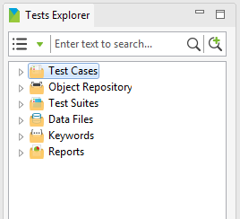

You can open each folder and explore its content.

|  |  |
| --- | --- |
| **Folder** | **Description** |
| Test Cases | This folder is to keep all your test cases in your project. |
| Object Repository | This folder is to keep all test objects used in your test cases in your project. |
| Test Suites | This folder is to keep all your test suites in your project. |
| Data Files | This folder is to keep all data file objects used in your test suites in your project. |
| Keywords | This folder is to keep all the custom keywords you created in your project. |
| Reports | This folder is to keep all the historical test execution reports in your project. |

Moreover, your project will also be saved into the specified location in your file system with the following folder structure:

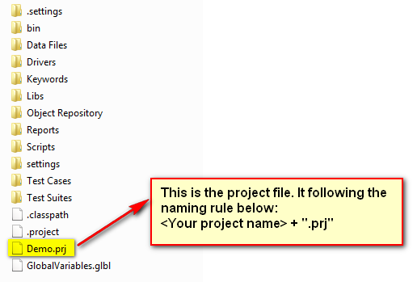

## Open an existing test project

Follow the steps below in order to open an existing test project:

* Select *File → Open Project* from the menu. The following popup will be displayed:

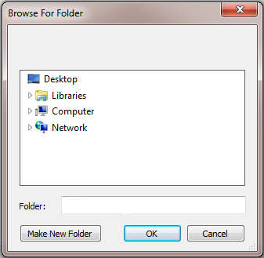

* Browse to the folder where your project is located and select that folder.
* Then press the “OK” button.

The existing project located in the specified location will be open and displayed in Katalon Studio.

Besides you can also quickly open a test project which has been open recently by selecting it from a list of recent projects displayed under the *File* menu, as below:

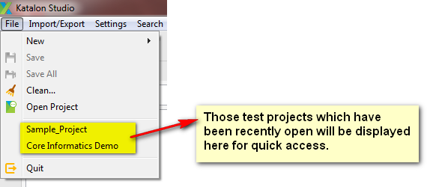

## Refresh project

There are cases that your test project is modified outside Katalon Studio while your test project is being open in Katalon Studio. In such cases, your test project displayed in Katalon Studio might not be in sync with the modification done outside Katalon Studio. Thus, you can keep your test project in sync and showing the up-to-date information by using the “Refresh” function under the “Project” menu, as illustrated below:

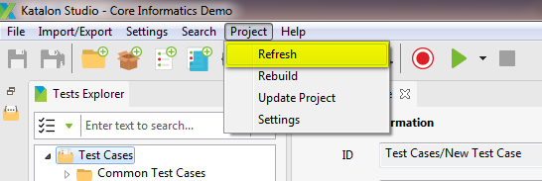

## Rebuild project

TBD

## Update project

TBD

## Project settings

TBD

# Folder

## Create a folder

Besides the default folder structure provided for a test project, you can also create your own folders to organize your test project’s assets into different categories depending on your project’s need.

You can create your own folders under each of the following folders:

* Test Cases
* Object Repository
* Test Suites
* Data Files
* Any sub-folder under one of the folders above.

You can create a folder by using either one of the following methods:

* Method 1: Using menu bar:
  + In the Tests Explorer view, select one of the folders above.
  + Select *File → New → Folder* from the menu.

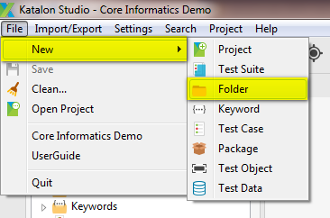

* Method 2: Using toolbar:
  + In the Tests Explorer view, select one of the folders above.
  + Click on the “New Folder” button on the toolbar.

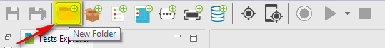

* Method 3: Use the context menu:
  + In the Tests Explorer view, right click on one the folders above (e.g., “Test Cases” in this example).
  + A context menu will be displayed.
  + Select *New → Folder* from the above context menu.

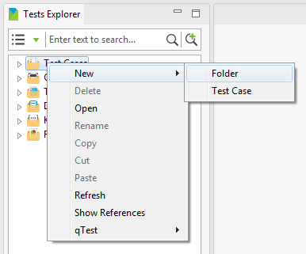

A popup which looks like the following will be displayed asking you to provide the name for the new folder:

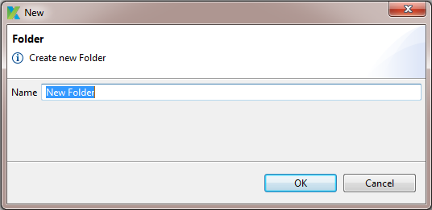

Provide the name for the new folder, then press “OK” button. A new folder is created and displayed under the folder specified above.

## Delete a folder

A folder can be deleted if and only if it was manually created.

Follow the steps below in order to delete a folder:

* In the Tests Explorer view, right click on the folder that you want to delete.
* A context menu will be displayed.
* Select *Delete* from the above context menu.

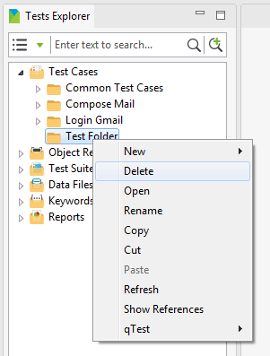

* A popup which looks like the following will be displayed:

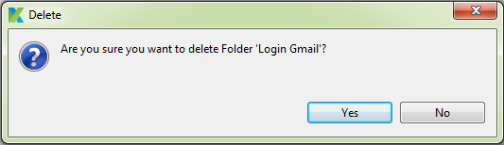

* Press the “Yes” button on the above popup:
  + If the selected folder is a folder under the “Test Cases” folder, Katalon Studio will inspect whether each test case in the selected folder can be deleted or not.
    - If there’s any test case which is currently in use, then the selected folder cannot be deleted.
    - Otherwise:
      * The selected folder will be deleted right away from your test project.
      * And all the references to any item object under the selected folder will also be removed from your test project.
  + In any other cases:
    - The selected folder will be deleted right away from your test project.
    - And all the references to any item object under the selected folder will also be removed from your test project.

## Rename a folder

A folder can be renamed if and only if it was manually created.

Follow the steps below in order to rename a folder:

* In the Tests Explorer view, right click on the folder that you want to rename.
* A context menu will be displayed.
* Select *Rename* from the above context menu.

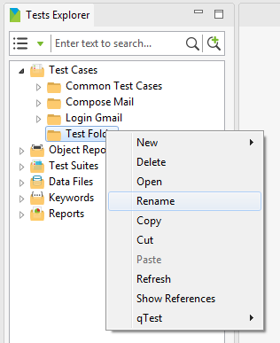

* A popup which looks like the following will be displayed asking you to provide the new name for the folder:

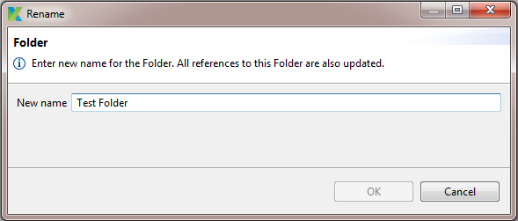

* Once you provide a valid new name for the folder, the “OK” button will be enabled. Simply press on the “OK” button, the selected folder will be renamed and all references to this folder in your test project will also be updated accordingly.

## Copy a folder

A folder can be copied if and only if it was manually created. A folder can only be copied and pasted under the same default folder category. For example, a sub-folder under “Test Cases” folder can only be copied and pasted under “Test Cases” folder, and its copies cannot be pasted into any other default folders.

Follow the steps below in order to copy a folder:

* In the Tests Explorer view, right click on the folder that you want to copy.
* A context menu will be displayed.
* Select *Copy* from the above context menu.

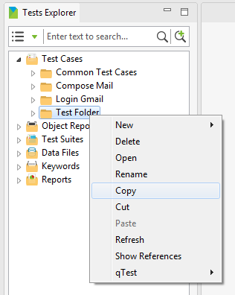

* Select the destination where you want to paste the copied folder. Right click on it and select *Paste* from the context menu which has just been displayed.

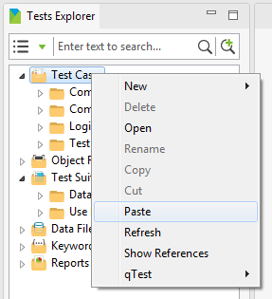

A copied version of the specified folder will be pasted at the destination.

Notice that:

* The folder name of the copied version will follow the below rule:

copiedFolderName = sourceFolderName + “- Copy”

* If there’s already an existing folder with the same name as the folder name of the copied version at the destination, the folder name of the copied version will be automatically renamed by appending “(1)” at the end.

## Move a folder

A folder can be moved if and only if it was manually created. A folder can only be moved under the same default folder category. For example, a sub-folder under “Test Cases” folder can only be moved under “Test Cases” folder, but not into any other default folders.

Follow the steps below in order to move a folder:

* In the Tests Explorer view, right click on the folder that you want to move.
* A context menu will be displayed.
* Select *Cut* from the above context menu.

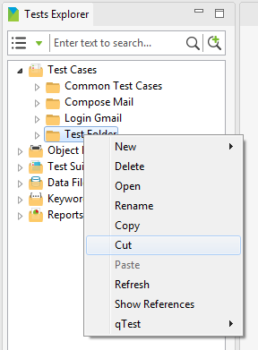

* Select the destination where you want to paste the folder. Right click on it and select *Paste* from the context menu which has just been displayed.



The specified folder will be moved to the destination.

Notice that if there’s already an existing folder with the same name as the folder name of the being-pasted folder at the destination, the folder name of the being-pasted folder will be automatically renamed by appending “(1)” at the end in this case.

# Test Case

## Create a test case

You can create a test case by using either one of the following methods:

* Method 1: Using menu bar:
  + Click anywhere in the Tests Explorer view.
  + Select *File → New → Test Case* from the menu.

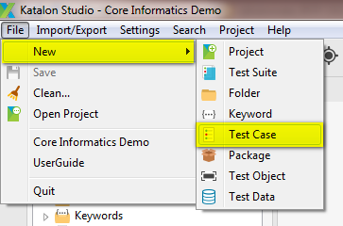

* Method 2: Using toolbar:
  + Click anywhere in the Tests Explorer view.
  + Click on the “New Test Case” button on the toolbar.

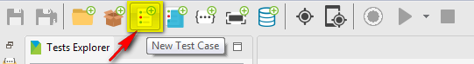

* Method 3: Use the context menu:
  + In the Tests Explorer view, right click on either the “Test Cases” folder or any sub-folder under “Test Cases” folder.
  + A context menu will be displayed.
  + Select *New → Test Case* from the above context menu.

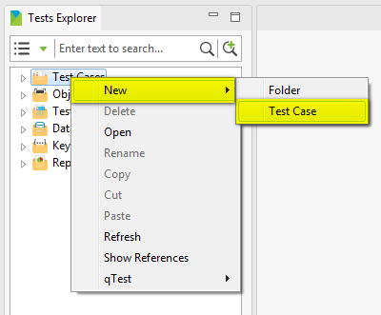

A popup which looks like the following will be displayed asking you to provide the name for the new test case:

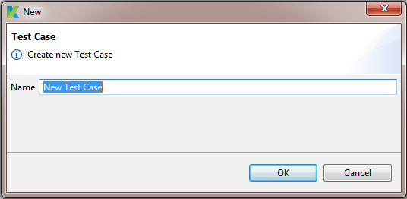

Provide the name for the new test case, then press “OK” button. A new test case is created and displayed under either the “Test Cases” folder or the folder specified above depending on the each case.

## Delete a test case

A test case can be deleted if and only if it is not currently in use (i.e., it is not currently being referenced from anywhere in your test project). For example, if your test case is being used in one of your test suite, then you are not allowed to delete this test case.

Follow the steps below in order to delete a test case:

* In the Tests Explorer view, under “Test Cases” folder, right click on the test case that you want to delete.
* A context menu will be displayed.
* Select *Delete* from the above context menu.

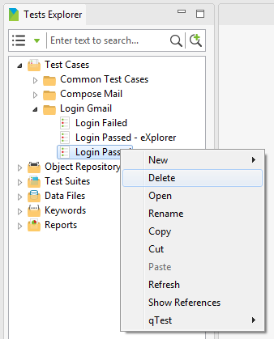

* A popup which looks similar to the following will be displayed asking for your confirmation to delete the selected test case:

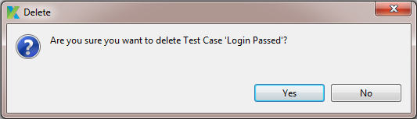

* Press on the “Yes” button to agree to delete the test case:
  + If the selected test case is not being referenced from anywhere in your test project, it will be deleted immediately from your test project.
  + Otherwise, a popup containing an error message will be displayed to inform you why the selected test case cannot be deleted. For example, it would look like the following:

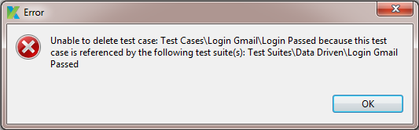

## Rename a test case

Follow the steps below in order to rename a test case:

* In the Tests Explorer view, under “Test Cases” folder, right click on the test case that you want to rename.
* A context menu will be displayed.
* Select *Rename* from the above context menu.

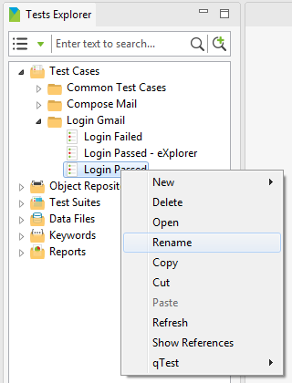

* A popup which looks like the following will be displayed asking you to provide the new name for the test case:

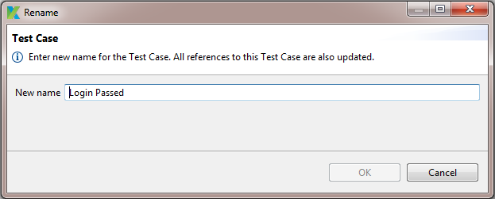

* Once you provide a valid new name for the test case, the “OK” button will be enabled. Simply press on the “OK” button, the selected test case will be renamed and all references to this test case in your test project will also be updated accordingly.

## Copy a test case

A test case can only be copied and pasted under “Test Cases” folder. That is, a copied test case can only be pasted under “Test Cases” folder, but not into any other default folders.

Follow the steps below in order to copy a test case:

* In the Tests Explorer view, under “Test Cases” folder, right click on the test case that you want to copy.
* A context menu will be displayed.
* Select *Copy* from the above context menu.

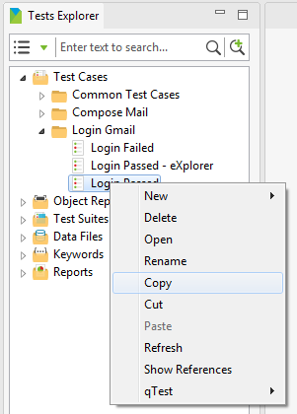

* Select the destination where you want to paste the copied test case. Right click on it and select *Paste* from the context menu which has just been displayed.

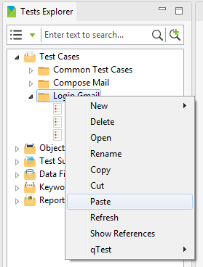

A copied version of the specified test case will be pasted at the destination.

Notice that:

* The name of the copied version will follow the below rule:

copiedTestCaseName = sourceTestCaseName + “- Copy”

* If there’s already an existing test case with the same name as the name of the copied version at the destination, the name of the copied version will be automatically renamed by appending “(1)” at the end.

## Move a test case

A test case can only be moved under “Test Cases” folder, but not into any other default folders.

Follow the steps below in order to move a test case:

* In the Tests Explorer view, under “Test Cases” folder, right click on the test case that you want to move.
* A context menu will be displayed.
* Select *Cut* from the above context menu.

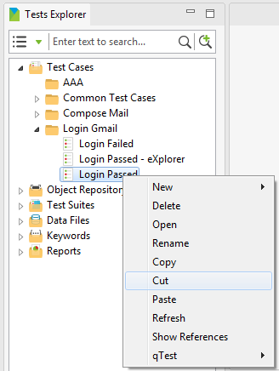

* Select the destination where you want to paste the test case. Right click on it and select *Paste* from the context menu which has just been displayed.

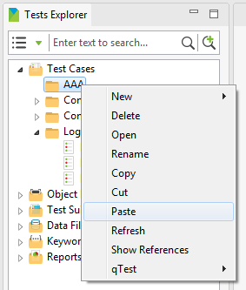

The specified test case will be moved to the destination.

Notice that if there’s already an existing test case with the same name as the name of the being-pasted test case at the destination, the name of the being-pasted test case will be automatically renamed by appending “(1)” at the end in this case.

## Edit a test case

In order to edit a test case, simply follow the steps below:

* In the Tests Explorer view, under “Test Cases” folder, double click on the test case that you want to edit.
* A tab containing the Test Case Editor will be open to display the detailed information of the selected test case.
* Modify the data of the test case.
* Save your modification. You can save your modification by using either one of the following methods:
  + Method 1: Press Ctrl + S
  + Method 2: Select *File → Save* or *File → Save All* from the menu.

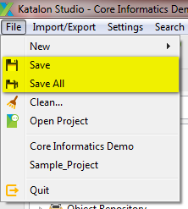

* + Method 3: Click on the “Save” or “Save All” button on the toolbar.

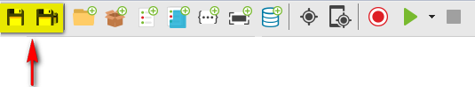

## Manage test step

Basically a test case will contain a list of test steps. These test steps define the execution sequence of a test scenario. Therefore, knowing how to work with test step will boost your progress in designing test case.

Here’s the list of activities you can perform on test steps:

* Add a test step
* Insert a test step
* Delete a test step
* Edit a test step
* Copy a test step
* Re-sequence the test steps
* Change failure handling schema

### Add a test step

You can add a test step by using either one of the following methods:

* Method 1: Using Manual mode (i.e., using Katalon Studio’s GUI controls)
* Method 2: Using Scripting mode

#### Add a test step using Manual mode

Using the Test Case Editor in Manual mode, you can add a test step by using either one of the following methods:

* Method 1: Using “Add” button in the toolbar of the Test Case Editor
  + In the Test Case Editor, click on the down arrow next to the “Add” button, as illustrated below:

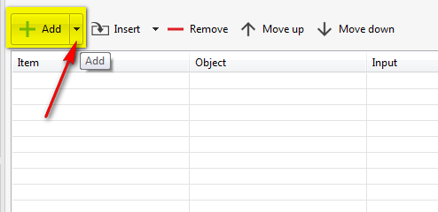

* + A dropdown menu will be displayed to show the available groups of keywords for your selection:

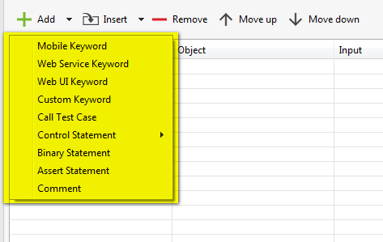

* + Select one of the available options in the dropdown menu above depending on your need. For example, select “Web UI Keyword”. A test step will be added and displayed as a new row in the test step grid:

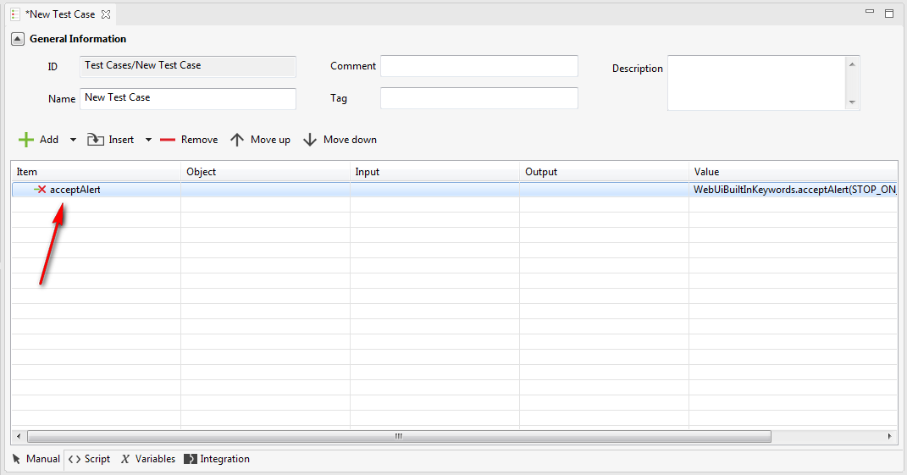

* Method 2: Drag and drop the keywords from the Keywords Browser View to the Test Case Editor
  + From the Keywords Browser view, select a keyword of your interest.
  + Then drag the selected keyword and drop it into the Test Case Editor.
  + A test step will be added and displayed as a new row at the place where you release the mouse after dragging the keyword into the test step grid
* Method 3: Using the “Add” function in the context menu of any test step
  + In the Test Case Editor, right click on any test step. A context menu will be displayed as below:

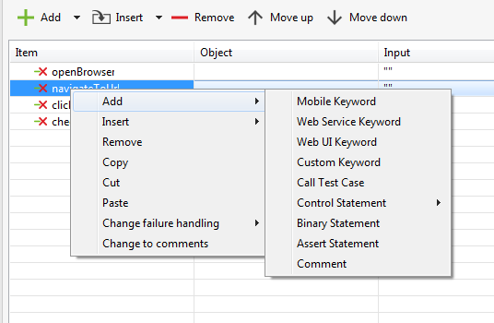

* + Select the “Add” item in the context menu above.
  + Then select the suitable option(s) in the next level(s).
  + The new test step will be added right after the test step which is currently being selected in the test step grid.

Save your modification.

Done! You have already successfully added a test step.

#### Add a test step using Scripting mode

If you are a test engineer who’d like to design your test case using your scripting skills, you can use the Test Case Editor in Scripting mode to add a test step.

Before continuing, it’s good to know that the keywords which are embedded in Katalon Studio are grouped in the following packages:

|  |  |
| --- | --- |
| **Package** | **Description** |
| WebUiBuiltInKeywords | This package contains those keywords used to test web applications. |
| WSBuiltInKeywords | This package contains those keywords used to test web services. |
| MobileBuiltInKeywords | This package contains those keywords used to test mobile native applications. |

And in order to be able to use any keyword while scripting your test case, you have to ensure that the corresponding package containing that keyword is imported in your test case, as below:

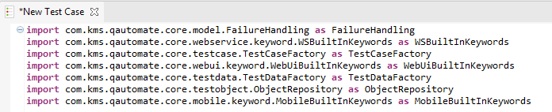

This is also true if you are developing your custom keywords. You have also to import the corresponding package containing your custom keywords before being able to use them in your test case.

Then, follow the steps below in order to add a test step in your test case:

* Key in the package name
* Key in “.”
* The “Content Assist” function will be invoked. Content assist is the functionality in Katalon Studio which allows the tester to get context-sensitive code completion in a test case editor upon user request. That is, a combo box containing all the keywords belonging to the specified package will be displayed as below:

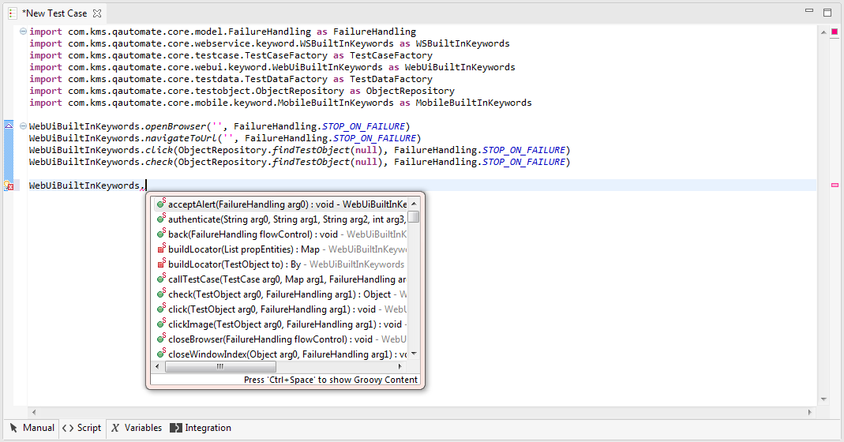

* Choose the keyword that suites your need.
* Then provide all parameters as required for the selected keyword.
* Save your modification.

Done! You have already successfully added a test step.

### Insert a test step

For this section, as it is straightforward for how to insert a test step in your test case using the Test Case Editor in Scripting mode, thus the following is just to explain how you can insert a test step using the Test Case Editor in Manual mode.

Using the Test Case Editor in Manual mode, you can insert a test step by using either one of the following methods:

* Method 1: Using “Insert” function in the toolbar of the Test Case Editor
  + In the Test Case Editor, click on the down arrow next to the “Insert” button, as illustrated below:

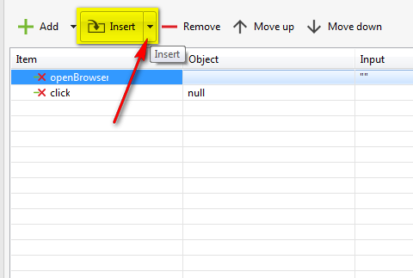

* + A dropdown menu will be displayed to show the available options for your selection:

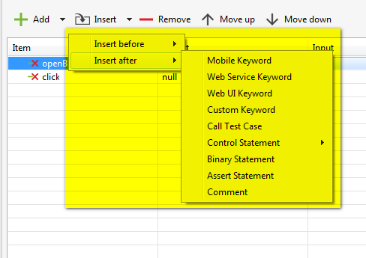

* + You can choose to insert a test step either before or after the test step which is currently selected in the test step grid.
  + For example, choosing to insert a test step after the first test step, using the group “Web UI Keyword”. A test step will be inserted after the first test step in the test step grid, as below in this example:

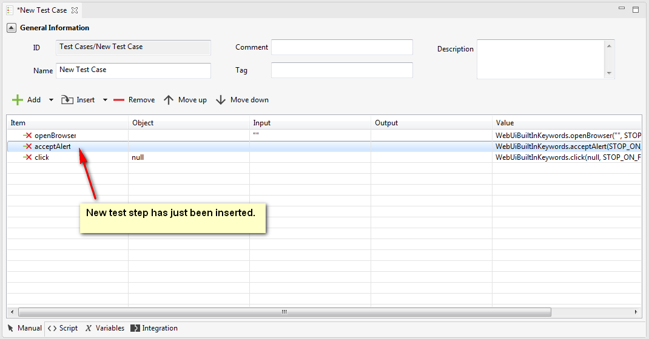

* Method 2: Using the “Insert” function in the context menu of any test step
  + In the Test Case Editor, right click on any test step. A context menu will be displayed as below:

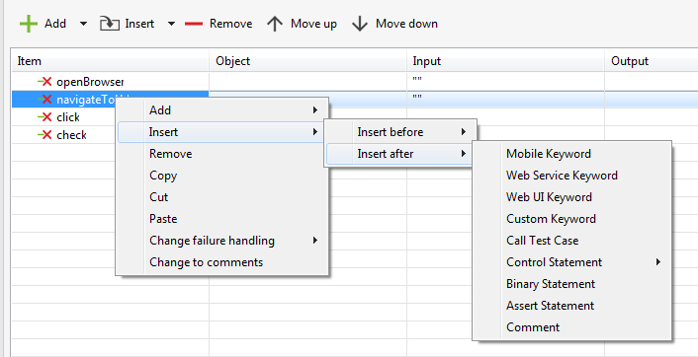

* + Select the “Insert” item in the context menu above.
  + Then select the suitable options in the next level(s).
  + The new test step will be inserted in the test step grid accordingly:
    - If you selected “Insert before” in the step above, the new test step will be inserted before the test step which is currently being selected in the test step grid.
    - If you selected “Insert after” in the step above, the new test step will be inserted after the test step which is currently being selected in the test step grid.

Save your modification.

Done! You have already successfully inserted a test step.

### Delete a test step

For this section, as it is straightforward for how to delete a test step in your test case using the Test Case Editor in Scripting mode, thus the following is just to explain how you can delete a test step using the Test Case Editor in Manual mode.

Using the Test Case Editor in Manual mode, you can delete a test step by using either one of the following methods:

* Method 1: Using “Remove” button in the toolbar of the Test Case Editor
  + In the test step grid, select the test step(s) that you’d like to remove. You can select multiple test steps at the same time by holding the Ctrl key while selecting test step.
  + Click on the “Remove” button in the toolbar of the Test Case Editor, as illustrated below:

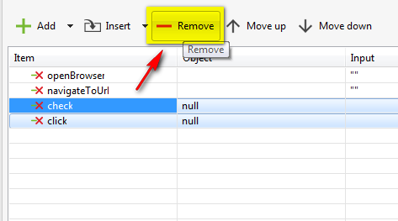

* Method 2: Using the “Remove” function in the context menu of any test step
  + In the Test Case Editor:
    - Select any test step. Right click on it. A context menu will be displayed as below:

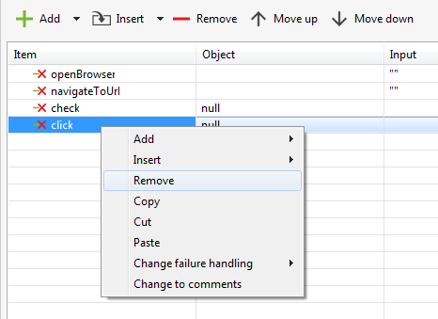

* Or select multiple test steps. Right click on your selection. A context menu will be displayed as below:

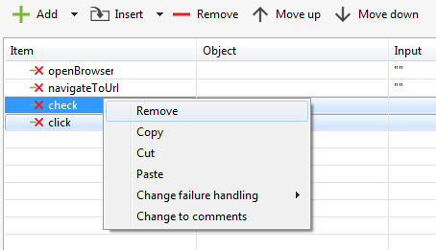

* + Select either the “Remove” item in the context menu above.

Save your modification.

Done! You have already successfully deleted a test step.

### Edit a test step

For this section, as it is straightforward for how to edit a test step in your test case using the Test Case Editor in Scripting mode, thus the following is just to explain how you can edit a test step using the Test Case Editor in Manual mode.

Here’s the list of which activities you can perform to edit a test step:

* Change keyword
* Edit object
* Edit input
* Edit output

#### Change item action

##### Change item action using Manual mode

Using the Test Case Editor in Manual mode, follow the steps below in order to change the item action used for a test step:

* Double click on the cell in the “Item” column of the interested test step, it will be changed to edit mode. That is, a dropdown containing a list of available keywords of the group to which the current selected keyword is belonging will be displayed, as below:

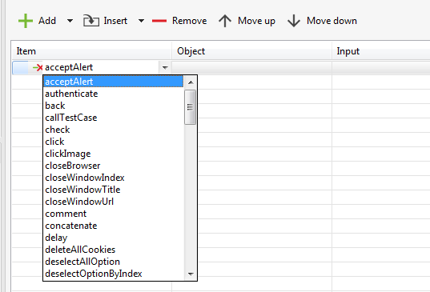

* Select the interested keyword.

Notice that you can also dynamically filter down the list of keywords displayed by typing in the cell. As soon as when you start keying any character, the list of keywords in the dropdown will be automatically filtered to only display those keywords whose name starts with the characters specified. Notice that the first keyword displayed in the list always gets focus by default.

##### Change item action using Scripting mode

Using the Test Case Editor in Scripting mode, follow the steps below in order to change the item action used for a test step:

* Remember to import the corresponding keyword package that you would like to use

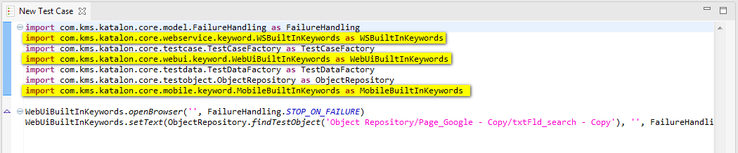

* Then simply change the existing item action to the one that you would like to use

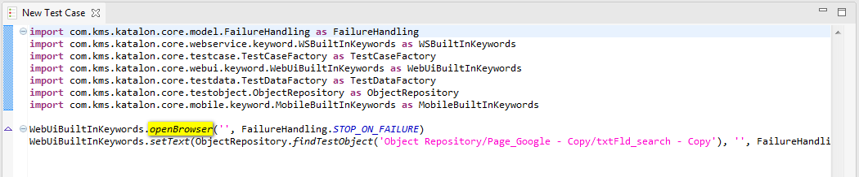

* Then provide all parameters as required for the selected keyword.

#### Change object under test

Among those actions that a user can perform on the application under test, there are actions that need to be performed on a specific object in the application. For example, click on a button; click on a hyperlink … These objects are called test objects. Refer to “Test Object > Detect and capture test object” and “Test Object > Create a custom test object” sections for how to define a test object. In this section you will know how to change the test object used in a test step.

##### Change object under test using Manual mode

A test step which requires a test object would look like the following in the test step grid (i.e., the cell under “Object” column of the test step row will not be empty): 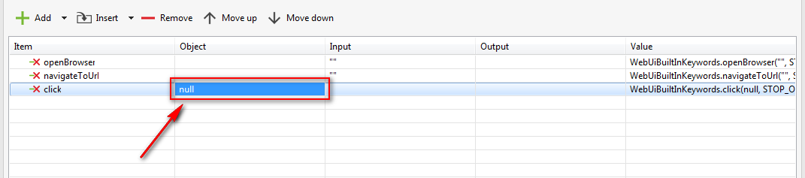

Using the Test Case Editor in Manual mode, follow the steps below in order to change the test object used for a test step:

* Double click on the cell in the “Object” column of the interested test step, the following popup will be displayed:

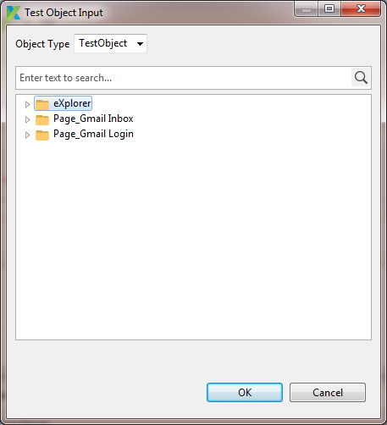

* Browse through the test object tree and select the interested test object. Then press the “OK” button.
* The selected test object will be displayed in the corresponding cell in the “Object” column of the test step that you are working on.

##### Change object under test using Scripting mode

A test step which requires a test object would look like the following in the Test Case Editor in Scripting mode:

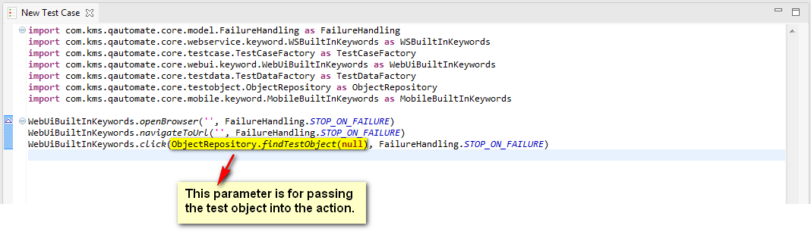

Then you can change the test object of a test step by specifying the relative path to the place where your test case can locate the test object, such as the following:

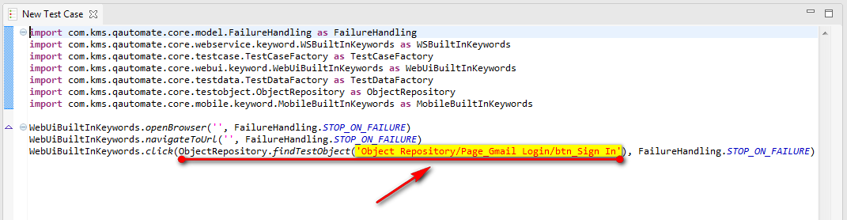

#### Edit input

Among those actions that a user can perform on the application under test, there are cases that require the user to provide input for a specific object in the application. For example, key in some value in a text field, etc. In this section you will know how to change the input parameter used in a test step.

##### Edit input using Manual mode

A test step which requires an input would look like the following in the test step grid (i.e., the cell under “Input” column of the test step row will not be empty):

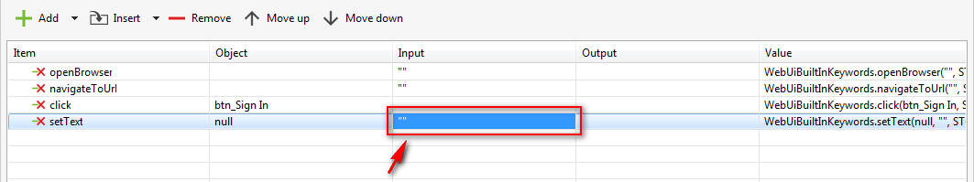

Using the Test Case Editor in Manual mode, follow the steps below in order to change the input used for a test step:

* Double click on the cell in the “Input” column of the interested test step, the following popup will be displayed:

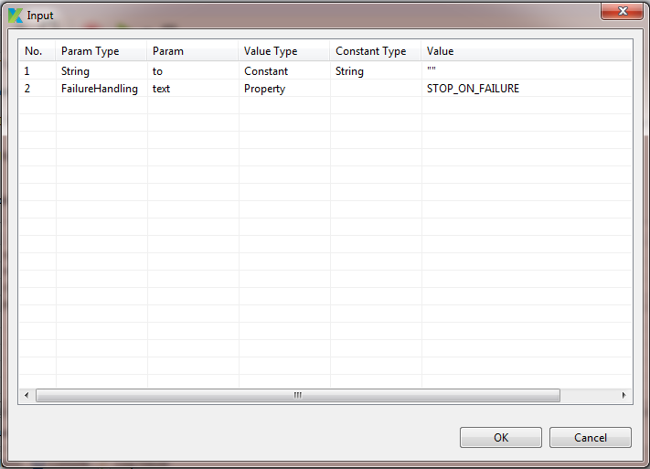

* There are several types of input that you can use to pass the input to the test step. Refer to Value Types for the list of available value types supported in Katalon Studio.
* Double click on the cell under the “Value Type” column. A dropdown containing the available options will be displayed as below:

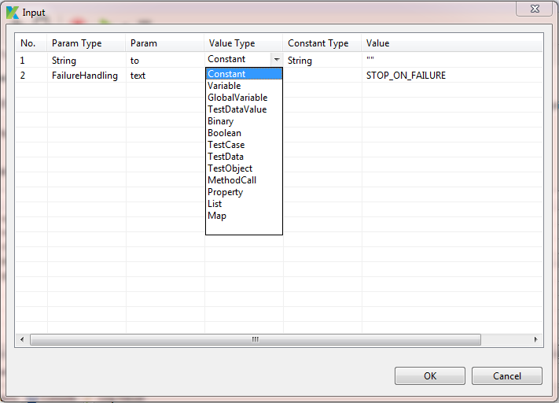

* From the above dropdown, select the value type that you’d like to use for the current input parameter.
* Refer to the subsequence sections for more information on how to specify input value for each value type.
* Override the default failure handling schema applied for the test step if needed. Refer to “Override failure handling schema” section for more detailed instruction.
* Press on the “OK” button.

Done! You have already successfully specified the input value for the current test step.

###### Input with value type = “Constant”

If you selected “Constant” as the value type in the previous step, then you can further specify the data type for the input parameter in the “Constant Type” column. Simply follow the steps below:

* Double click on the cell under the “Constant Type” column. A dropdown containing the available options will be displayed as below:

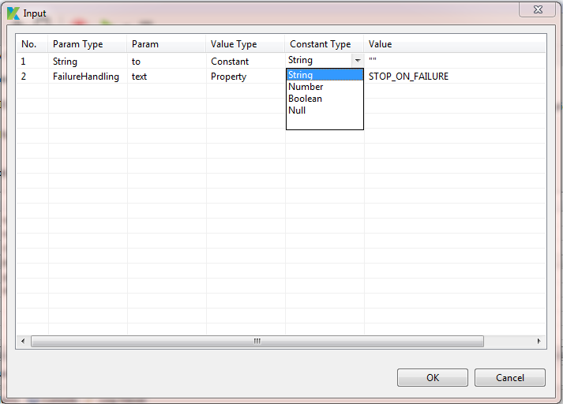

* From the above dropdown, select the data type needed.
* Provide the value in the “Value” column.

###### Input with value type = “Variable”

If you selected “Variable” as the value type in the previous step, then you can further specify the value for the input parameter by simply typing in the interested variable’s name in the “Value” column.

###### Input with value type = “Global Variable”

If you selected “Global Variable” as the value type in the previous step, then you can further specify the value for the input parameter as following:

* Double click on the cell under the “Value” column. Double click on the cell under the “Value” column. A dropdown containing all the global variables will be displayed.
* Select the global variable that you would like to use.

###### Input with value type = “Test Data Value”

If you selected “Test Data Value” as the value type in the previous step, then you can further specify the value for the input parameter as following:

* Double click on the cell under the “Value” column. A popup which looks like the following will be displayed:

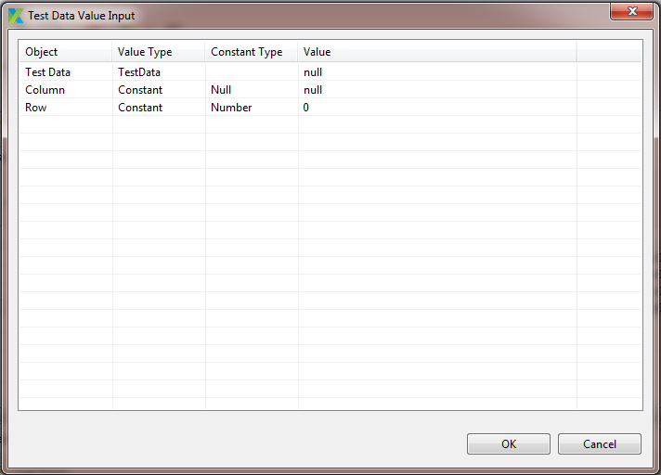

* In order to specify the input data which should be retrieved from a test data file, you should specify the following information:
  + Test Data: which test data file should be used?
  + Column: which column in the test data file should be used?
  + Row: which column in the test data file should be used?
* To define which test data file should be used, follow the steps below:
  + Double click on the corresponding cell under “Value” column. A popup which looks like the following will be displayed:

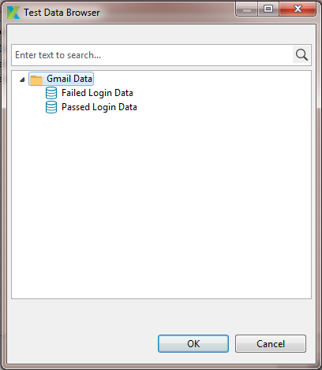

* + The above popup is to display all the existing test data file objects in your test project. Refer to ??? for how to manage your test data files.
  + Select the test data file object that you would like to use and press the “OK” button. The selected test data file object will be displayed in the “Value” column of the “Test Data” row.
* To define which column in the test data file should be used, follow the steps below:
  + Double click on the corresponding cell under “Value Type” column. A dropdown containing the available options will be displayed as below.

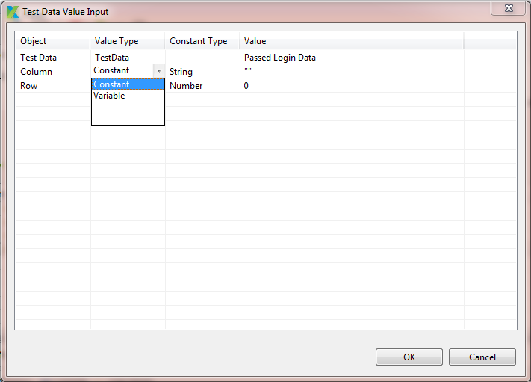

* + To define the value for each value type here, you just simply follow the same steps as when you define the value for the same value type described previous sections.
* To define which column in the test data file should be used, follow the steps below:
  + Double click on the corresponding cell under “Value Type” column. A dropdown containing the available options will be displayed as below.

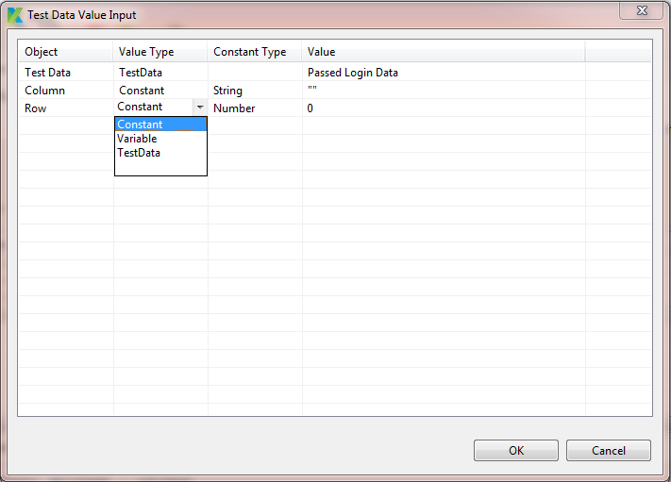

* + To define the value for each value type here, you just simply follow the same steps as when you define the value for the same value type described previous sections.
* For example: define all the information as following:

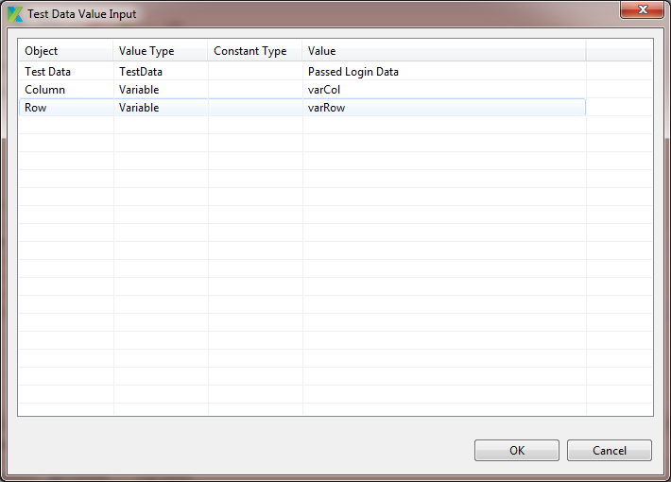

* Once all the needed items have already been added, press the “OK” button.
* The list of items specified will be displayed in the “Input” popup as below:

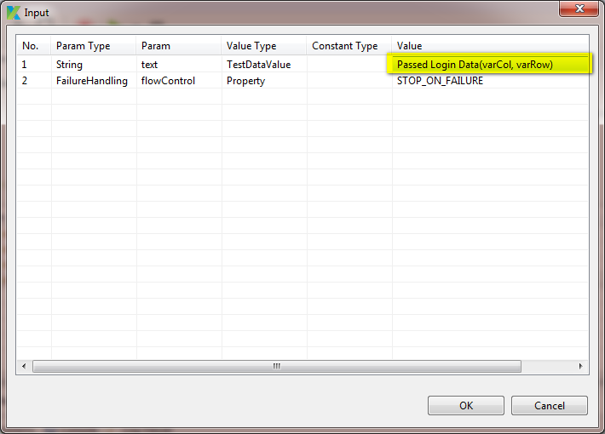

###### Input with value type = “Binary”

If you selected “Binary” as the value type in the previous step, then you can further specify the value for the input parameter as following:

* Double click on the cell under the “Value” column. A popup which looks like the following will be displayed:

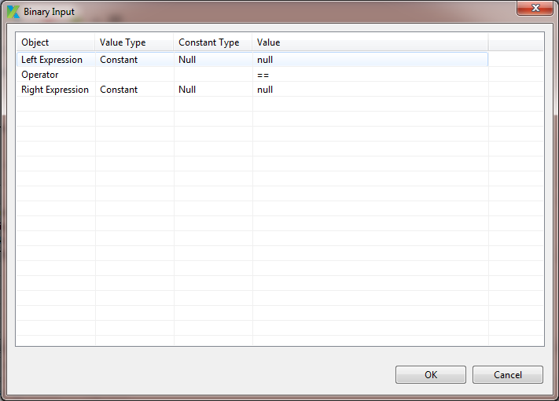

* In order to specify the input data of this type, you should specify the following information:
  + Left Expression: the left expression for this binary expression
  + Operator: which binary operator should be used?
  + Right Expression: the left expression for this binary expression
* To define the left expression, follow the steps below:
  + Double click on the corresponding cell under “Value Type” column. A dropdown containing the available options will be displayed as below.

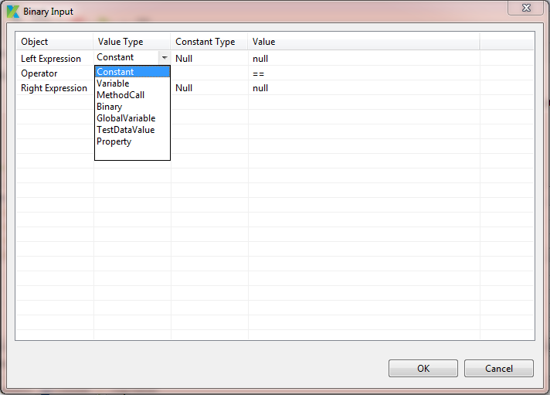

* + To define the value for each value type here, you just simply follow the same steps as when you define the value for the same value type described previous sections.
* To define the operator, follow the steps below:
  + Double click on the corresponding cell under “Value” column. A dropdown containing the available options will be displayed as below. Refer to Binary Operators for the list of binary operators supported in Katalon Studio.

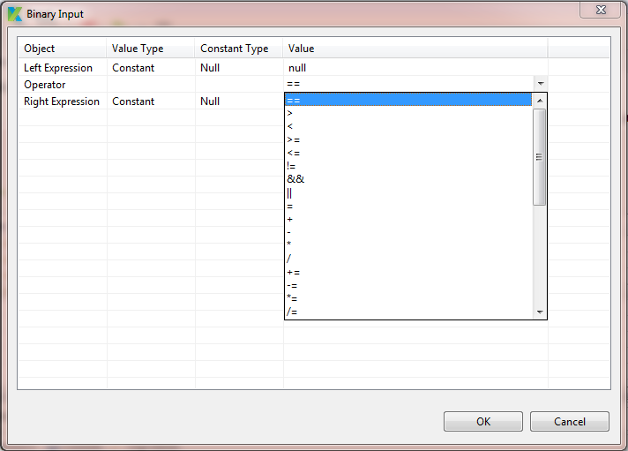

* To define the right expression, follow the steps below:
  + Double click on the corresponding cell under “Value Type” column. A dropdown containing the available options will be displayed as below.

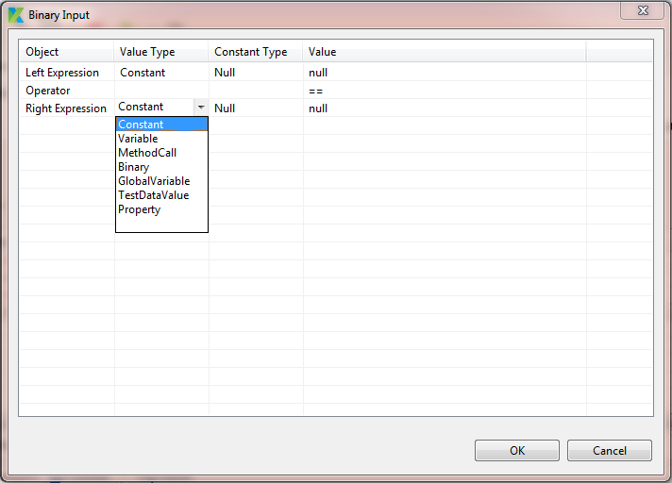

* + To define the value for each value type here, you just simply follow the same steps as when you define the value for the same value type described previous sections.
* After defining all the needed information, press the “OK” button.
* The binary expression specified will be displayed in the “Input” popup.

###### Input with value type = “Boolean”

If you selected “Boolean” as the value type in the previous step, then you can further specify the value for the input parameter as following:

* Double click on the cell under the “Value” column. A popup which looks like the following will be displayed:

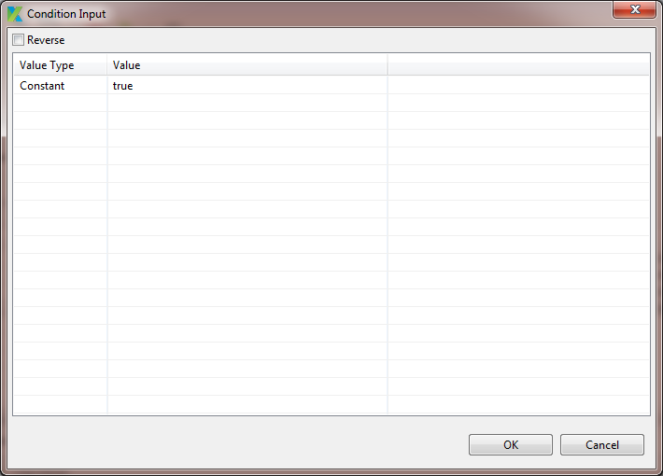

* Double click on the cell under the “Value” column. A dropdown containing the available options will be displayed as below.

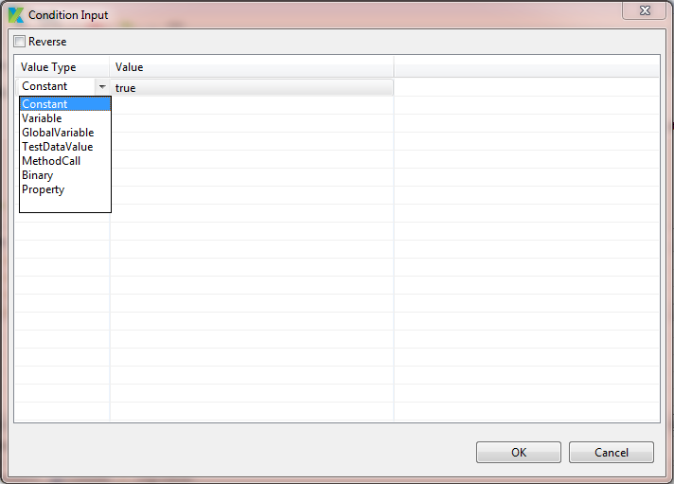

* If you select “Constant” in the “Value Type” column, you can further specify the input value, as following:
  + Double click on the cell under the “Value” column. A dropdown containing the available options will be displayed as below.

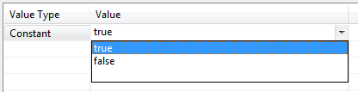

* + Select the value that you would like to use.
* If you select “Variable” in the “Value Type” column, you can further specify the input value by typing in the value in the cell under the “Value” column.
* If you select “Global Variable” in the “Value Type” column, you can further specify the input value, as following:
  + Double click on the cell under the “Value” column. A dropdown containing all the global variables will be displayed.
  + Select the global variable that you would like to use.
* If you select “Test Data Value” in the “Value Type” column, you can further specify the input value, as following:
  + Double click on the cell under the “Value” column. You will be presented with a popup allowing you to specify a test data value, as below:

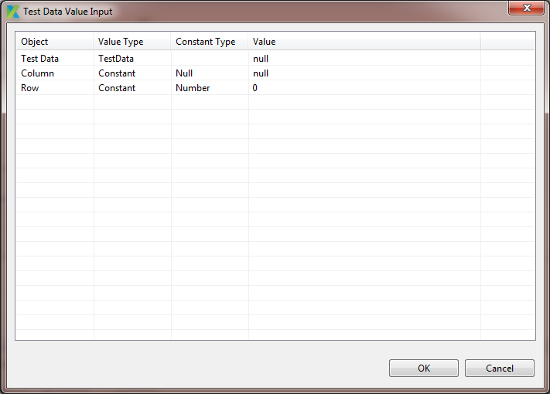

* + In fact, just simply follow the same steps which are being described in Input with value type = “Test Data Value” section in order to do this.
* If you select “Method Call” in the “Value Type” column, you can further specify the input value, as following:
  + Double click on the cell under the “Value” column. You will be presented with a popup allowing you to specify a method call, as below:

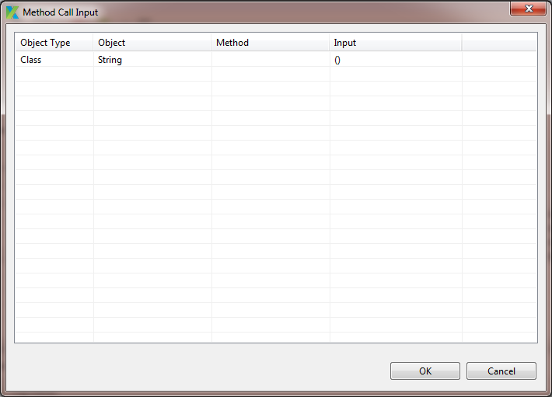

* + In fact, just simply follow the same steps which are being described in Input with value type = Method Call section in order to do this.
* If you select “Binary” in the “Value Type” column, you can further specify the input value, as following:
  + Double click on the cell under the “Value” column. You will be presented with a popup allowing you to specify a binary expression, as below:



* + In fact, just simply follow the same steps which are being described in Input with value type = Binary section in order to do this.
* If you select “Property” in the “Value Type” column, you can further specify the input value, as following:
  + Double click on the cell under the “Value” column. You will be presented with a popup allowing you to specify a property of an object, as below:

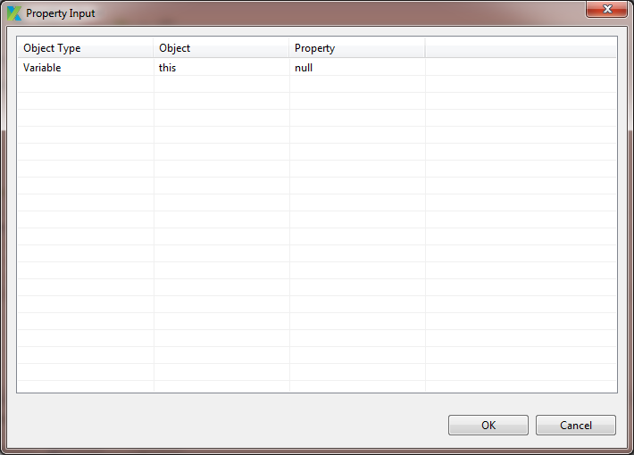

* + In fact, just simply follow the same steps which are being described in Input with value type = “Property” section in order to do this.
* If you want to use the reversed the result of the Boolean expression specified, just simply turn on the “Reverse” flag, as below:



* Press the “OK” button.
* The input specified will be displayed in the in the “Input” popup as below for an example:

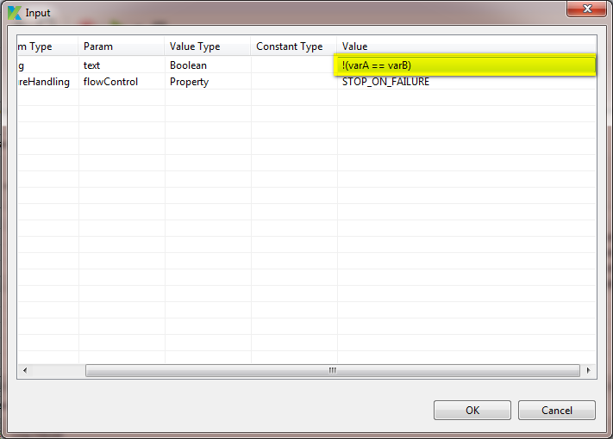

###### Input with value type = “Test Case”

If you selected “Test Case” as the value type in the previous step, then you can further specify the value for the input parameter as following:

* Double click on the cell under the “Value” column. A popup which looks like the following will be displayed:

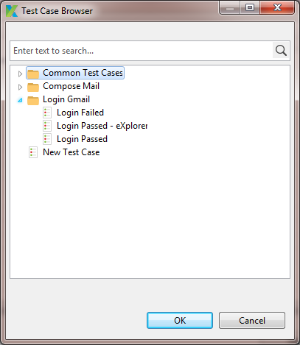

* Search and select the test case that you would like to use and press the “OK” button.
* The selected test case will be displayed in the “Value” column of the “Input” popup.

###### Input with value type = “Test Data”

If you selected “Test Data” as the value type in the previous step, then you can further specify the value for the input parameter as following:

* Double click on the cell under the “Value” column. A popup which looks like the following will be displayed:

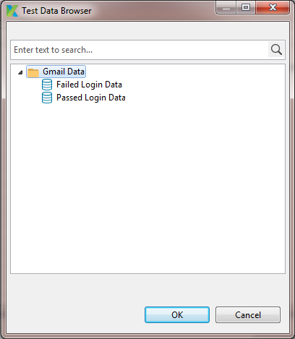

* Search and select the test data file object that you would like to use and press the “OK” button.
* The selected test data file object will be displayed in the “Value” column of the “Input” popup.

###### Input with value type = “Test Object”

If you selected “Test Object” as the value type in the previous step, then you can further specify the value for the input parameter as following:

* Double click on the cell under the “Value” column. A popup which looks like the following will be displayed:

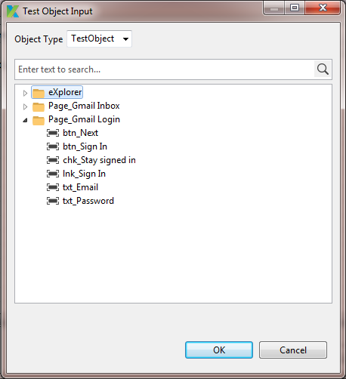

* You can specify the input test object either from the list of existing test objects or from another variable.
  + To specify a test object which is coming from an existing test object, follow the steps below:
    - Ensure that the item “Test Object” is selected in the “Object Type” dropdown.
    - Search and select the test object that you would like to use and press the “OK” button.
    - The selected test object will be displayed in the “Value” column of the “Input” popup, as below:

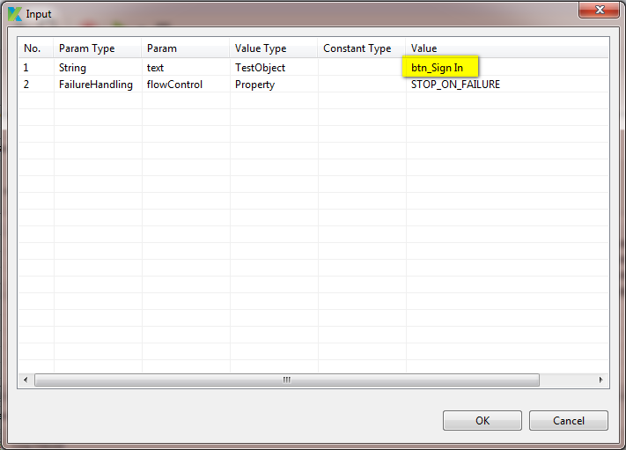

* + To specify a test object which is coming from another variable, follow the steps below:
    - Expand the “Object Type” dropdown, the following list of available options will be displayed:

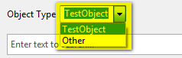

* + - Select “Other” item in the above dropdown, the popup will be reloaded as below:

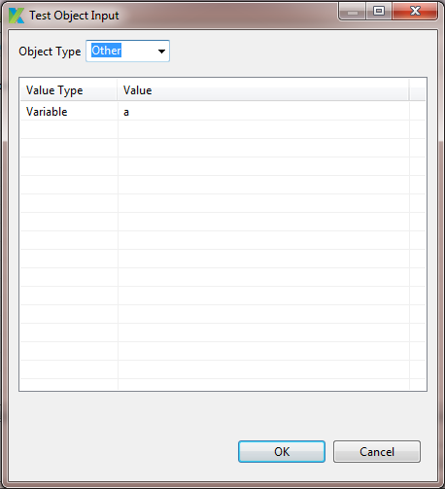

* + - Specify the variable that you’d like to use.
    - The selected variable will be displayed in the “Value” column of the “Input” popup, as below:

TBD

###### Input with value type = “Method Call”

If you selected “Method Call” as the value type in the previous step, then you can further specify the value for the input parameter as following:

* Double click on the cell under the “Value” column. A popup which looks like the following will be displayed:



* Double click on the cell under the “Object Type” column in the above popup. A dropdown containing the available options will be displayed as below:

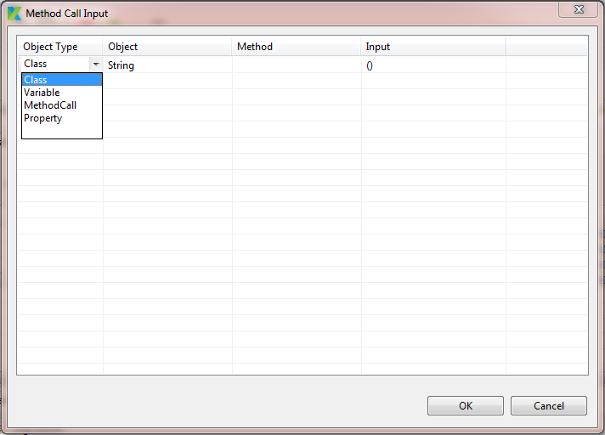

* With each of the object type supported above, you should further specify the following information:

|  |  |  |  |
| --- | --- | --- | --- |
| **Object Type** | **Object** | **Method** | **Input** |
| Class | Yes | Yes | * Yes if the method chosen requires some input. * No otherwise. |
| Variable | Yes | Yes | No |
| Method Call | Yes | Yes | No |
| Property | Yes | Yes | No |

* If you select “Class” in the “Object Type” column, you can further specify the object and its method that should be used as the input value, as following:
  + Double click on the cell under the “Object” column. A popup which looks like the following will be displayed:

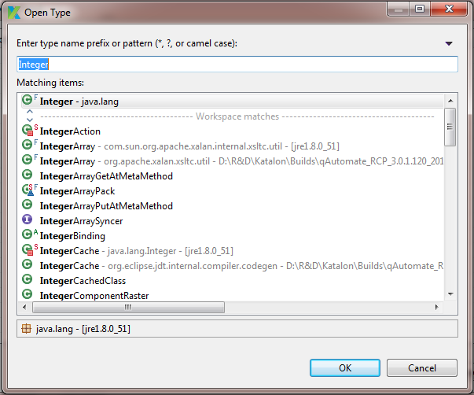

* + Search for the object that you are interested, and then press the “OK” button.
  + The selected object will be displayed in the “Object” column.
  + Double click on the cell under the “Method” column. A dropdown containing all available methods of the selected class will be displayed.
  + Select the method that you would like to use in the above dropdown:
    - If the selected method requires some input, you have to further provide the input for the method, by following double clicking on the cell under the “Input” column. Another popup will be displayed allowing you to specify input for the selected method. In fact, this popup is the same as the one open when you provide the input for a test step. Hence, just simply follow the same steps as when you are specifying input for a test step to define the input for the selected method here.
    - If the selected method requires no input, you don’t have to provide any input for it.
* If you select “Variable” in the “Object Type” column, you can further specify the object and its method that should be used as the input value, as following:
  + Key in the variable name in the “Object” column.
  + Key in the method name of the specified variable in the “Method” column.
* If you select “Method Call” in the “Object Type” column, you can further specify the object and its method that should be used as the input value, as following:
  + Double click on the cell under the “Object” column. You will be presented with a popup allowing you to specify an object of type “Method Call”. In fact, just simply follow the same steps which are being described in this section in order to do this.
  + Key in the method name of the specified variable in the “Method” column.
* If you select “Property” in the “Object Type” column, you can further specify the object and its method that should be used as the input value, as following:
  + Double click on the cell under the “Object” column. You will be presented with a popup allowing you to specify an object of type “Property”. In fact, just simply follow the same steps which are being described in Input with value type = “Property” section in order to do this.
  + Key in the method name of the specified variable in the “Method” column.
* Press the “OK” button.
* The input specified will be displayed in the in the “Input” popup as below for an example:

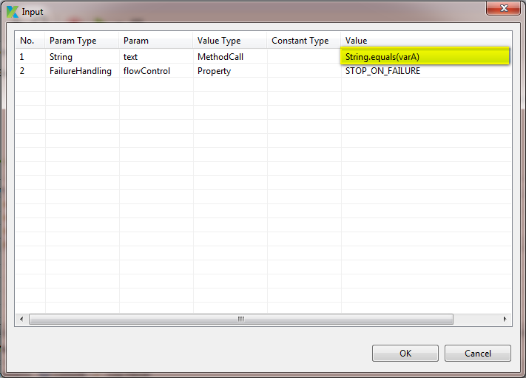

###### Input with value type = “Property”

If you selected “Property” as the value type in the previous step, then you can further specify the value for the input parameter as following:

* Double click on the cell under the “Value” column. A popup which looks like the following will be displayed:

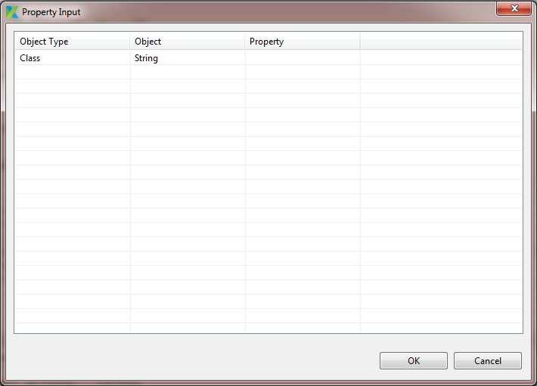

* Double click on the cell under the “Object Type” column in the above popup. A dropdown containing the available options will be displayed as below:

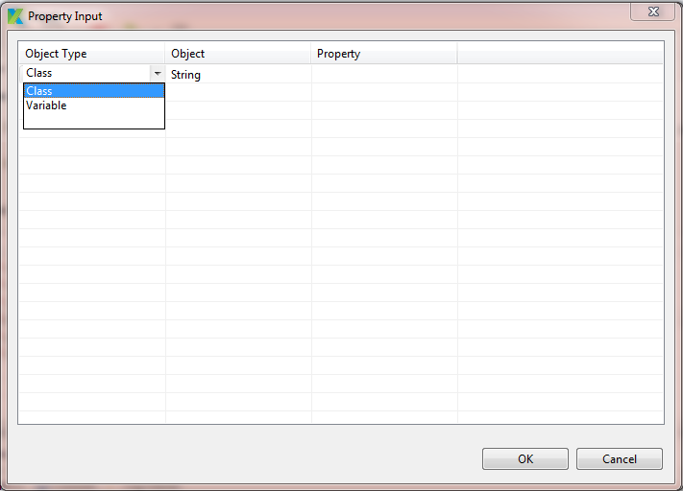

* If you select “Class” in the “Object Type” column, you can further specify the object and its property that should be used as the input value, as following:
  + Double click on the cell under the “Value” column. A popup which looks like the following will be displayed:



* + Search for the object that you are interested, and then press the “OK” button.
  + The selected object will be displayed in the “Object” column.
  + Double click on the cell under the “Property” column. A dropdown containing the available options will be displayed as below. Notice that the list of available properties displayed in the “Property” column is depending on the object selected in the “Object” column.

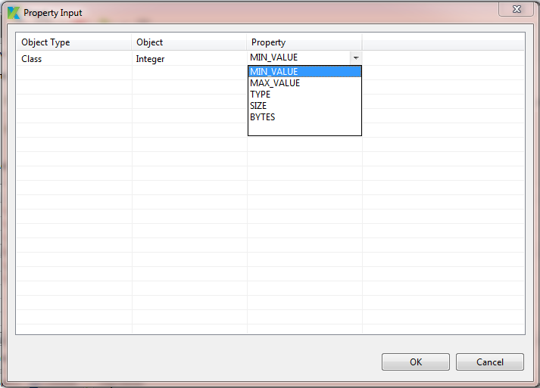

* + Select the interested property.
* If you select “Variable” in the “Object Type” column, you can further specify the object and its property that should be used as the input value, as following:
  + Key in the variable name in the “Object” column.
  + Key in the property name of the specified variable in the “Property” column.
* Press the “OK” button.

###### Input with value type = “List”

If you selected “List” as the value type in the previous step, then you can further specify the value for the input parameter as following:

* Double click on the cell under the “Value” column. A popup which looks like the following will be displayed:

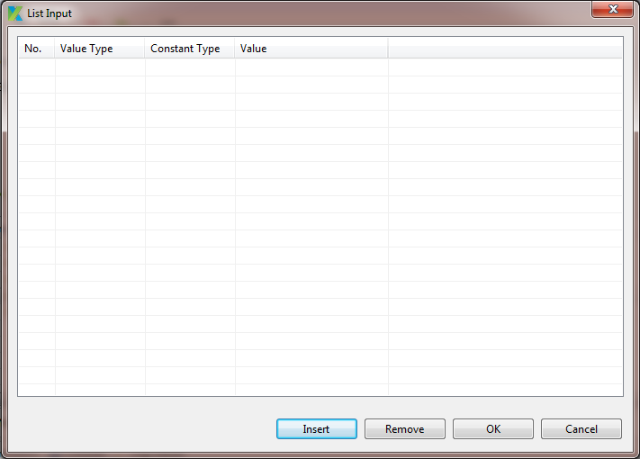

* Press the “Insert” button on the above popup. A row will be inserted and displayed in the grid as below:

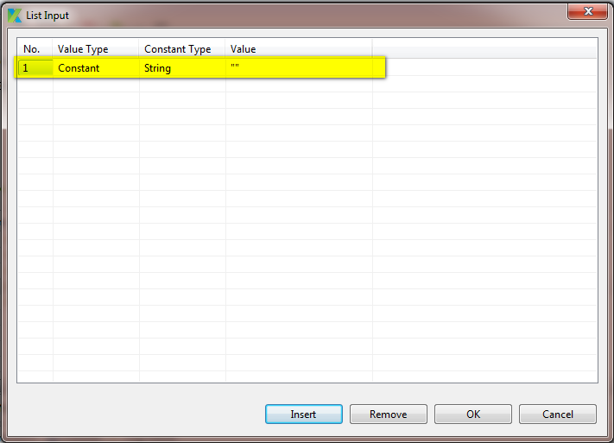

* Double click on the cell under the “Value Type” column. A dropdown containing the available options will be displayed as below:

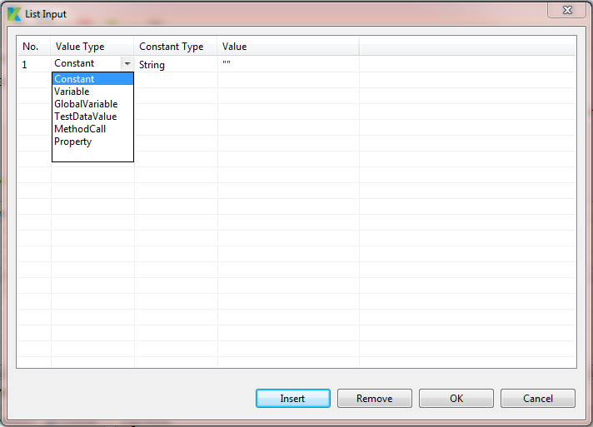

* Note:
  + To define the value for each value type here, you just simply follow the same steps as when you define the value for the same value type described previous sections.
  + To remove any row, you just need to select the row and press the “Remove” button.
* For example: define a list of items as following:

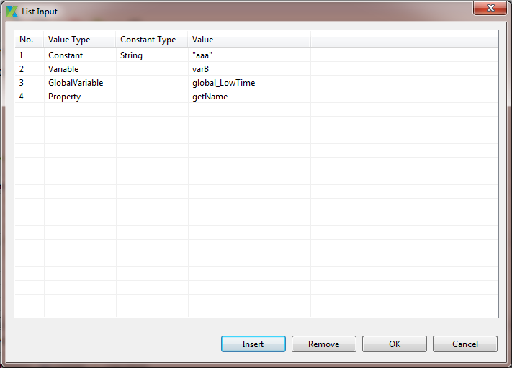

* Once all the needed items have already been added, press the “OK” button. The list of items specified will be displayed in the “Input” popup as below:

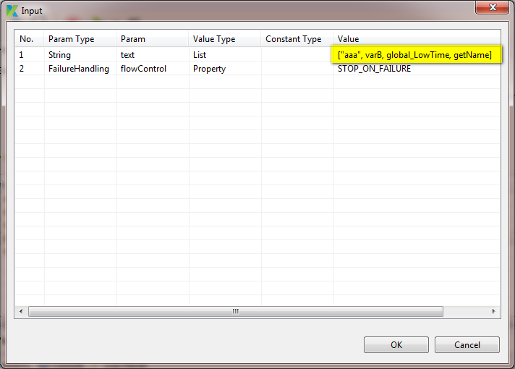

###### Input with value type = “Map”

If you selected “Map” as the value type in the previous step, then you can further specify the value for the input parameter as following:

* Double click on the cell under the “Value” column. A popup which looks like the following will be displayed:

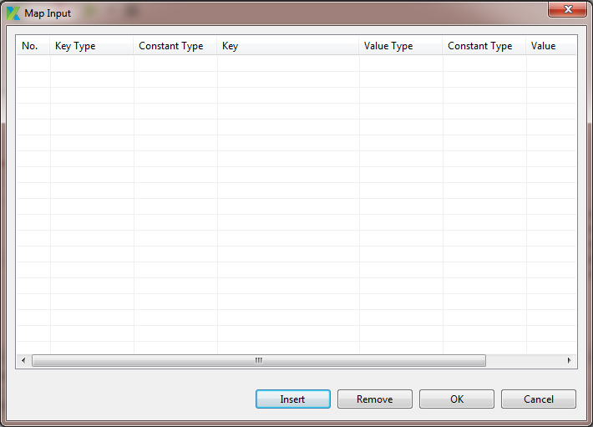

* Press the “Insert” button on the above popup. A row will be inserted and displayed in the grid as below:

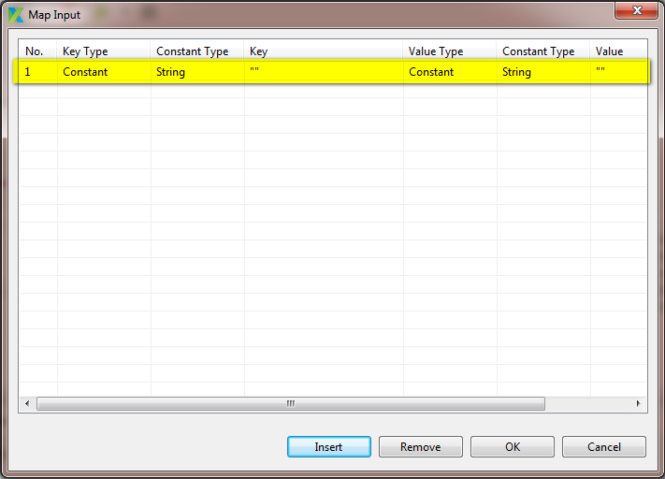

* Double click on the cell under the “Key Type” column. A dropdown containing the available options will be displayed as below:

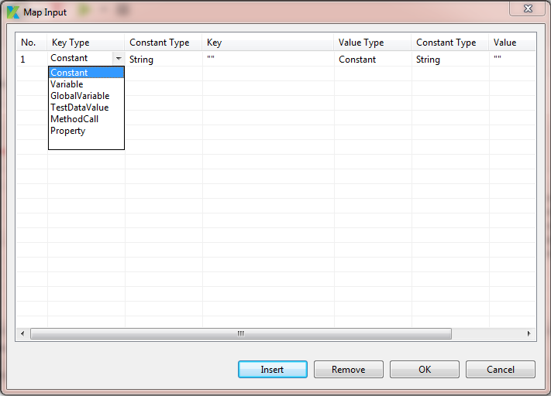

* Double click on the cell under the “Value Type” column. A dropdown containing the available options will be displayed as below:

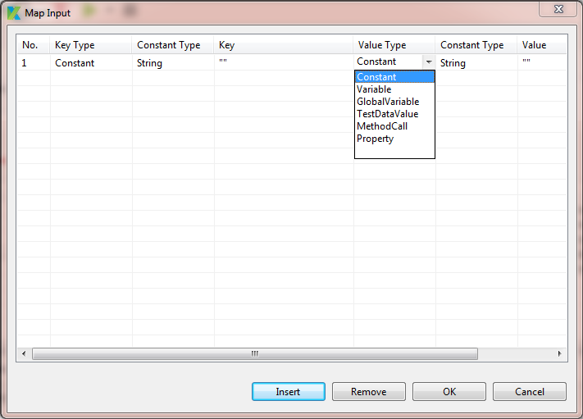

* Note:
  + To define the key/value for each key/value type here, you just simply follow the same steps as when you define the value for the same value type described previous sections.
  + To remove any row, you just need to select the row and press the “Remove” button.
* For example: define a map of items as following:

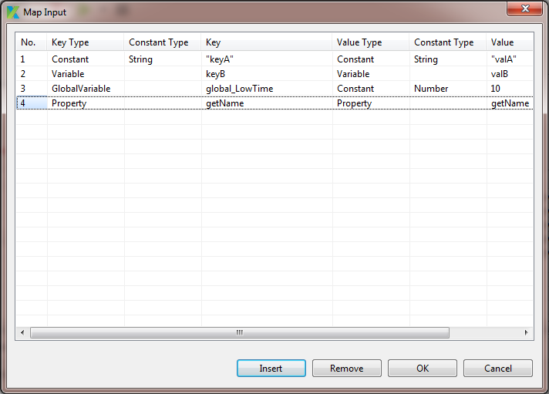

* Once all the needed items have already been added, press the “OK” button. The list of items specified will be displayed in the “Input” popup as below:

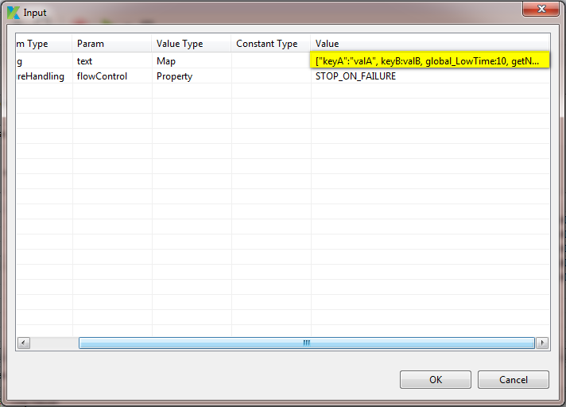

##### Edit input using Scripting mode

You can also use the Test Case Editor in Scripting mode to edit the input parameter for a test step. In this section you’ll know the syntax of each type of value type. This will help you to define the input parameter when scripting your test case.

###### Input with value type = “Constant”

If the input is a constant of type “String”, here’s how the input parameter looks like:

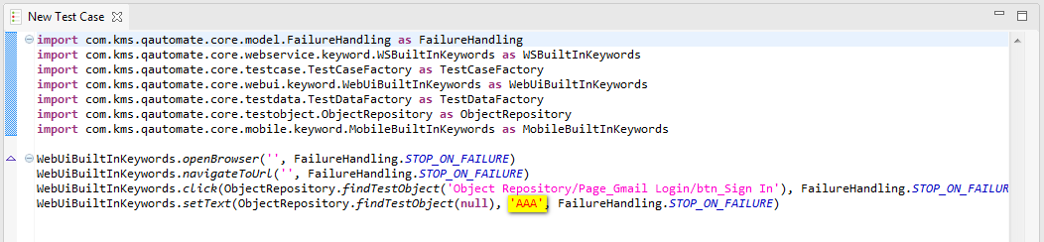

If the input is a constant of type “Number”, here’s how the input parameter looks like:

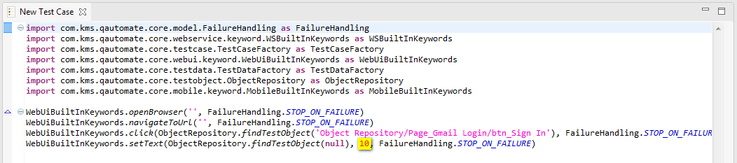

If the input is a constant of type “Boolean”, here’s how the input parameter looks like:

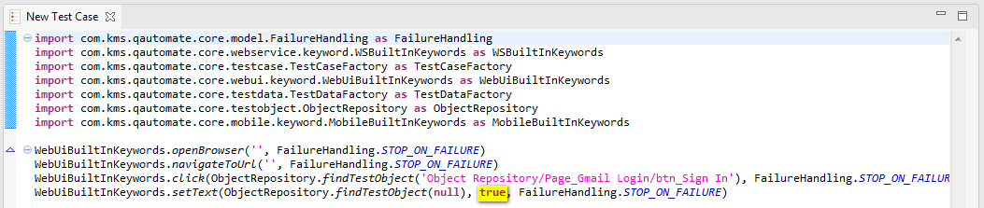

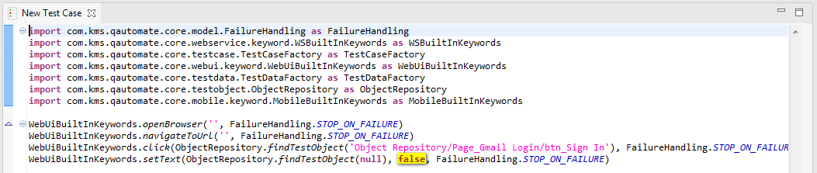

If the input is a constant of type “Null”, here’s how the input parameter looks like:

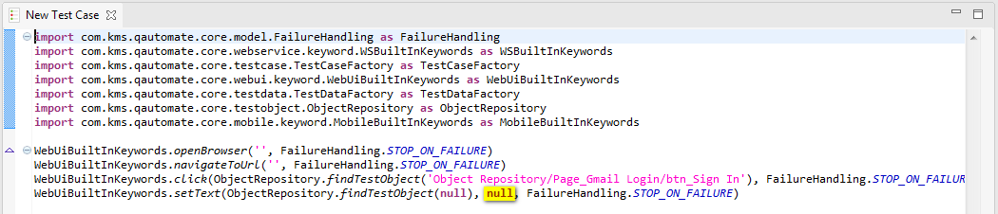

###### Input with value type = “Variable”

In order to specify the input parameter of this type, you just need to specify name of the interested variable as the input parameter, as below:

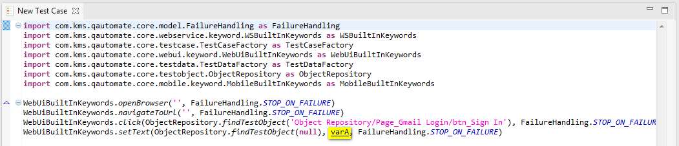

###### Input with value type = “Global variable”

In order to specify the input parameter of this type, you just need to specify name of the interested global variable as the input parameter with the following syntax:

GlobalVariable.globalVariableName

Where:

* globalVariableName is the name of the global variable that you would like to use

Here’s how the input parameter of this type looks like:

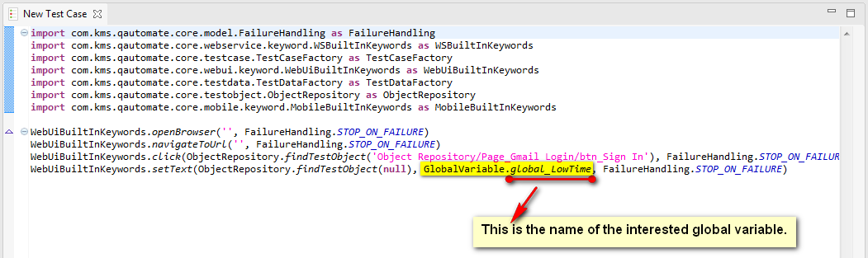

###### Input with value type = “Test Data Value”

In order to specify the input parameter of this type, you should specify the following information:

* Test Data: which test data file should be used?
* Column: which column in the test data file should be used?
* Row: which column in the test data file should be used?

Thus, just simply use the following syntax in order to specify input parameter of this type:

TestDataFactory.findTestData(relativePath).getValue(col, row)

Where:

* TestDataFactory.findTestData(relativePath) method is to find the test data file object corresponding to the relative path passed in the parameter.
* getValue(col, row) method is to get the value at the cell whose column and row indexes have been provided in the parameter, where:
  + Column index can be passed as a constant or variable.
  + Row index can be passed as a constant or variable.

Here’s how the input parameter of this type looks like:

* If column and row indexes are passed as constants:

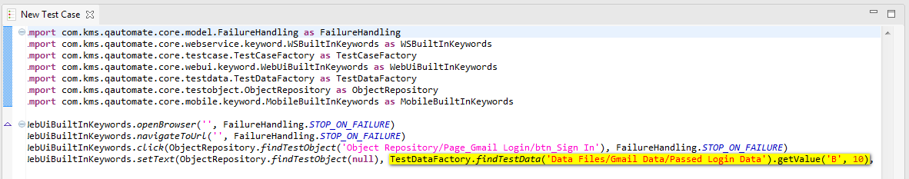

* If column and row indexes are passed as variables:

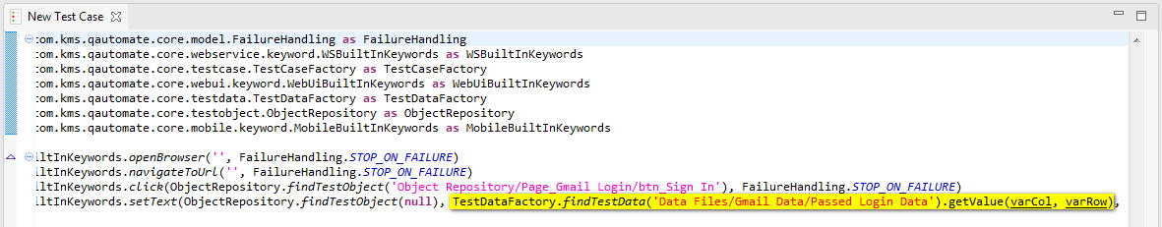

###### Input with value type = “Binary”

In order to specify the input data of this type, you should specify the following information:

* Left Expression: the left expression for this binary expression
* Operator: which binary operator should be used?
* Right Expression: the left expression for this binary expression

The left and right expressions can be of the following value types:

* Constant
* Variable
* Global Variable
* Test Data Value
* Binary
* Method Call
* Property

For the full list of binary operators supported in Katalon Studio, refer to Binary Operators.

The following is just to show one example of how a binary expression would look like in the scripting mode.

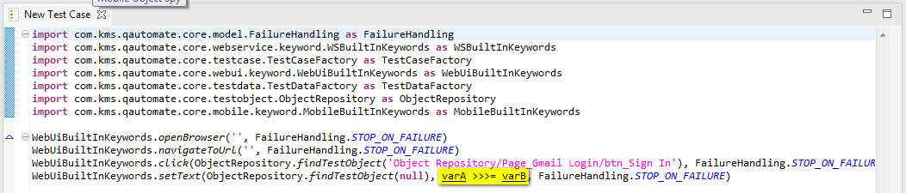

###### Input with value type = “Boolean”

In order to specify the input parameter of this type, you should ???

Here’s how the input parameter of this type looks like:

* If the input is a constant:
  + Use the original result of the Boolean expression:

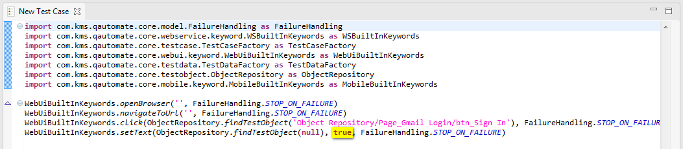

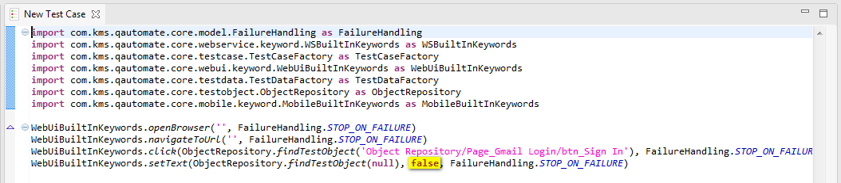

* Use the reversed result of the Boolean expression:

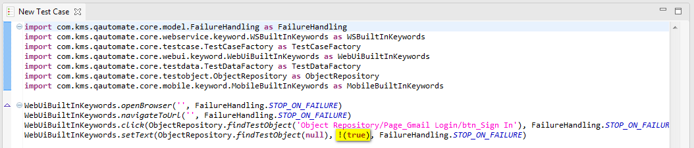

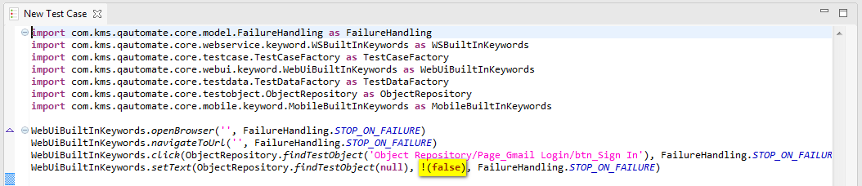

* If the input is a variable:
  + Use the original result of the Boolean expression:

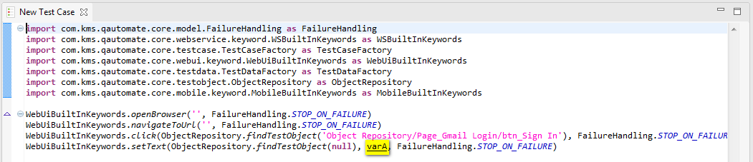

* + Use the reversed result of the Boolean expression:

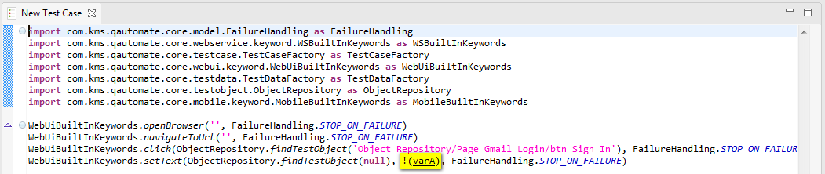

* If the input is a test data value:
  + Use the original result of the Boolean expression:

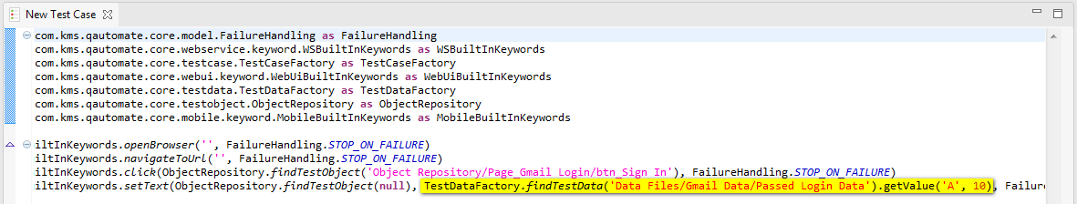

* + Use the reversed result of the Boolean expression:

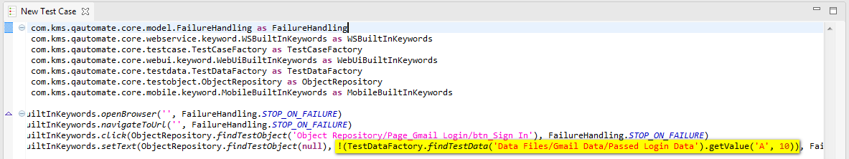

* If the input is a method call:
  + Use the original result of the Boolean expression:

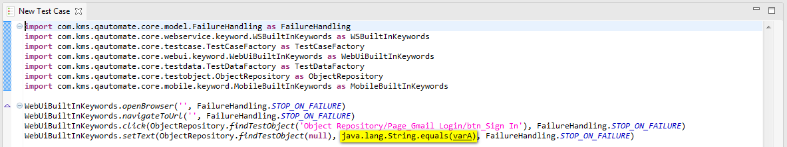

* + Use the reversed result of the Boolean expression:

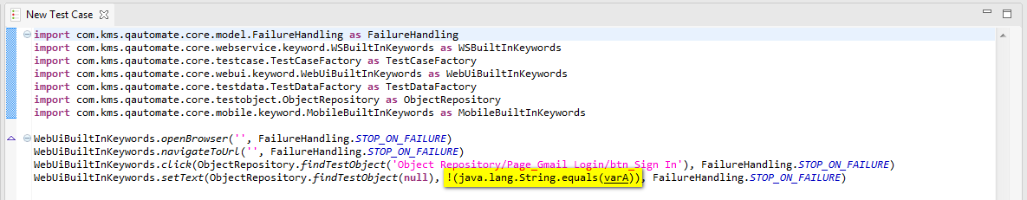

* If the input is a binary expression:
  + Use the original result of the Boolean expression:

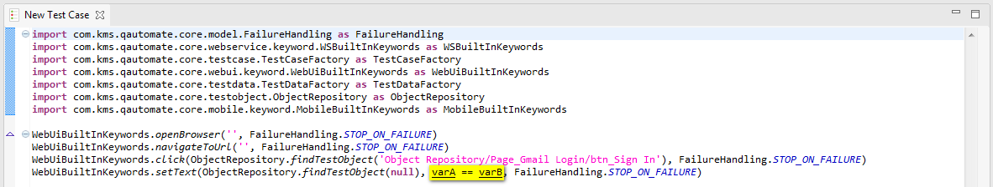

* + Use the reversed result of the Boolean expression:

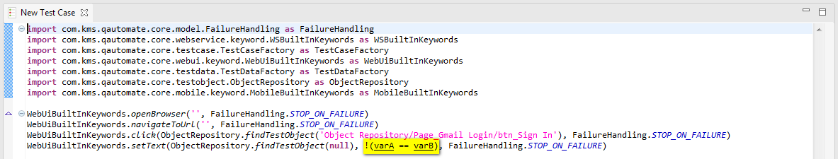

* If the input is a property of an object:
  + Use the original result of the Boolean expression:

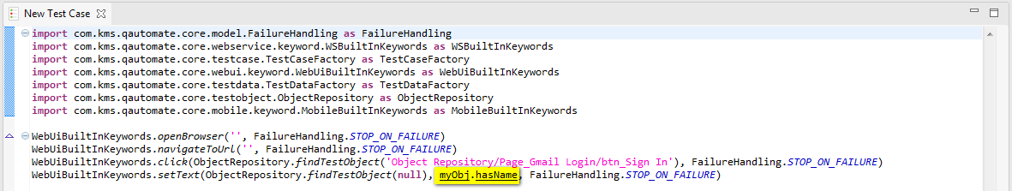

* + Use the reversed result of the Boolean expression:

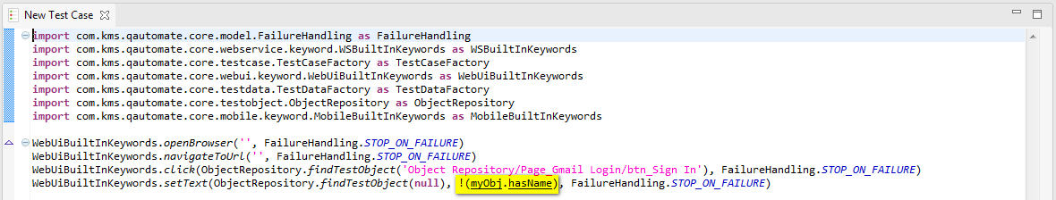

###### Input with value type = “Test Case”

In order to specify the input parameter of this type, just simply use the following syntax:

TestDataFactory.findTestCase(relativePath)

Where:

* relativePath is the relative path to the test case that you would like to use.

Here’s how the input parameter of this type looks like:

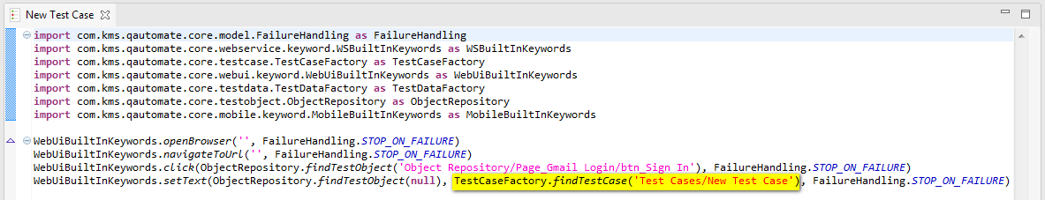

###### Input with value type = “Test Data”

In order to specify the input parameter of this type, just simply use the following syntax:

TestDataFactory.findTestData(relativePath)

Where:

* relativePath is the relative path to the test data file object that you would like to use.

Here’s how the input parameter of this type looks like:

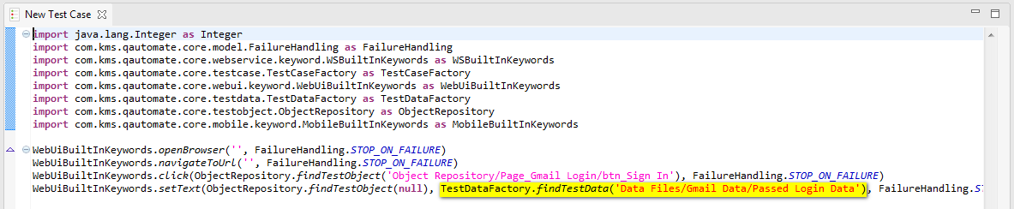

###### Input with value type = “Test Object”

In order to specify the input parameter of this type, just simply use the following syntax:

ObjectRepository.findTestObject (relativePath)

Where:

* relativePath is the relative path to the test object that you would like to use.

Here’s how the input parameter of this type looks like:

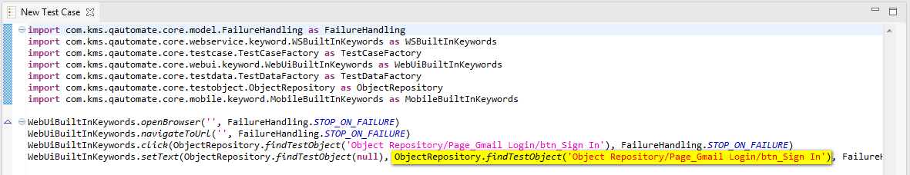

###### Input with value type = “Method Call”

In order to specify the input parameter of this type, you should specify the following information:

* The name of the object used
* The method name of the above object
* The input data for the above method if required

Thus, just simply use the following syntax in order to specify input parameter of this type:

object.method(input)

Where:

* object can be either the name of any object that you would like to use
* method is the name of the method of the above object that you would like to use
* input is the input data for the method used

Here’s how the input parameter of this type looks like:

* If the input is a method call from a class:

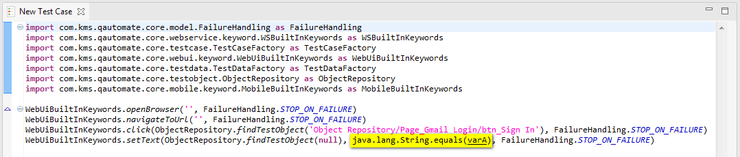

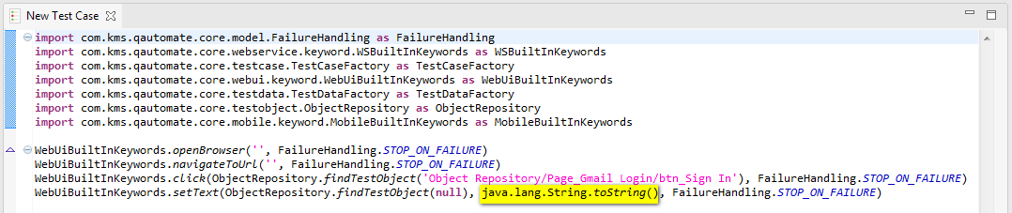

* If the input is a method call from a variable:

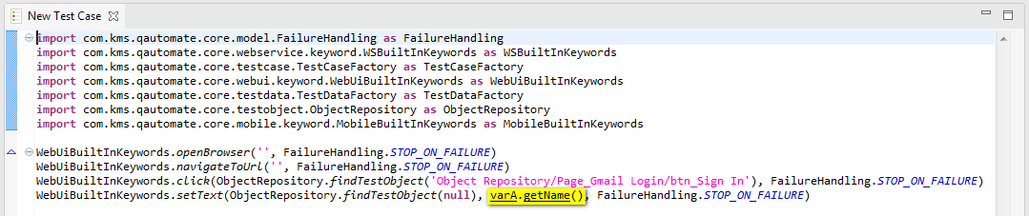

* If the input is another method call:

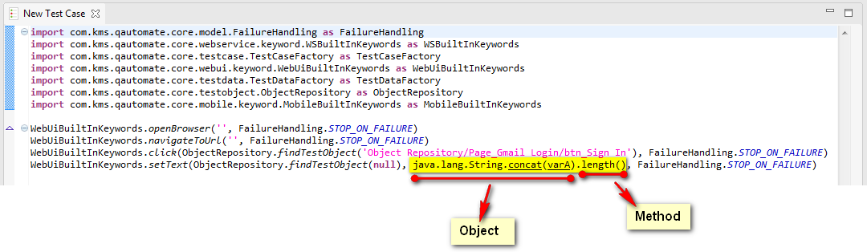

* If the input is a method call from a property:

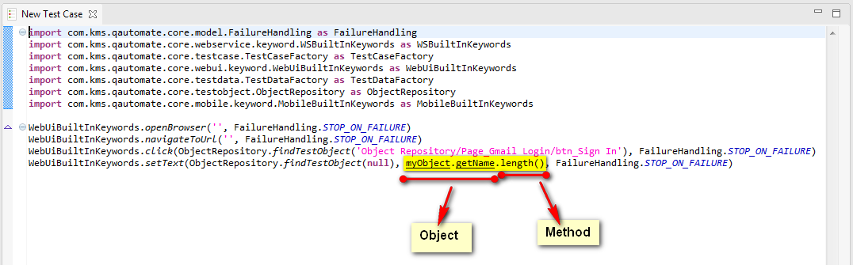

###### Input with value type = “Property”

In order to specify the input parameter of this type, you should specify the following information:

* The name of the object used
* The property name of the above object

Thus, just simply use the following syntax in order to specify input parameter of this type:

object.property

Where:

* object can be either the name of any Java/Groovy class or the name of a variable that you would like to use
* property is the name of the public property that you would like to use

Here’s how the input parameter of this type looks like:

* If the object used is a Java/Groovy class:
  + Use full identifier for the class name if it is not imported into your test case yet:

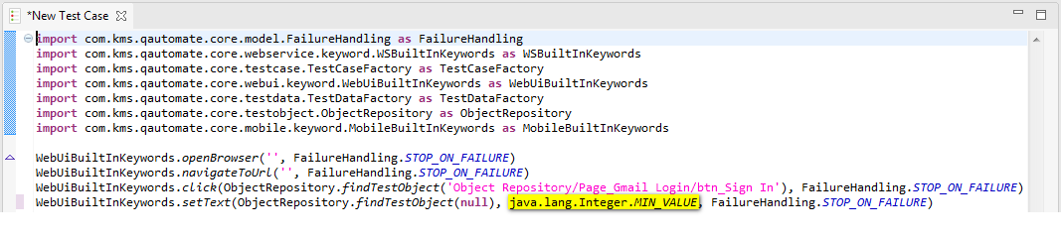

* + Or import the class into your test case so that you don’t have to use its full identifier whenever it is referenced in your test case:

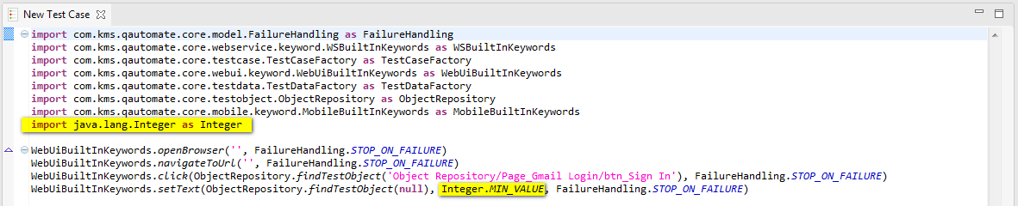

* If the object used is a variable:

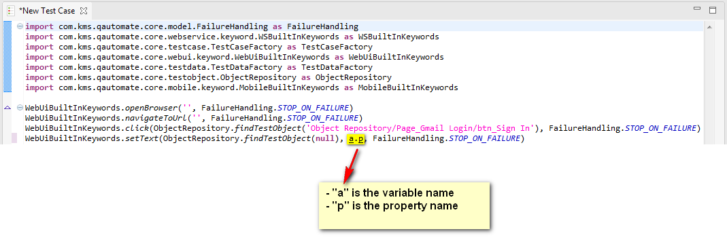

###### Input with value type = “List”

In order to specify the input parameter of this type, you need to define a list containing all values that you would like to use. This list can contain items of the following value types:

* Constant
* Variable
* Global variable
* Test Data Value
* Method Call
* Property

Thus, just simply use the following syntax in order to specify input parameter of this type:

[item1, item2, … , itemN]

Where:

* itemN is an individual value item belonging to your list
* “,” is the separator between items

Here’s how the input parameter of this type looks like:

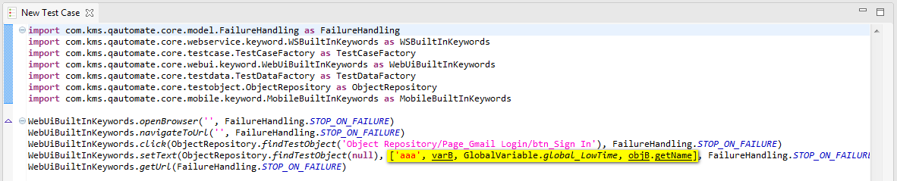

###### Input with value type = “Map”

In order to specify the input parameter of this type, you need to define a map containing all values that you would like to use.

* The key of each item can be of the following value types:
  + Constant
  + Variable
  + Global variable
  + Test Data Value
  + Method Call
  + Property
* The value of each item can be of the following value types:
  + Constant
  + Variable
  + Global variable
  + Test Data Value
  + Method Call
  + Property

Thus, just simply use the following syntax in order to specify input parameter of this type:

[key1:value1, key2:value2, … , keyN:valueN]

Where:

* keyN is the key used to identify an individual item in your map
* valueN is the value of an individual item in your map
* “,” is the separator between items

Here’s how the input parameter of this type looks like:

TBD

#### Edit output

In a test case, there are situations where the execution of subsequence test steps depending on the output of the previous test steps. In such cases, you will need to store the output of a test step somewhere for later use. And Katalon Studio does provide you such ability. Notice that this feature is only available for those keywords that will return some output after its execution. Refer to ??? for more detailed explanation for how to use each keyword.

##### Edit output using Manual mode

Using the Test Case Editor in Manual mode, follow the below steps in order to capture the output of a test step:

* Double click on the cell under the “Output” column of the test step.
* Key in the name of the variable that you would like to use to store the output of this test step. For example:

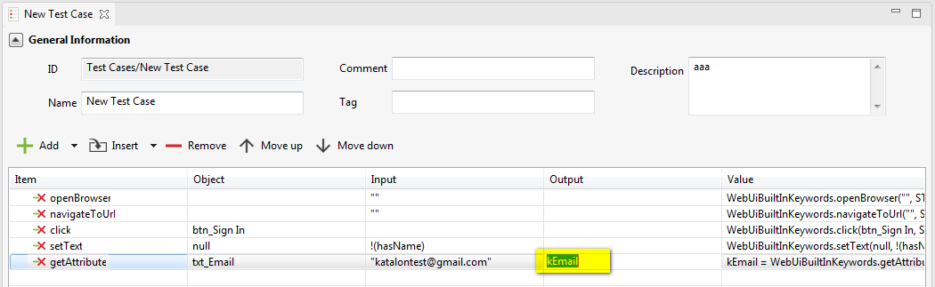

* Then, here’s how the output definition looks like in the Test Case Editor:

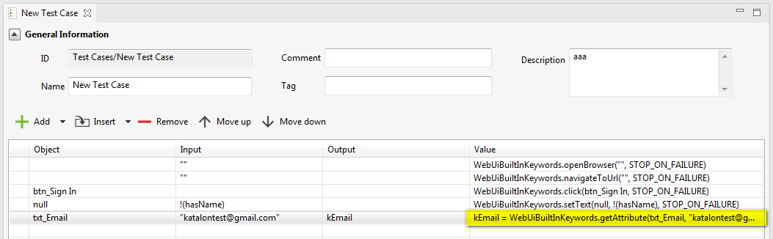

Notice that you don’t have to type in the name of a variable which is already declared in the “Variables” tab of your test case. Because in fact, the variable provided in the “Output” cell above will be declared and assigned a value coming from the output of the test step when the test step is executed.

##### Edit output using Scripting mode

Using the Test Case Editor in Manual mode, you can declare and assign the output of a test step to a variable as following:

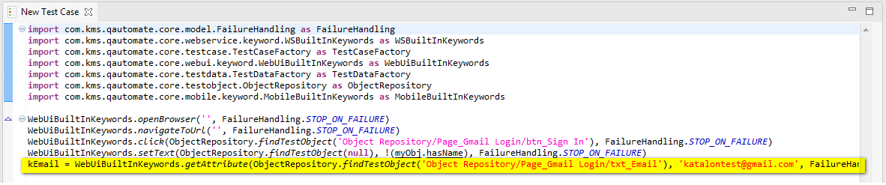

### Copy a test step

For this section, as it is straightforward for how to copy a test step in your test case using the Test Case Editor in Scripting mode, thus the following is just to explain how you can copy a test step using the Test Case Editor in Manual mode.

Using the Test Case Editor in Manual mode, you can copy a test step by using the “Copy” function in the context menu of any test step, as following:

* In the Test Case Editor, right click on any test step. A context menu will be displayed as below:

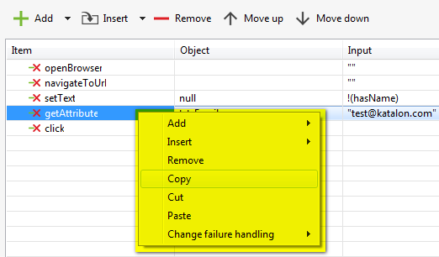

* Select the “Copy” item in the context menu above.
* Then right click on any existing test step. The same context menu will be displayed.
* Select the “Paste” item in the context menu above. The test step which was copied before will be pasted after the selected test step.
* Save your modification.

Done! You have already successfully copied a test step.

Notice that a test step can be copied and pasted in the same test case only.

### Re-sequence the test steps

For this section, as it is straightforward for how to re-sequence a test step in your test case using the Test Case Editor in Scripting mode, thus the following is just to explain how you can re-sequence a test step using the Test Case Editor in Manual mode.

Using the Test Case Editor in Manual mode, you can re-sequence a test step by using either one of the following methods:

* Method 1: Using “Move up” and “Move down” buttons in the toolbar of the Test Case Editor
  + Select the test step that you would like to re-sequence.
  + Click on the “Move up” button if you want to move the selected test step up:

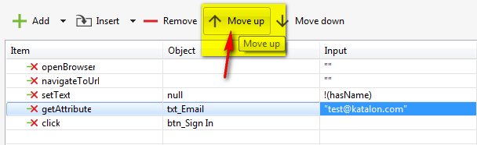

* + Click on the “Move down” button if you want to move the selected test step down:

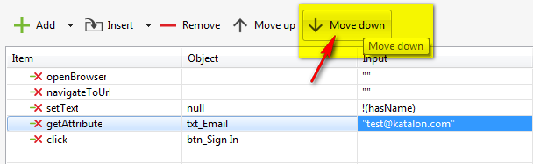

* Method 2: Drag and drop the test step up/down in the test step grid
  + Click on the test step(s) that you would like to re-sequence.
  + Hold the left mouse down while dragging the mouse up/down to the destination in the test step grid.
  + Release the mouse to drop the test step(s) at the destination.
* Method 3: Using the “Cut” and “Paste” functions in the context menu of any test step
  + In the Test Case Editor, right click on any test step. A context menu will be displayed as below:

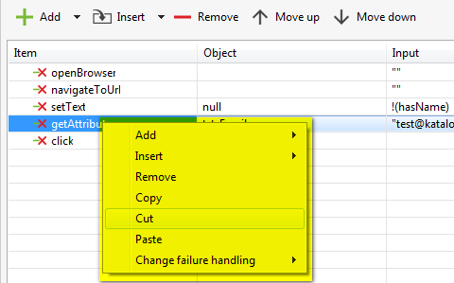

* + Select either the “Cut” item in the context menu above. The selected test step will be cut from the test step grid.
  + Then right click on any existing test step. The same context menu will be displayed.
  + Select the “Paste” item in the context menu above. The test step which was cut before will be moved and placed after the selected test step.
  + Notice that a test step can be cut and pasted in the same test case only.

Save your modification.

Done! You have already successfully re-sequenced a test step.

### Change failure handling schema

Refer to Failure handling > Override failure handling schema for more information.

## Manage variables

There are two type of variables supported in Katalon Studio, as below:

|  |  |
| --- | --- |
| **Variable Type** | **Description** |
| Local Variable | A local variable is a variable which can be referenced only within the scope of the test case where it is defined. |
| Global Variable | A global variable is a variable which can be referenced anywhere in your test project. |

Refer to the subsequence sections for how to define a variable of each type.

### Mange local variables

You can manage the list of local variables of your test case by using the “Variables” tab in your Test Case Editor.

#### Add a local variable

In order to add a local variable for a test case, simply follow the steps below:

* Click on the “Add” button on the toolbar in the “Variables” tab of the Test Case Editor, as being illustrated below:

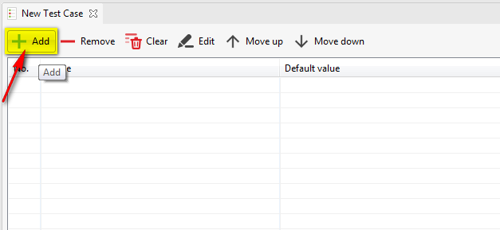

* A popup which looks like the following will be displayed:

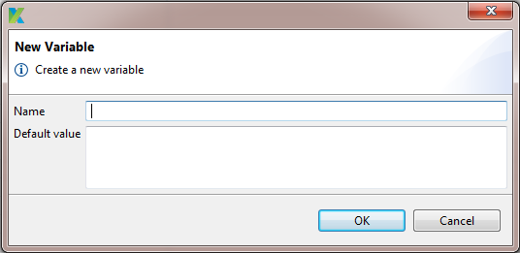

* Key in the name for the new variable. You can also key in the default value for the new variable if you like.
* Press the “OK” button.
* The newly added variable will be displayed in the variable grid, for example as below:

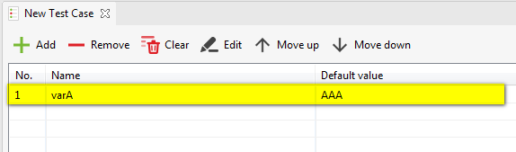

* Save your modification.

Done! You have already successfully added a local variable in your test case.

#### Delete a local variable

In order to delete a local variable for a test case, simply follow the steps below:

* Select the local variable(s) that you would like to remove.
* Click on the “Remove” button on the toolbar in the “Variables” tab of the Test Case Editor, as being illustrated below:

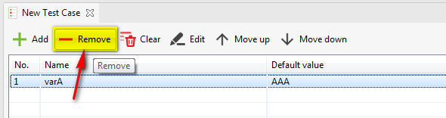

* The selected local variable(s) will be removed from your test case right away.
* Save your modification.

Done! You have already successfully deleted local variable(s) in your test case.

#### Edit a local variable

In order to edit a local variable for a test case, you can use either one of the following methods:

* Method 1: Editing directly in the variable grid
  + Click on the cell that you would like to edit.
  + Key in the new value.
  + Press Enter or click anywhere outside the above cell.
* Method 2: Using “Edit” button in the toolbar of the “Variables” tab
  + Select a local variable that you would like to edit.
  + Click on the “Edit” button in the toolbar, as illustrated below:

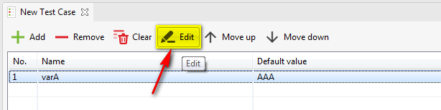

* + A popup which looks like the following will be displayed:

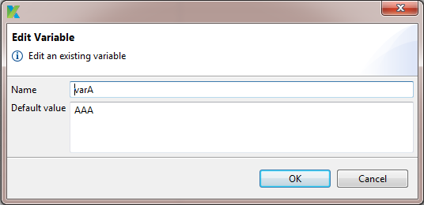

* + Key in the new name and /or default value.
  + Press the “OK” button.

Save your modification.

Done! You have already successfully edited a local variable in your test case.

#### Re-sequence the local variables

In order to re-sequence a local variable for a test case, you can use either one of the following methods:

* Method 1: Using “Move up” and “Move down” buttons in the toolbar of the “Variables” tab
  + Select the local variable that you would like to re-sequence.
  + Click on the “Move up” button if you want to move the selected local variable up:

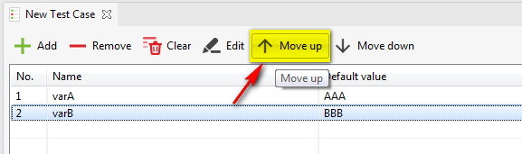

* + Click on the “Move down” button if you want to move the selected local variable down:

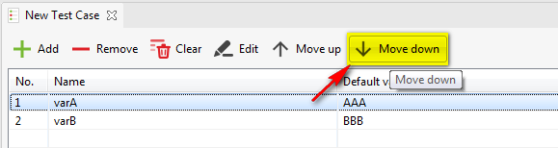

* Method 2: Drag and drop the local variable up/down in the variable grid
  + zzz

Save your modification.

Done! You have already successfully re-sequenced a local variable in your test case.

#### Clear all the local variables

In order to remove all the local variables in your test case, you can simply use the “Clear” function provided in the toolbar in the Variables tab of the Test Case Editor, as illustrated below:

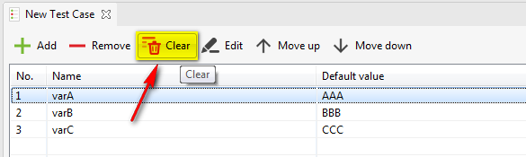

### Manage global variables

You can manage the list of global variables in your test project by using the Global Variables View.

#### Add a global variable

In order to add a global variable to your test project, simply follow the steps below:

* Click on the “Add” button on the toolbar of the Global Variables View , as being illustrated below:

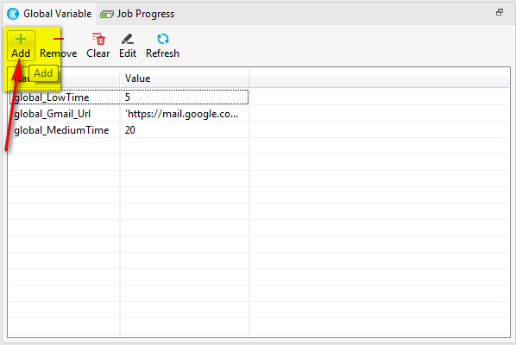

* A popup which looks like the following will be displayed:



* Key in the name for the new variable. You can also key in the default value for the new variable if you like.
* Press the “OK” button.
* The newly added variable will be displayed in the variable grid, for example as below:

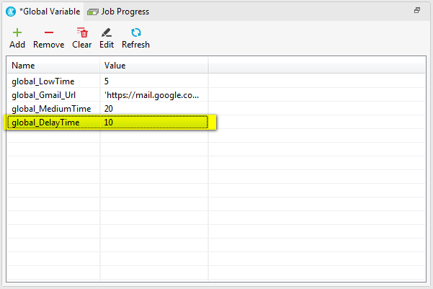

Done! You have already successfully added a global variable to your test project.

#### Delete a global variable

In order to delete a global variable from your test project, simply follow the steps below:

* Select the global variable(s) that you would like to remove.
* Click on the “Remove” button on the toolbar of the Global Variables View, as being illustrated below:

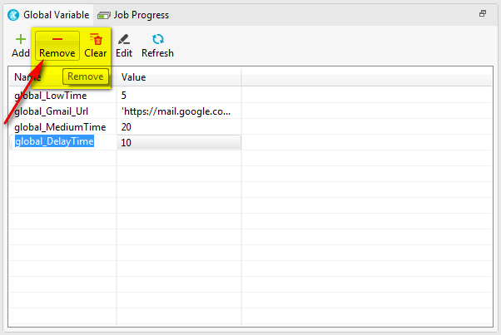

* The selected global variable(s) will be removed from your test project right away.

Done! You have already successfully deleted global variable(s) in your test project.

#### Edit a global variable

In order to edit a global variable in your test project, you can use either one of the following methods:

* Method 1: Editing directly in the variable grid
  + Click on the cell that you would like to edit.
  + Key in the new value.
  + Press Enter or click anywhere outside the above cell.
* Method 2: Using “Edit” button in the toolbar of the Global Variables View
  + Select a global variable that you would like to edit.
  + Click on the “Edit” button in the toolbar, as illustrated below:

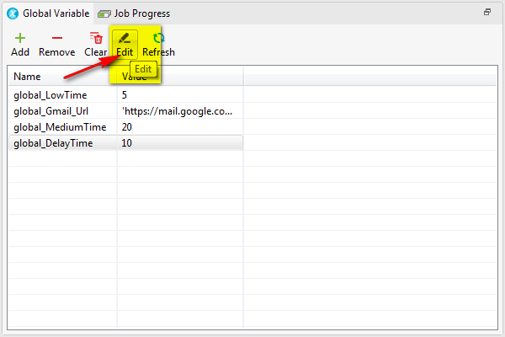

* + A popup which looks like the following will be displayed:

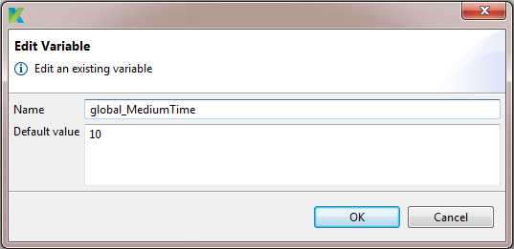

* + Key in the new name and /or default value.
  + Press the “OK” button.

Done! You have already successfully edited a global variable in your test project.

#### Clear all global variables

In order to remove all the global variables in your test project, you can simply use the “Clear” function provided in the toolbar of the Global Variables View, as illustrated below:

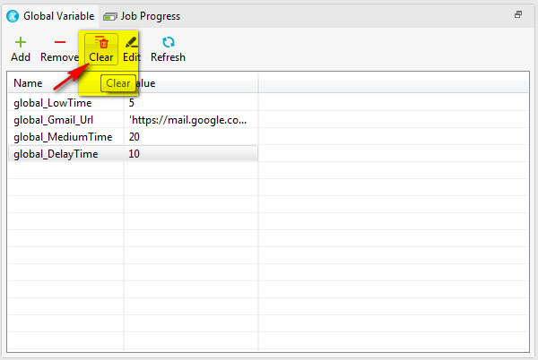

#### Refresh the list of global variables

There are cases that the list of global variables in your test project is modified outside Katalon Studio while your test project is being open in Katalon Studio. In such cases, the list of global variables in your test case displayed in Katalon Studio might not be in sync with the modification done outside Katalon Studio. Thus, you can keep this list in sync and showing the up-to-date information by using the “Refresh” function in the toolbar of the Global Variables View, as illustrated below:

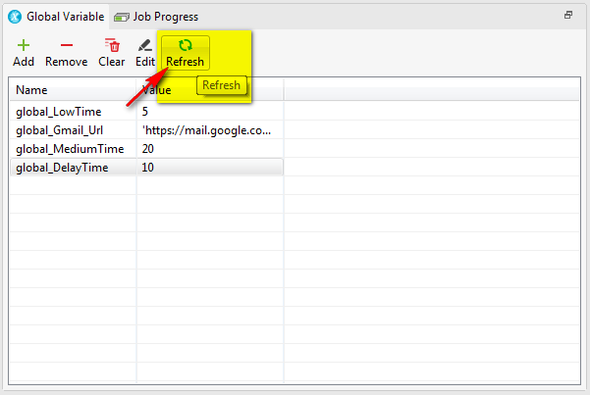

## Refresh a test case

There are cases that your test case is modified outside Katalon Studio while your test project is being open in Katalon Studio. In such cases, the test case displayed in Katalon Studio might not be in sync with the modification done outside Katalon Studio. Thus, you can keep the test case in sync and showing the up-to-date information by using either one of the following methods:

* Method 1: Using the context menu of a specific test case
  + In the Tests Explorer view, right click on the test case that you would like to refresh. A context menu will be displayed as below:

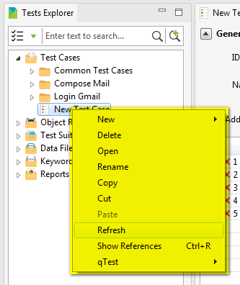

* + Select the “Refresh” item in the context menu above.
* Method 2: Using the context menu of the “Test Cases” folder
  + In the Tests Explorer view, right click on the ‘”Test Cases” folder. A context menu will be displayed as below:

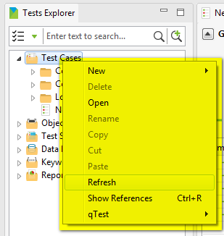

* + Select the “Refresh” item in the context menu above.

Done! You have already successfully refreshed your test case(s).

## Failure handling

There are cases that error will be raised while your test case is being executed. And there should be a failure handling schema defined in your test project to determine whether the execution should be allowed to continue or stop in such cases.

Currently, Katalon Studio supports the following failure handling schema:

|  |  |
| --- | --- |
| **Binary Operator** | **Description** |
| Stop on Failure | This means that whenever there’s an error occur during test case/step execution, the execution will be stopped right away. And the step where the error was raised will be marked as FAILED. |
| Continue on Failure | This means that the test case/step execution will simply continue no matter what and/or when an error is raised during its execution. And the step where the error was raised will be marked as FAILED. |
| Optional | This means that the test case/step execution will simply continue no matter what and/or when an error is raised during its execution. And the step where the error was raised will be marked as WARNING. |

### Define default failure handling schema

You can define a default failure handling schema that should be applied across your test project by following the below steps:

* Select *Settings → Preferences* from the menu. A popup will be displayed. Select item “Test Case” in the left menu navigation on that popup, the following screen will be displayed:

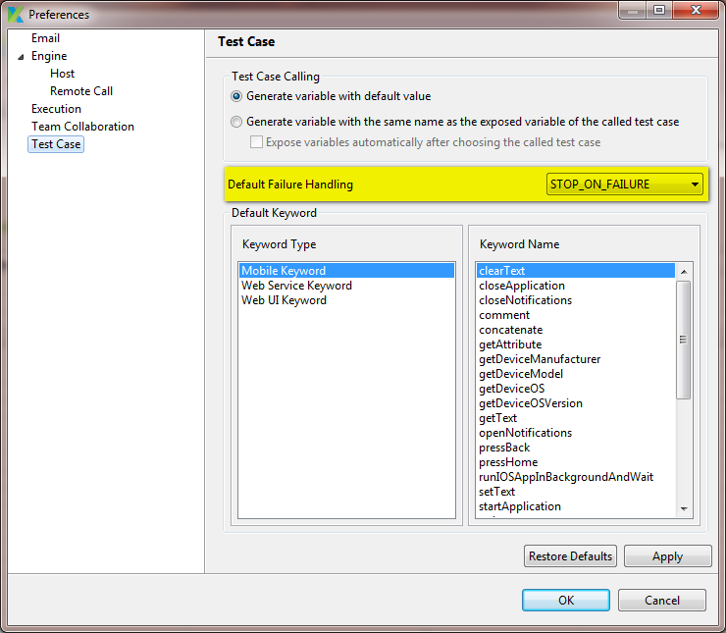

* Expand the “Default Failure Handling” dropdown (which was highlighted in yellow in the above screenshot), you will be presented with the following options:

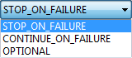

* Select the option that you would like to use as your default failure handling schema for your test project.
* Press on the “Apply” button then press the “OK” button. Or you can also simply press the “OK” button instead.

Done! You have already successfully defined the default failure handling schema for your test project. Notice that the newly chosen failure handling schema will only be applied as default failure handling schema in those test steps added in any test case after this point. For those test steps which have already existed in your test cases, their existing failure handling schemas are still kept unchanged.

### Override failure handling schema

Once a test step is added/inserted in your test case, its default failure handling schema will be inherited from the default failure handling schema defined for your entire test project. However, you can still override this and specify another failure handling schema as the one that would be used for the test step. In order to do this, you can simply use either one of the following methods:

* Method 1: When editing the input parameter of a test step using the Test Case Editor in Manual mode
  + In the test step grid, double click on the cell under the “Input” column. A popup which looks like the following will be displayed as below:

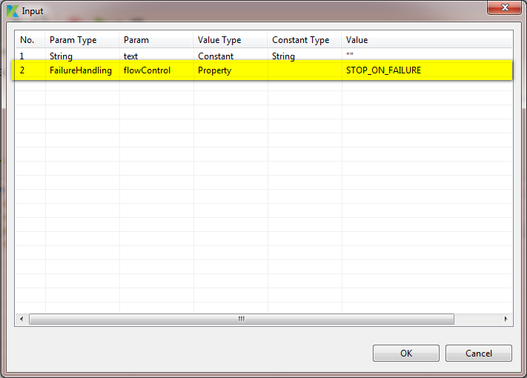

* + At the row “Failure Handling”, double click on the cell under the “Value” column. A dropdown containing all the available options will be displayed as below: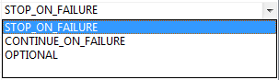
  + Select the option that you would like to use as the failure handling schema for the test step.
  + Press on the “OK” button.
* Method 2: Using the “Change failure handling” function in the context menu of any test step
  + In the Test Case Editor in Manual mode, right click on any test step. A context menu will be displayed as below:

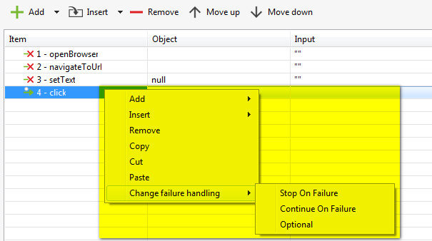

* + Select the “Change failure handling” item in the context menu above.
  + Then select the failure handling schema that you would like to use for the test step.
* Method 3: When editing a test step using the Test Case Editor in Scripting mode
  + Use the following options in order to specify the failure handling schema for a test step:
    - FailureHandling.STOP_ON_FAILURE
    - FailureHandling.CONTINUE_ON_FAILURE
    - FailureHandling.OPTIONAL
  + For example:

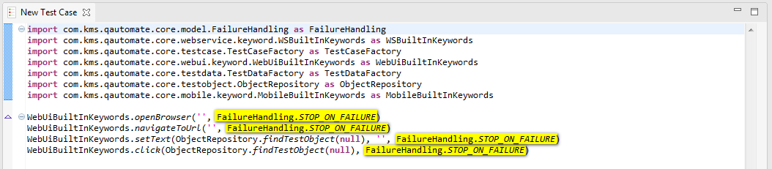

Done! You have already successfully overridden the failure handling schema that would be used for a test step in your test case.

## Call another test case

While designing your test cases, there are cases when you recognize some test step sequence is duplicated from one test case to another. This might be due to some logic sequence is common among test cases (e.g.: login, logout …). In such cases, it would be much better if you can separate those common logic sequences into separate test cases which then can be reused across your test project. Thus Katalon Studio also provides this ability for you to call another test case within your test case. You can do this by using either one of the following methods:

* Method 1: Using Manual mode (i.e., using Katalon Studio’s GUI controls)
* Method 2: Using Scripting mode

### Call another test case using Manual mode

Using the Test Case Editor in Manual mode, you can call another test case when doing the following:

* Add a test step
* Insert a test step

Please follow the hyperlink to refer to the each specific section for the detailed steps of how to perform each activity. Hence, this section will only give you a brief instruction on how to access to this functionality while performing each of the activities above.

Notice that once a test step is added/inserted as a call to another test case, then you are not allowed to change the item action keyword for the test step any more.

#### Call another test case when adding a test step

To do this, you can use either one of the following methods:

* Method 1: Using “Add” button in the toolbar of the Test Case Editor, select the “Call Test Case” item in the context menu, as illustrated below: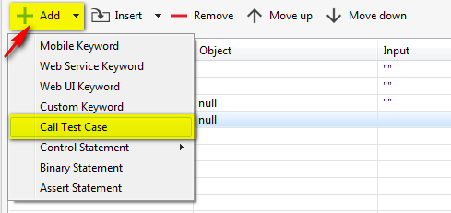
* Method 2: Using the “Add” function in the context menu of any test step, select the “Call Test Case” item in the context menu, as illustrated below: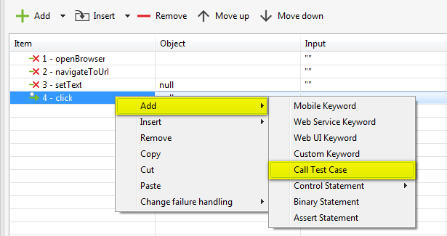

Then:

* A popup which looks like the following will be displayed: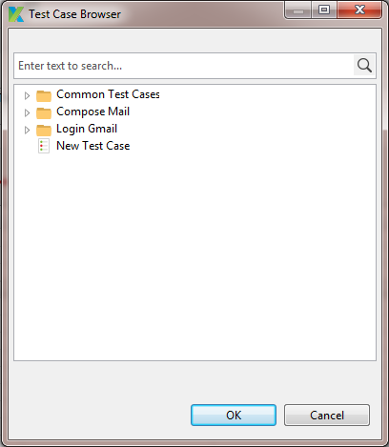
* You can search for the existing test case that you would like to call in the current test case.
* Select the interested test case.
* Press the “OK” button.
* The selected test case will be denoted as being called in the current test case, as below for an example:

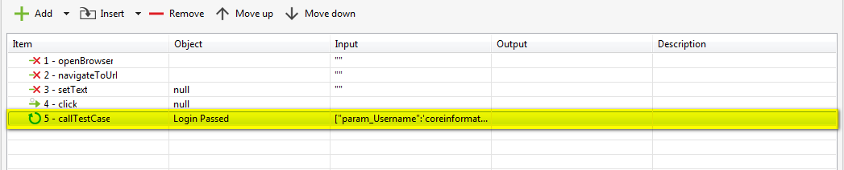

#### Call another test case when inserting a test step

To do this, you can use either one of the following methods:

* Method 1: Using “Insert” button in the toolbar of the Test Case Editor, select the “Call Test Case” item in the context menu, as illustrated below:

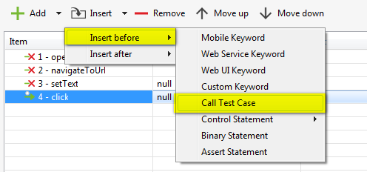

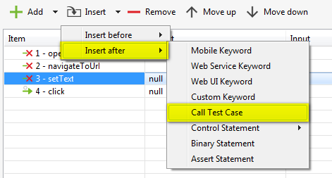

* Method 2: Using the “Insert” function in the context menu of any test step, select the “Call Test Case” item in the context menu, as illustrated below:

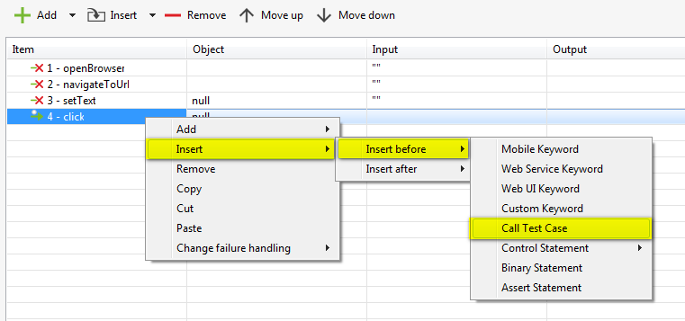

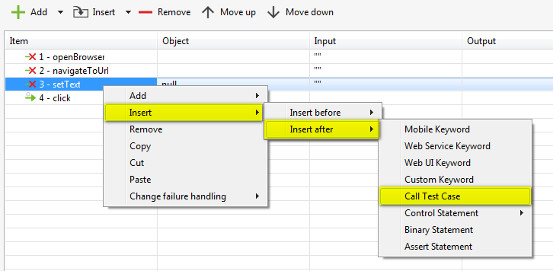

Then:

* A popup which looks like the following will be displayed:
* You can search for the existing test case that you would like to call in the current test case.
* Select the interested test case.
* Press the “OK” button.
* The selected test case will be denoted as being called in the current test case, as below for an example:



### Call another test case using Scripting mode

In order to call another test case in your current test case, you should specify the following information:

* The test case to be called
* The map of input parameters containing the following:
  + Key: is the local variable defined in the called test case
  + Value: the value that you would like to use for the corresponding local variable
* The failure handling schema that would be used for the current test step

Thus, simply use the following syntax:

MobileBuiltInKeywords.callTestCase(TestCaseFactory.findTestCase(relativePath), [key1 : value1, key2:value2, … , keyN:valueN], FailureHandling.failureHandlingSchema)

Where:

* relativePath is the relative path to the test data file object that you would like to use
* keyN is the key used to identify an individual item in your map
* valueN is the value of an individual item in your map
* failureHandlingSchema is the failure handling schema that you would like to use

Here’s how the test step would look like:

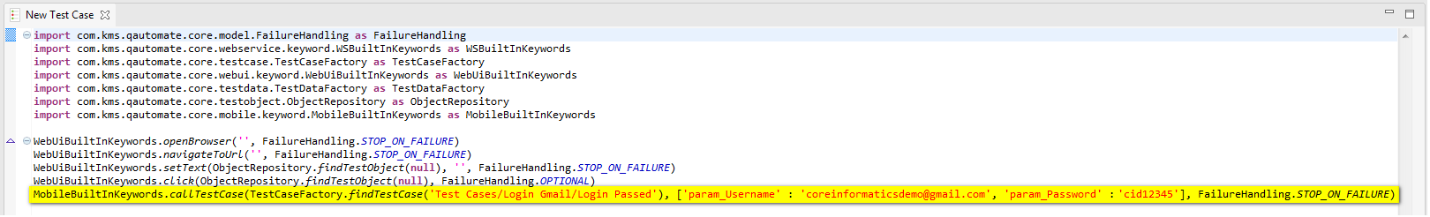

## Record a test case

Katalon Studio provides you the ability to design a test case by recording user actions performed on the application under test. Those recorded actions will then be used to automatically generate the scripts that can be played back later.

This section will guide you through the steps for how to record user actions performed on different kinds of applications:

* Web application
* Desktop application
  + Java application
  + .NET application
* Mobile application
  + Native application
  + Web application

### For a web application

In order to record user actions of a web application, simply follow the steps below:

* Open the test case that you would like to edit. Suppose that you are opening a new test case which has currently no test step yet.
* Click on the “Record” button on the toolbar, as illustrated below:



* A popup which looks like the following will be displayed:

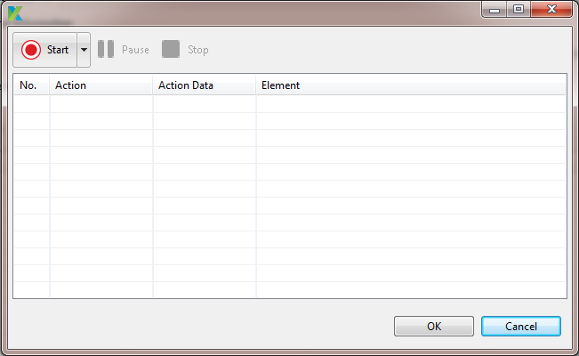

* You can choose to start the web application under test on which specific web browser by expanding the dropdown in the “Start” button on the toolbar of the above popup, as illustrated below:

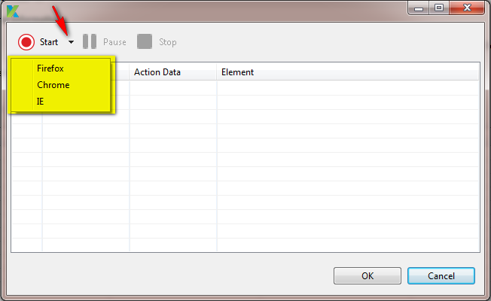

* Select the web browser that you would like to use.
  + The corresponding browser embedded in Katalon Studio will be open.
  + The two buttons “Pause” and “Stop” on the toolbar of the above popup are changed to “enabled” mode. This means that the recording is being taken place. The above popup would look like the below as an example:

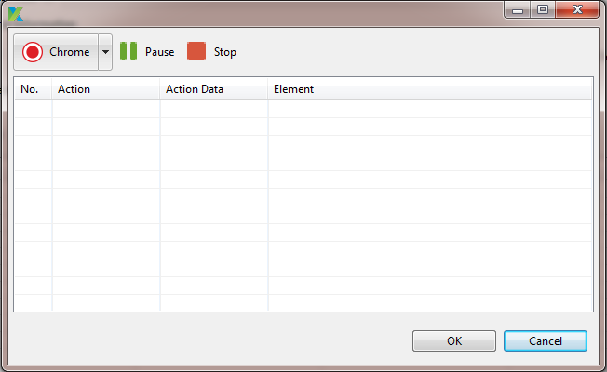

* Simply perform all the needed activities on that embedded browser. For example, navigate to the website under test, click on any link/button, key in some text in any input … Each action you perform will be recorded immediately and shown in the action grid in the above popup.
* While interacting with the application under test which is currently being open on the selected embedded browser, you can perform the following actions on Katalon Studio:
  + Press the “Pause” button on the above popup to temporarily stop the recording process. The “Pause” button will be replaced by the “Resume” button, as illustrated below:

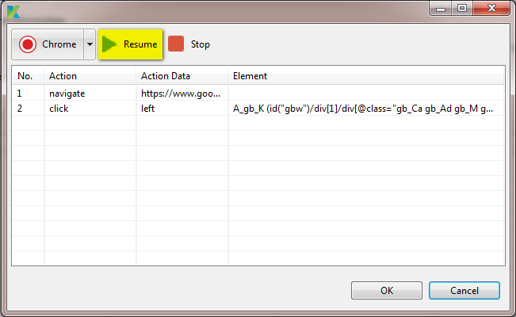

* Press the “Resume” button to resume the recording process.
* Press the “Stop” button to completely stop the recording process. The embedded browser where the application under test is being open is closed immediately. And all the recorded actions are displayed in the action grid, as illustrated below:

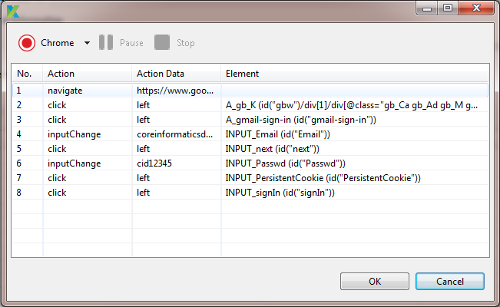

* Once you are done with the recording, press the “OK” button.
* Each recorded action will be automatically generated into a test step. This means that:
  + The correct action keyword will be used as the item action in the test step.
  + The corresponding test object will be created and referenced in the test step.
  + The data keyed in by the user will become the corresponding input parameters for the test step.
* Thus, the result test case would look like the following:

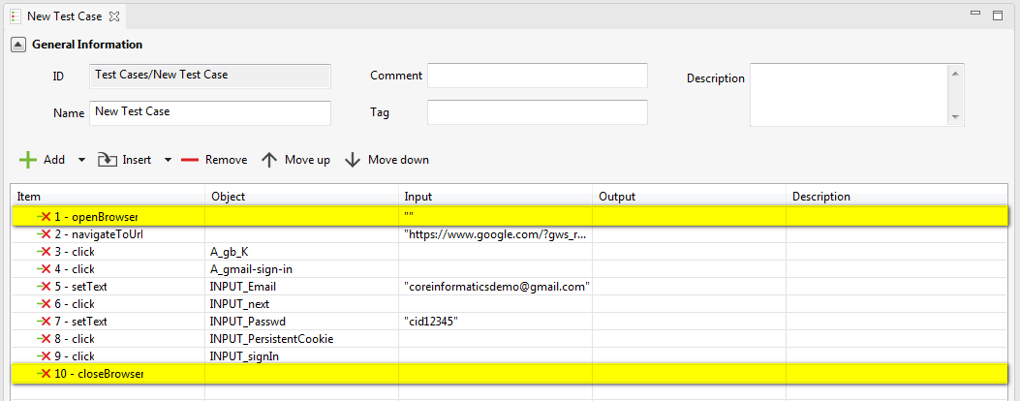

Notice that there are two more test steps which are automatically added into your test case although they did not appear in the original list of recorded actions. In fact, they are those actions which are generated when you select a browser to start recording and when you stop the recording process. They are also highlighted in yellow in the above screenshot for your visualization.

Done! You have already successfully recorded a test case for a web application.

### For a mobile application

This feature is under implementation.

### For a desktop application

This feature is under implementation.

## Execute a test case

Once you have finished designing your test case, you can ask Katalon Studio to execute the test case so that you can verify whether your test case is correctly designed or not.

Currently, Katalon Studio supports to execute the test case in the following environment:

|  |  |
| --- | --- |
| **Execution Environment** | **Description** |
| Firefox | This is used to execute a test case in Firefox. |
| Chrome | This is used to execute a test case in Chrome. |
| IE | This is used to execute a test case in Internet Explorer. |
| Safari | This is used to execute a test case in Safari. |
| Remote | This is used to execute a test case on a remote environment. |
| iOS | This is used to execute a test case of a mobile application. The test case will be executed in ???. |
| Android | This is used to execute a test case of a mobile application. The test case will be executed in ???. |
| Mixed mode | The test case will be executed in ???. |

This section will guide you through the steps for how to execute test cases on different kinds of applications and environment:

* Web application
* Desktop application
  + Java application
  + .NET application
* Mobile application
  + Native application
  + Web application
* On a remote environment

### Execute a test case for a web application

In order to execute a test case of a web application, simply follow the steps below:

* Open the test case that you would like to execute.
* Click on the “Run” button on the toolbar, as illustrated below:



* If you simply click on the “Run” button above, the test case will be automatically executed using the embedded browser which is specified as default browser used in Katalon Studio. Refer to ??? for more information.
* If you want to execute the test case on a browser different than the default one used in Katalon Studio, follow the below steps:
  + Click on the down arrow next to the “Run” button in the toolbar. A dropdown containing available options will be expanded, as illustrated below:

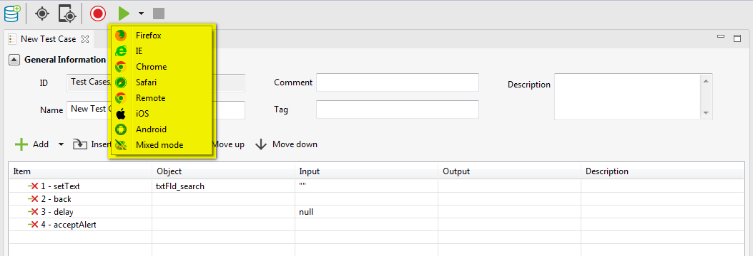

* + Select a web browser that you would like your test case to be executed on.
  + Then:
    - The test case which is currently being open will be automatically executed using the selected web browser.
    - The Job Progress and Log Viewer views will be automatically displayed to show the progress while your test case is being executed.

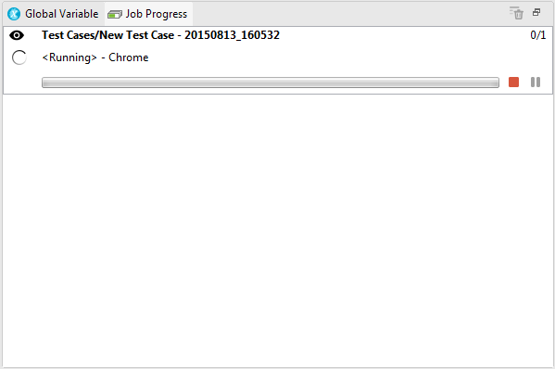

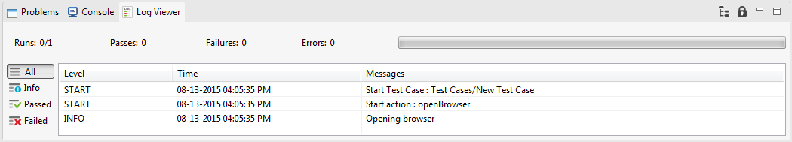

* Once your test case finishes its execution, you can also review its result using the Job Progress and Log Viewer views.

### Execute a test case for a mobile application

This feature is under implementation.

### Execute a test case for a desktop application

This feature is under implementation.

### Execute a test case on a remote environment

TBD

# Test Object

## Detect and capture test object

Among those actions that a user can perform on the application under test, there are actions that need to be performed on a specific object in the application. For example, click on a button, key in some value in a text field … These objects in the application are usually captured and become test objects. Thus, to detect and capture those test objects for being used in your test cases, you can use the “Object Spy” function which is provided in Katalon Studio.

Objects from applications of different types require different way to capture. Thus, follow the subsequence sections for the detailed instruction on how to detect and capture test objects in applications under test.

This section will guide you through the steps for how to detect and capture test objects on different kinds of applications:

* Web application
* Desktop application
  + Java application
  + .NET application
* Mobile application
  + Native application
  + Web application

### For a web application

#### Detect and capture an object of a web application

Notice that an object in the application under test will be detected and captured using xpath property by default.

You can detect and capture a test object of a web application by following the steps below:

* Click on the “Spy Object” button on the toolbar, as illustrated below:



* A popup which looks like the following will be displayed:

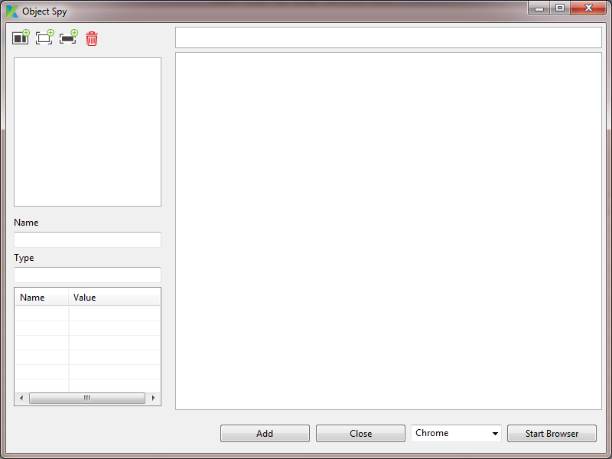

* Select the browser that you would like to use to run the application under test. Then press the “Start Browser” button.

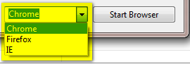

* The corresponding browser embedded in Katalon Studio will be open.
* Navigate to the website under test. Let’s take Gmail in this example.

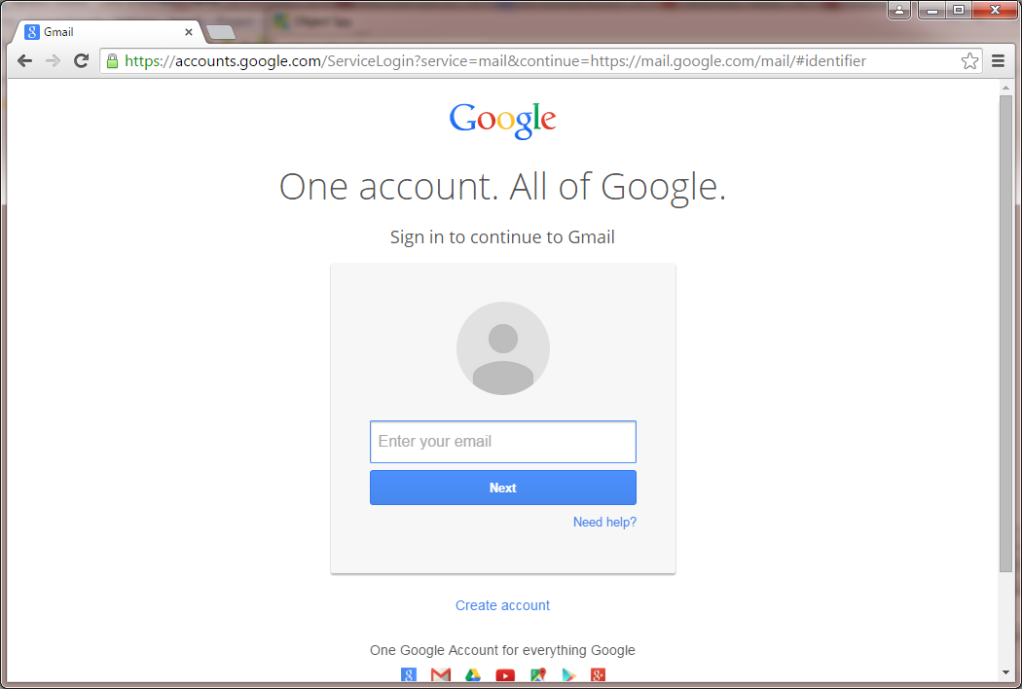

* To detect any object on the website, you just need to move the mouse over that element. That object will be highlighted in red border. For example: detect the “Email” field as illustrated below:

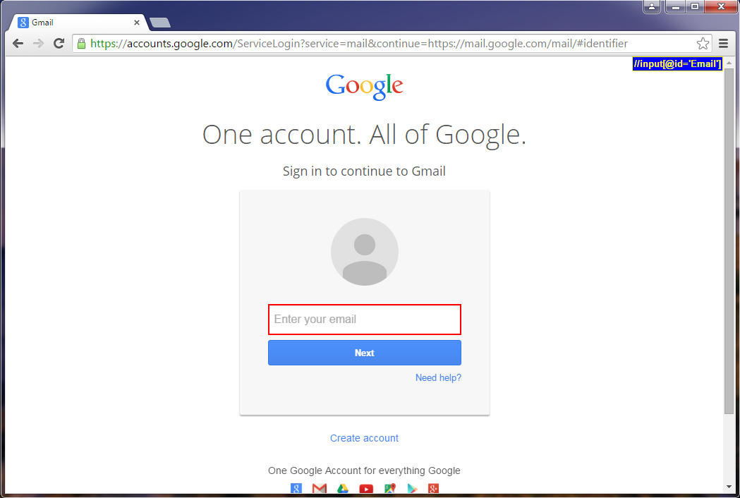

* To capture any object on the website, you just need to press the combination of <Alt + back quote> key on the keyboard while moving the mouse over that element. That object will be highlighted in green border. For example: detect and capture the “Email” field as illustrated below:

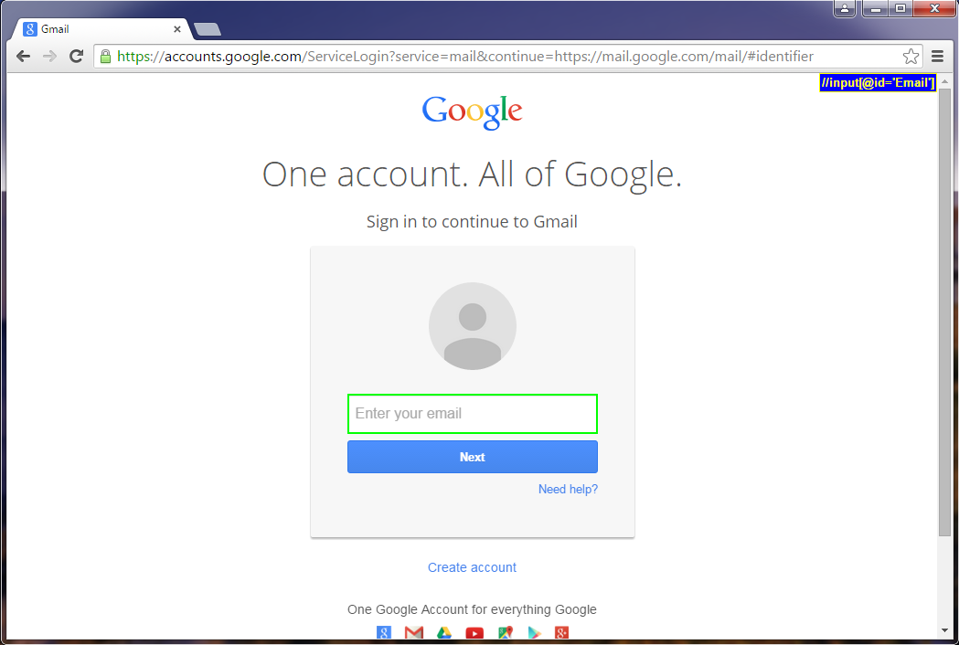

* Once the field in the website is highlighted in green border, this means that the object has already been captured successfully. You can view the result in the “Object Spy” popup in Katalon Studio, as illustrated below:

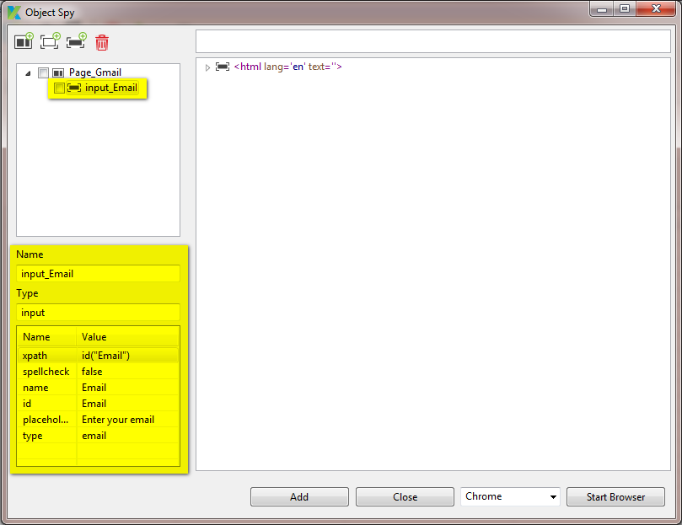

* Select the object in the “Object Spy” popup, its properties will be displayed in the detailed section, as being highlighted in yellow in the above screenshot.
  + You can rename the selected object by modifying the value in the “Name” field.
  + You can also edit the properties’ value by modifying the value displayed in the cells under the “Value” column.
* Suppose that you have already detected and captured the following objects which would be used in your test case. Notice that there are two page elements having the same name “Page_Gmail” captured in this example because there are two pages involving in the login process in Gmail. The object of which page will be captured and grouped in the corresponding page element.

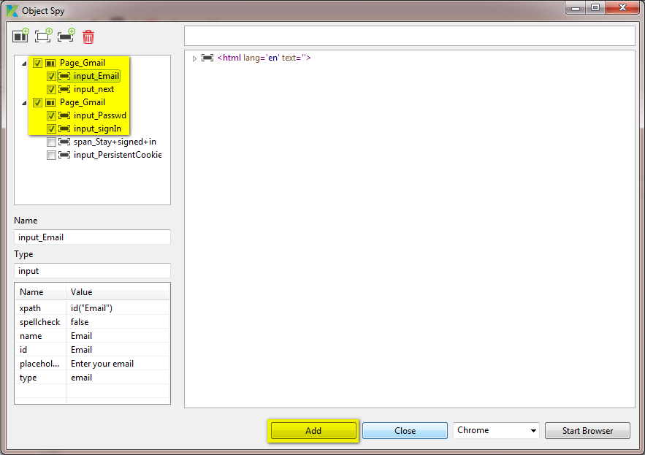

* Tick on those captured objects that you would like to keep. And press the “Add” button. Those selected objects will be added as test objects in the “Object Repository” folder. Notice that because there are two page elements having the same name to be added, thus there will be two folders having similar name created under the “Object Repository” folder, as illustrated below. You can always re-order the test objects around under the “Object Repository” folder (refer to ??? for more details).

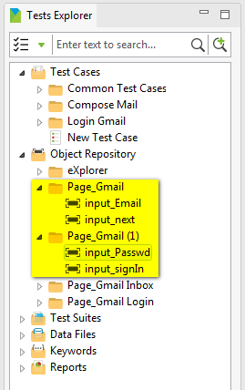

Done! You have already successfully detected and captured a test object.

#### Delete an object that has been captured

In order to delete any object that has been captured while doing object spy, simply follow the steps below:

* Suppose that you have been doing object spy for the case of logging into Gmail and capturing the following objects:

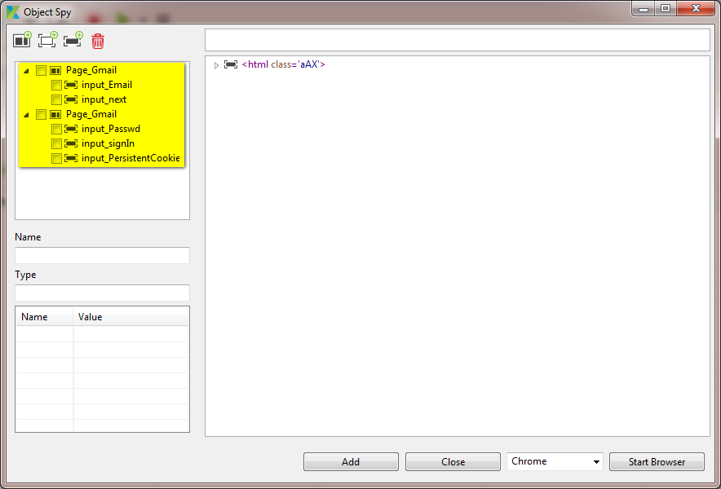

* Ticket on those object(s) that you don’t want to use any more, then click on the “Remove element” button on the toolbar of the “Object Spy” popup, as illustrated below:

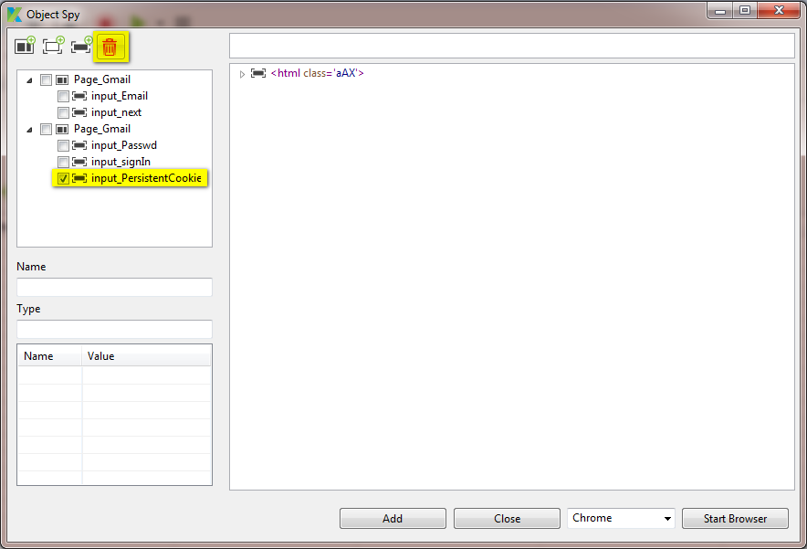

Done! You have already successfully removed those selected object(s) from the list of captured objects

#### Add a page element

As you might notice, whenever a new object is captured in a new web page, a new page element will be added in the “Object Spy” popup for grouping those objects of the same web page into the same page element. Besides that, you can also add a page element to group some objects for your own purpose.

In order to add a page element while doing object spy, simply follow the steps below:

* In the “Object Spy” popup, click on the “New page element” button on the toolbar of the popup, as illustrated below:

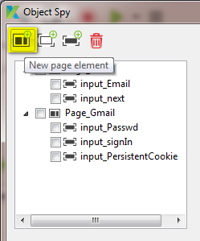

* A new page element will be added and displayed in the object tree as below:

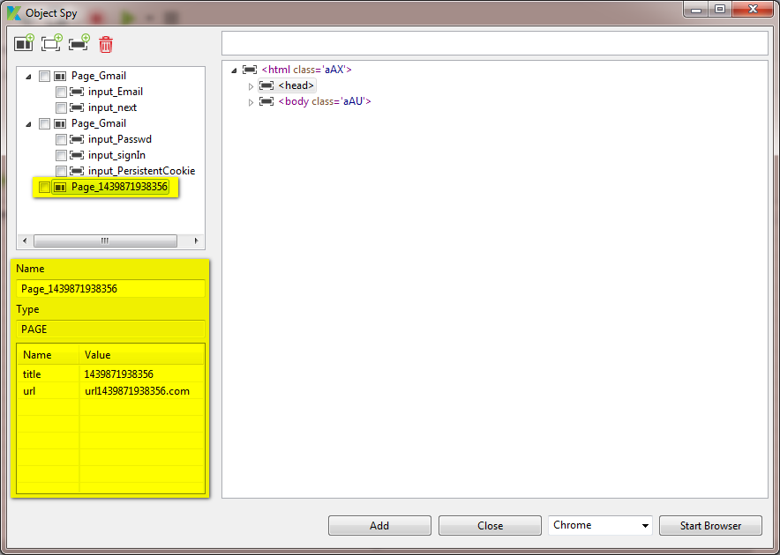

* Notice that the name of the newly added page element is randomly defined by Katalon Studio. You can still modify this name as well as those other properties of the newly added page element.

Done! You have already successfully added a page element for doing object spy.

#### Add a frame element

There are cases when a web page is implemented with frame layout. And each frame is also to display its own objects. Besides that, you can also add a frame element to group some objects for your own purpose.

In order to add a frame element while doing object spy, simply follow the steps below:

* Notice that a frame element can only be added into a page element. Thus, in the “Object Spy” popup, select either an existing page element or any object under an existing page element. Then click on the “New frame element” button on the toolbar of the popup, as illustrated below:

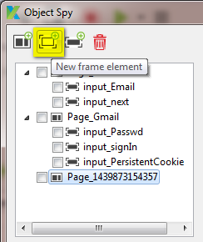

* A new frame element will be added and displayed in the object tree as below:

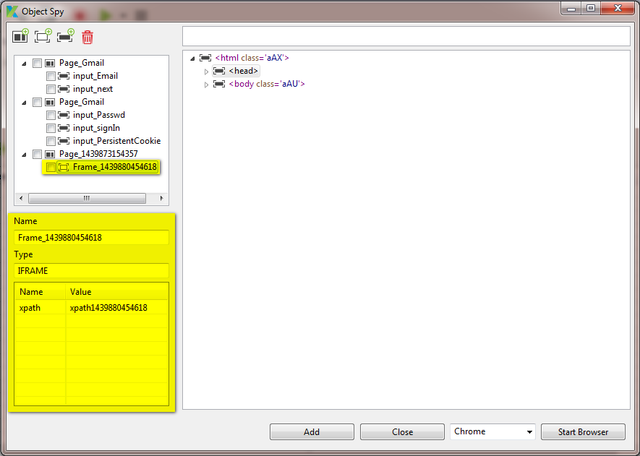

* Notice that the name of the newly added frame element is randomly defined by Katalon Studio. You can still modify this name as well as those other properties of the newly added frame element.

Done! You have already successfully added a frame element for doing object spy.

#### Add an object element

In order to add an object element while doing object spy, simply follow the steps below:

* Notice that an object element can only be added into a page element or a frame element. Thus, in the “Object Spy” popup, select either an existing page/frame element or any object under an existing page/frame element. Then click on the “New element” button on the toolbar of the popup, as illustrated below:

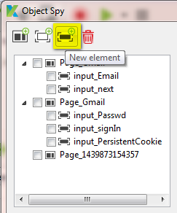

* A new object element will be added and displayed in the object tree as below:

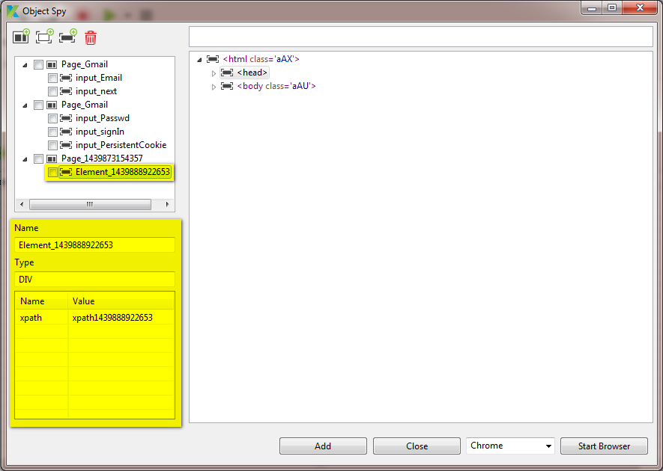

* Notice that the name of the newly added object element is randomly defined by Katalon Studio. You can still modify this name as well as those other properties of the newly added object element.

Done! You have already successfully added an object element for doing object spy.

#### Query element by xpath

When a page of the web application under test is loaded in the browser embedded in Katalon Studio, the entire HTML code of the page is loaded in preview section in the “Object Spy” popup, as illustrated below:

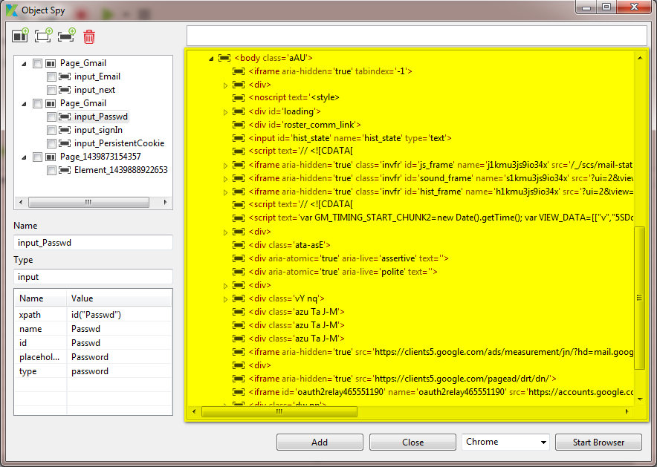

From this preview, Katalon Studio provides you an ability to search for elements using xpath query. This will help you to quickly verify whether there’s any element corresponding to a given xpath is existed in the page. In order to do this, just simply follow the steps below:

* In the search field just above the preview section, key in the xpath that you would like to search for. For example:

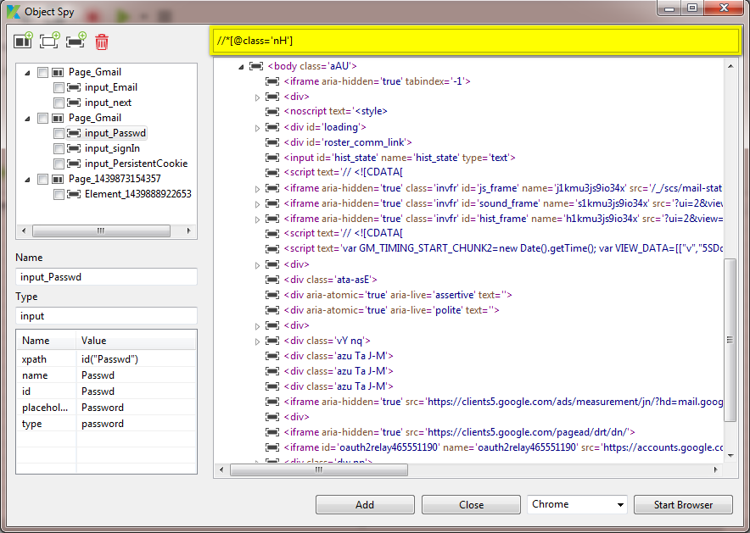

* Press the Enter key.
* Katalon Studio will then search for those elements whose xpath is corresponding to the search criteria. Those elements found will then be highlighted in yellow in the preview section, as illustrated in the below example:

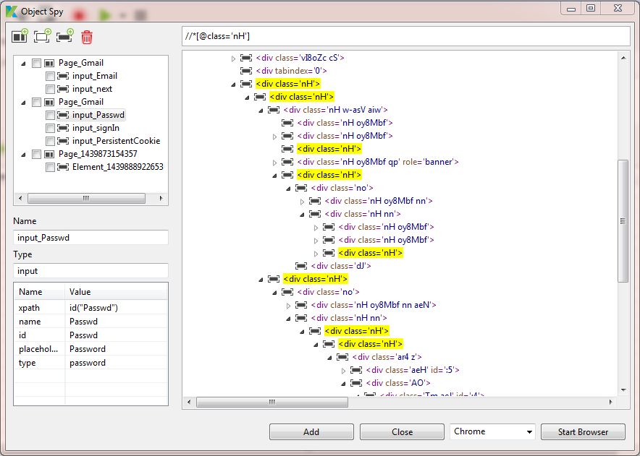

#### Verify object

While doing object spy, you might want to verify whether an object is correctly detected and captured before deciding whether that object would be able to be used in your test script or not. Requesting Katalon Studio to verify an element is in fact asking Katalon Studio to search for that element against the HTML code displayed in the preview section by using xpath query.

In order to verify an object when doing object spy, simply follow the steps below:

* Suppose that you have already detected and captured the following objects:

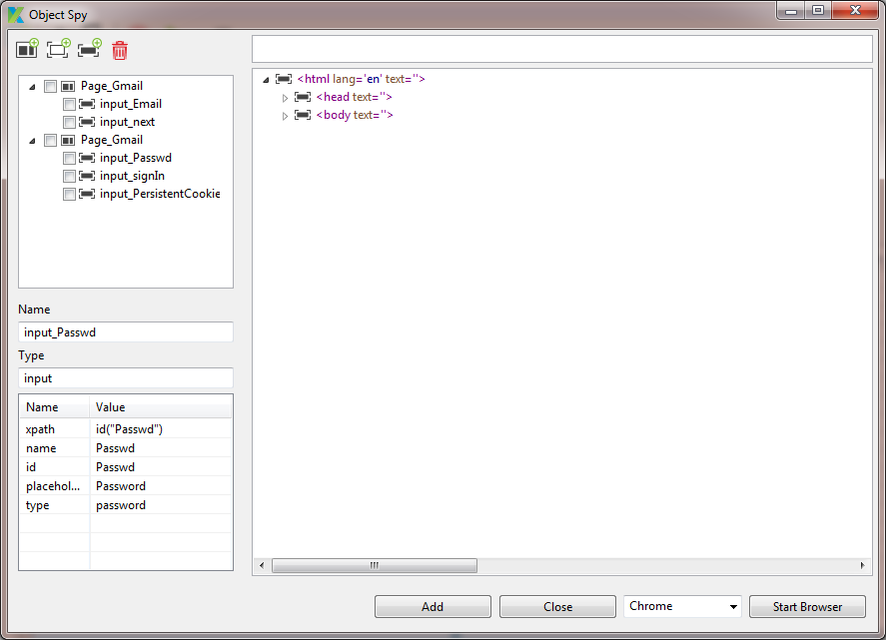

* If an element is not verified yet, when you move the mouse over it, you will see a tooltip saying that the element is not verified yet, as illustrated below:

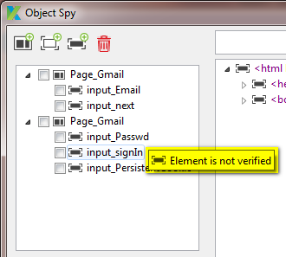

* Right click on the element that you would like to verify, a context menu will be displayed as below:

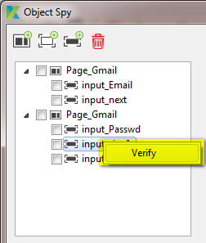

* Select the “Verify” item in the context menu above.
* Katalon Studio will automatically verify whether the selected element can be found in the HTML of the page or not, as following:
  + The xpath value of the selected element will be copied into the search field, as illustrated below:



* + Search for the element using xpath query.
  + If the corresponding element is found:
    - Such element will be highlighted in yellow in the preview section.

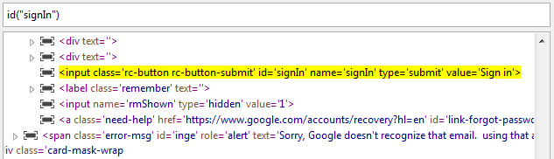

* + - And the selected element displayed in the object tree will also be marked as “existed”, as illustrated below:

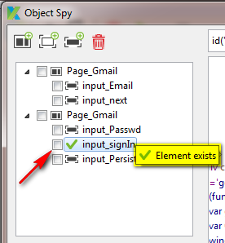

* + If the corresponding element cannot be found:
    - The selected element displayed in the object tree will also be marked as “missing”, as illustrated below:

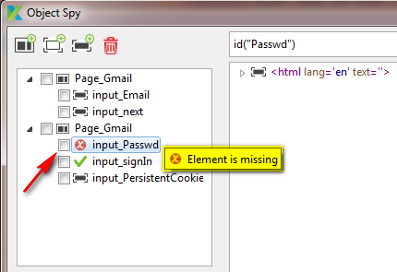

* In the example above, the password object is denoted as missing because the password field is not visible in the original HTML code when the Gmail login page is first loaded. This password field only visible after you key in the email and press the “Next” button on the Gmail login page. However, after the “Next” button is pressed, only a portion of the web page is reloaded. That’s why Katalon Studio cannot locate such password field in the preview section. For such cases, you just need to “reload” the preview section so that it displays the HTML code of the page in the state when the password field is visible. In order to reload the preview section, simply switch to the embedded browser and press the combination <Alt + Ctrl + back quote> key on it. Then switch back to the “Object Spy” popup in Katalon Studio and verify the password element again as usual. As you will find out, the password element can now be found in the HTML code, as illustrated below:

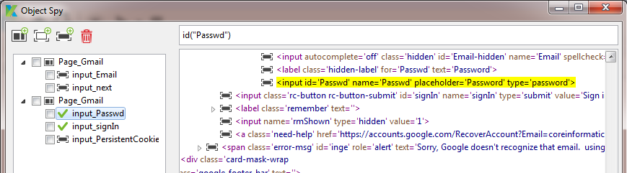

* + If there are multiple elements are found under the same element definition:
    - The selected element displayed in the object tree will be marked as following:

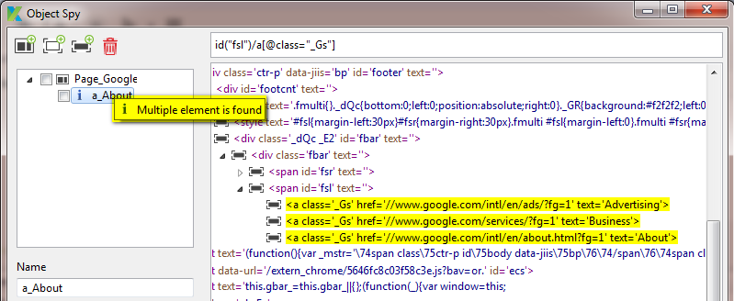

### For a mobile application

TBD

## Create a custom test object

Besides those test objects that are detected and captured from the application under test, Katalon Studio also allows you to define custom test objects for your own need. You can create a custom test object by using either one of the following methods:

* Method 1: Using Manual mode (i.e., using Katalon Studio’s GUI controls)
* Method 2: Using Scripting mode

### Create custom test object using Manual mode

Using the Katalon Studio, you can create a custom test object by using either one of the following methods:

* Method 1: Using menu bar:
  + Click anywhere in the Tests Explorer view.
  + Select *File → New → Test Object* from the menu.

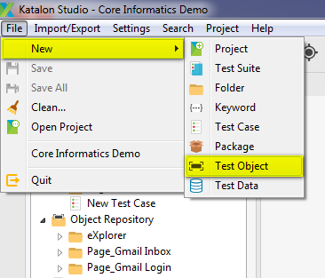

* Method 2: Using toolbar:
  + Click anywhere in the Tests Explorer view.
  + Click on the “New Test Object” button on the toolbar.

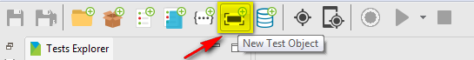

* Method 3: Use the context menu:
  + In the Tests Explorer view, right click on either the “Object Repository” folder or any sub-folder under “Object Repository” folder.
  + A context menu will be displayed.
  + Select *New → Test Object* from the above context menu.

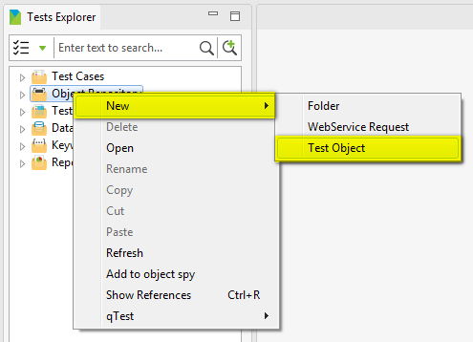

A popup which looks like the following will be displayed asking you to provide the name for the new test object:

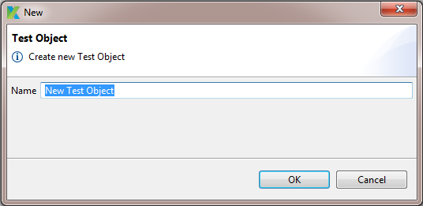

Provide the name for the new test object, then press “OK” button. A new test object is created and displayed under either the “Object Repository” folder or the folder specified above depending on the each case.

### Create custom test object using Scripting mode

TBD

## Delete a test object

Follow the steps below in order to delete a test object:

* In the Tests Explorer view, under “Object Repository” folder, right click on the test object that you want to delete.
* A context menu will be displayed.
* Select *Delete* from the above context menu.

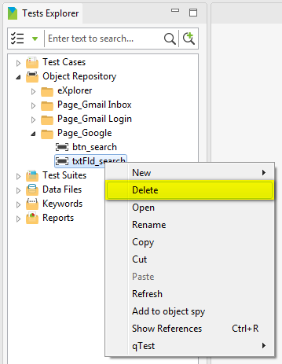

* A popup which looks similar to the following will be displayed asking for your confirmation to delete the selected test object:

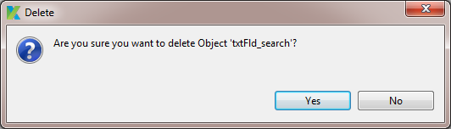

* Press on the “Yes” button to agree to delete the test object:
  + The selected test object will be deleted immediately from your test project.
  + If that test object is being used anywhere in your test project (e.g.: it is being used in one of your test case), then Katalon Studio will also remove such reference.

## Rename a test object

Follow the steps below in order to rename a test object:

* In the Tests Explorer view, under “Object Repository” folder, right click on the test object that you want to rename.
* A context menu will be displayed.
* Select *Rename* from the above context menu.

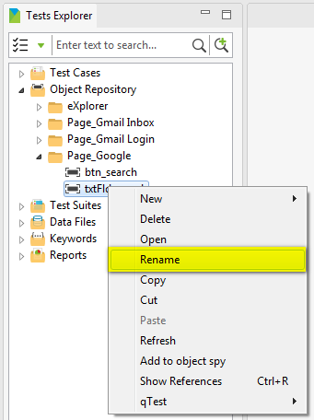

* A popup which looks like the following will be displayed asking you to provide the new name for the test object:

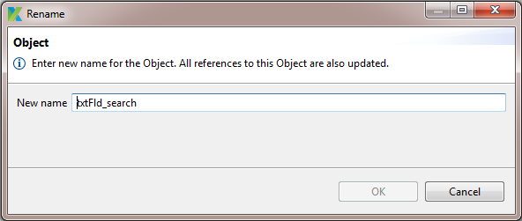

* Once you provide a valid new name for the test object, the “OK” button will be enabled. Simply press on the “OK” button, the selected test object will be renamed and all references to this test object in your test project will also be updated accordingly.

## Copy a test object

A test object can only be copied and pasted under “Object Repository” folder. That is, a copied test object can only be pasted under “Object Repository” folder, but not into any other default folders.

Follow the steps below in order to copy a test object:

* In the Tests Explorer view, under “Object Repository” folder, right click on the test object that you want to copy.
* A context menu will be displayed.
* Select *Copy* from the above context menu.

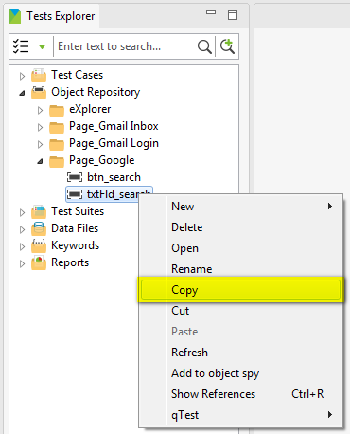

* Select the destination where you want to paste the copied test object. Right click on it and select *Paste* from the context menu which has just been displayed.

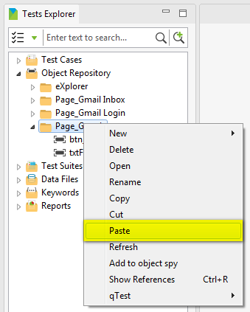

A copied version of the specified test object will be pasted at the destination.

Notice that:

* The name of the copied version will follow the below rule:

copiedTestObjectName = sourceTestObjectName + “- Copy”

* If there’s already an existing test object with the same name as the name of the copied version at the destination, the name of the copied version will be automatically renamed by appending “(1)” at the end.

## Move a test object

A test object can only be moved under “Object Repository” folder, but not into any other default folders.

Follow the steps below in order to move a test object:

* In the Tests Explorer view, under “Object Repository” folder, right click on the test object that you want to move.
* A context menu will be displayed.
* Select *Cut* from the above context menu.

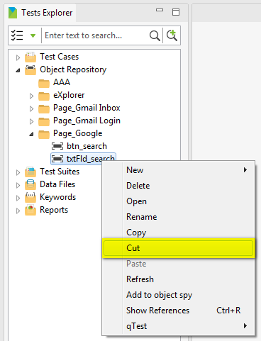

* Select the destination where you want to paste the test object. Right click on it and select *Paste* from the context menu which has just been displayed.

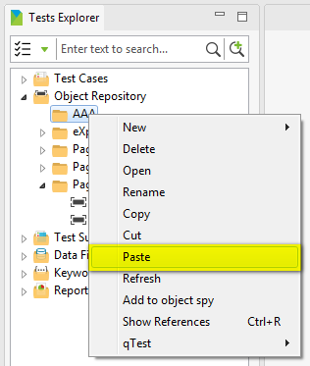

The specified test object will be moved to the destination.

Notice that if there’s already an existing test object with the same name as the name of the being-pasted test object at the destination, the name of the being-pasted test object will be automatically renamed by appending “(1)” at the end in this case.

## Edit a test object

In order to edit a test object, simply follow the steps below:

* In the Tests Explorer view, under “Object Repository” folder, double click on the test object that you want to edit.
* A tab containing the Test Object Editor will be open to display the detailed information of the selected test object.
* Modify the data of the test object.
* Save your modification. You can save your modification by using either one of the following methods:
  + Method 1: Press Ctrl + S
  + Method 2: Select *File → Save* or *File → Save All* from the menu.



* + Method 3: Click on the “Save” or “Save All” button on the toolbar.



## Manage test object’s properties

### Add a property

You can add a property into a test object by using either one of the following methods:

* Method 1: Using Manual mode (i.e., using Katalon Studio’s GUI controls)
* Method 2: Using Scripting mode

Notice that there cannot be two properties with the same name existed in the same test object.

#### Add a property using Manual mode

Using the Test Object Editor, you can add a property into a test object by following the steps below:

* In the Test Object Editor, click on the “Add” button, as illustrated below:

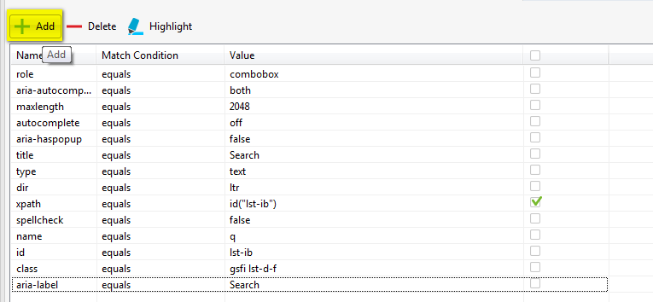

* A popup which looks like the following will be displayed:

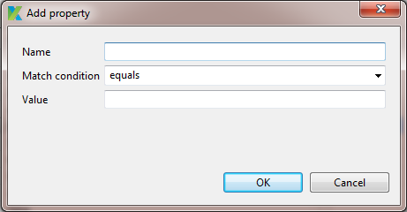

* Provide all the needed information for the new property:
  + Key in the name of the property
  + Specify the condition which will be used to compare and search for the “real” object in the application under test when the test case is executed. In order to do this, just expand the “Match condition” dropdown and select the appropriate option.

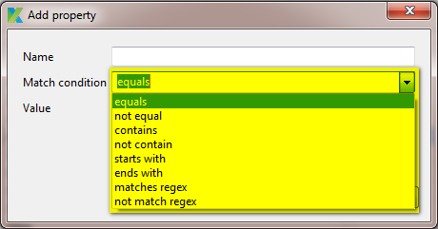

* + Key in the value which will be used to compare and search for the “real” object in the application under test when the test case is executed.
* Press the “OK” button.
* Save your modification.

Done! You have already successfully added a property into a test object.

#### Add a property using Scripting mode

TBD

### Delete a property

Using the Test Object Editor, you can delete a property from a test object by following the steps below:

* In the Test Object Editor, select the property that you want to delete.
* Click on the “Delete” button, as illustrated below:

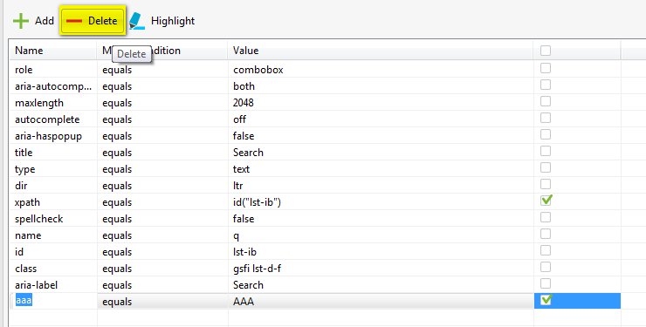

* Save your modification.

Done! You have already successfully deleted a property from a test object.

### Edit attribute of property

Using the Test Object Editor, you can edit an attribute of a property of a test object by following the steps below:

* In the grid of properties, select the attribute that you want to edit.
  + For example, if you want to edit the name of a property, then just click on the cell under the “Name" column, the cell will be changed to edit mode as illustrated below:

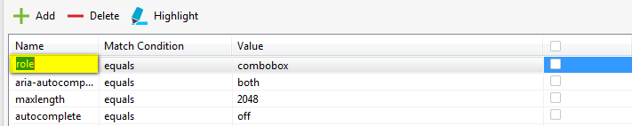

* + Or if you want to edit the match condition of a property, then just click on the cell under the “Match Condition" column, a dropdown containing available options will be enabled as illustrated below:

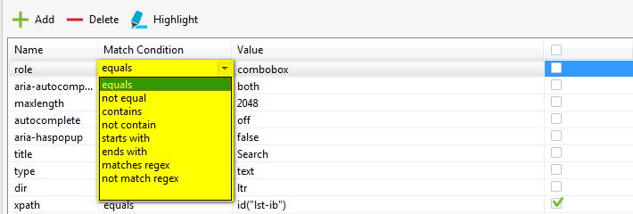

* + Or if you want to edit the value of a property, then just click on the cell under the “Value" column, the cell will be changed to edit mode as illustrated below:

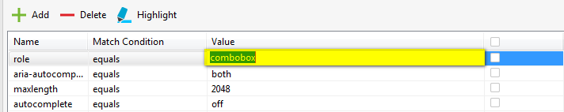

* Then simply key in or select the value that you would like to use for the selected attribute of the property.
* Save your modification.

Done! You have already successfully edited an attribute of a property.

### Copy attribute of property

Using the Test Object Editor, you can copy an attribute of a property by using the “Copy” function in the context menu, as following:

* In the Test Object Editor, right click on the attribute of a property that you want to copy. For example: right click on the name of a property. A context menu will be displayed as below:

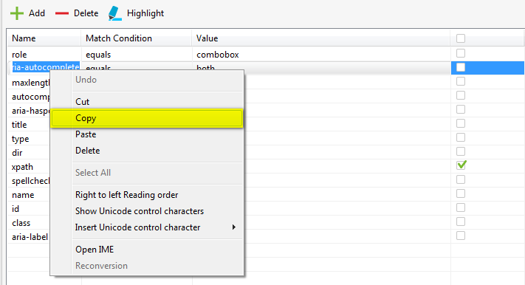

* Select the “Copy” item in the context menu above.
* Then right click on an attribute of another property where you want to paste the copied value. The same context menu will be displayed.
* Select the “Paste” item in the context menu above. The value which was copied before will be pasted into the selected attributed.
* Save your modification.

Done! You have already successfully copied an attribute of a property.

Notice that there cannot be two properties with the same name existed in the same test object.

### Indicate properties used for detecting object

As you might notice that a test object is usually built up by a number of properties. These properties are also the building blocks that shape the object in the application under test. Therefore, Katalon Studio also needs to base on such information in order to be able to detect an object during test execution. In short, Katalon Studio needs to know which properties would be used to detect the real object corresponding to a given object definition. In order to do this, you can follow the steps below:

* In the Test Object Editor, turn on the flag indicating that the corresponding property should be used to detect object during test execution. For example, if you want to use the “id” property to detect the object, then just check on the checkbox under the “Detect object by?” column for the “id” property, as illustrated below:

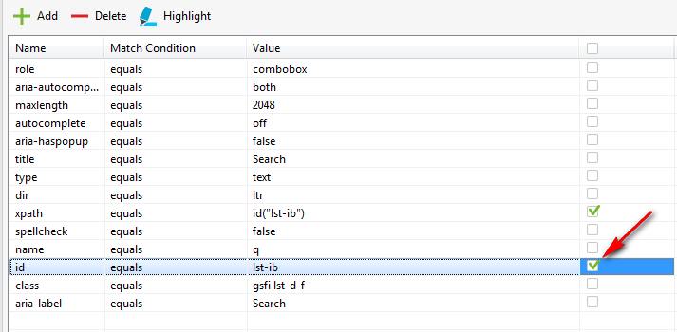

* And vice versa, if which properties should not be used to detect the object during test execution, just simply keep the corresponding checkbox unchecked.

Notice that the “xpath” property will be used to detect object during test execution by default. That’s why the checkbox corresponding to this property would be checked by default after the test object is captured using “Object Spy” function. You can still uncheck its checkbox to tell Katalon Studio not to use “xpath” property to detect object during test execution for a given object definition.

### Verify test object changed

There are cases when the test objects in your test project were detected and captured a long time ago and that there might have already been some change related to those test objects made in the application under test ever since. In such cases, you may want to verify whether the captured test objects are still correctly detected in the application under test. Thus, Katalon Studio does provide such ability to you. Refer to the subsequence sections for the detailed instruction.

#### For a web application

In order to verify whether the captured test objects are still correctly detected in a web application, simply follow the steps below:

* Suppose that you have already detected and captured the following test objects from the Google page (<https://www.google.com>) in your test project:

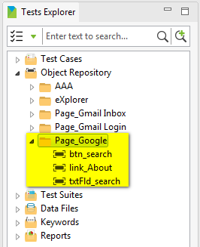

* Click on the “Spy Object” button on the toolbar, as illustrated below:



* A popup which looks like the following will be displayed:



* In the Tests Explorer View, under the “Object Repository” folder, right click on the folder containing all test objects of the page that you want to do the verification (i.e., the “Page_Google” folder in this example). A context menu will be displayed to you as below:

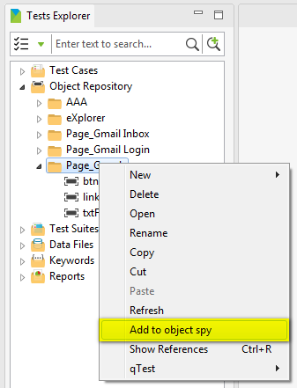

* Select the “Add to object spy” item in the above context menu. All the test objects under the selected folder will be added and displayed in the “Object Spy” popup, as illustrated below:

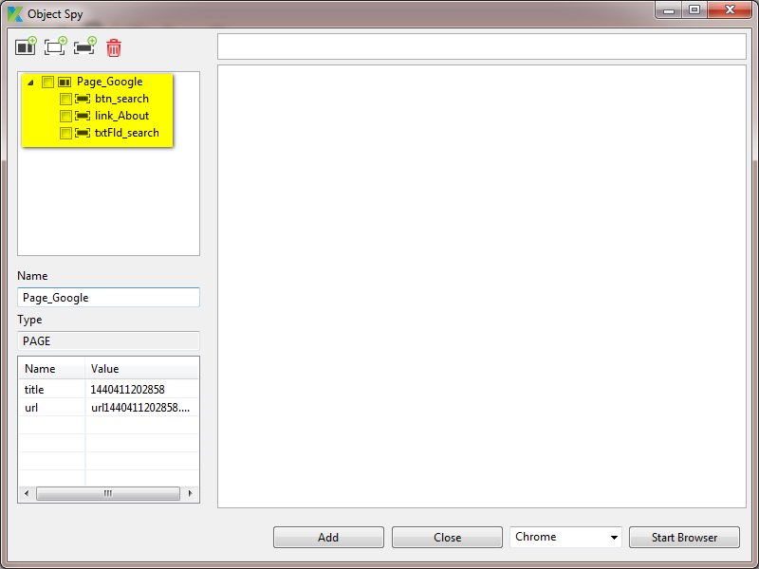

* Notice that the preview section is empty now because the embedded browser is not loaded and the web application is not navigated to yet. Select the browser that you would like to use to run the application under test. Then press the “Start Browser” button.



* The corresponding browser embedded in Katalon Studio will be open.
* Navigate to the website under test. That is, navigate to the Google page (<https://www.google.com>) in the embedded browser. Now the HTML of the Google page is loaded in the preview section of the “Object Spy” popup.

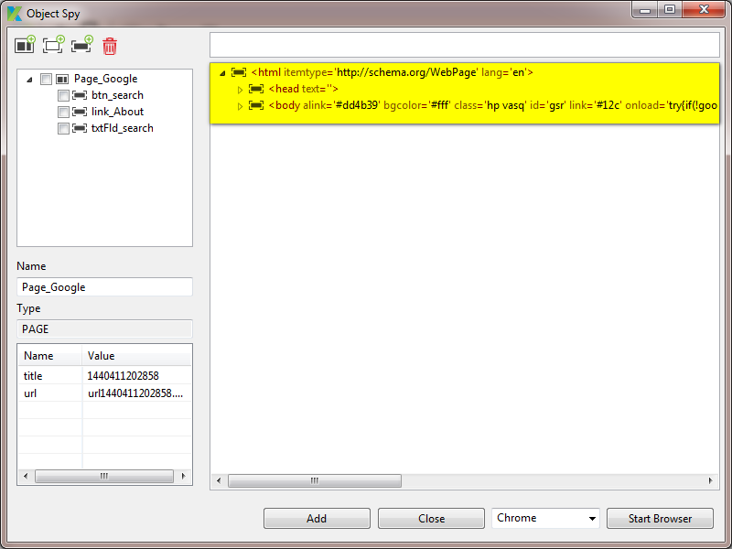

* Select those objects that you want to verify. Right click on them. A context menu will be displayed as below:

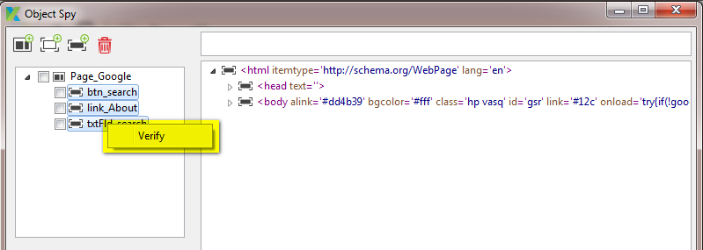

* Select the “Verify” item in the above context menu. The selected objects will then be verified against the HTML code displayed in the preview section. Once the verification is done, its result will be displayed in the object tree as illustrated below:

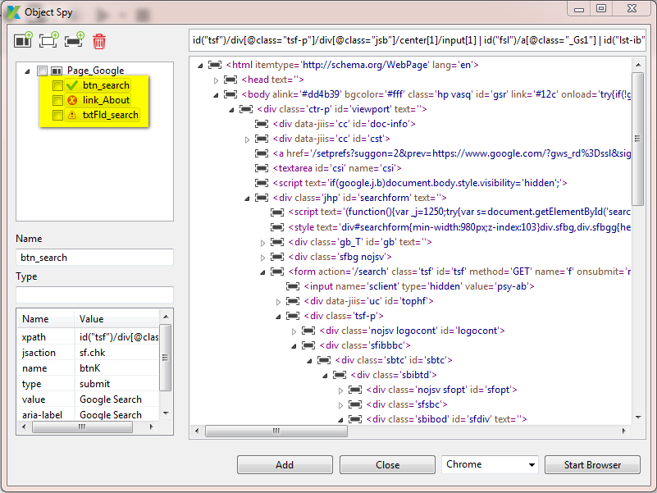

* Mouse the mouse over each object element, you will see the explanation of each case:
  + For those objects that can still be correctly found:

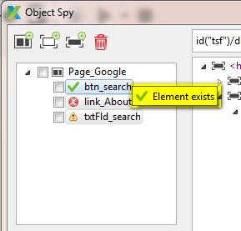

* + For those objects that cannot be found:

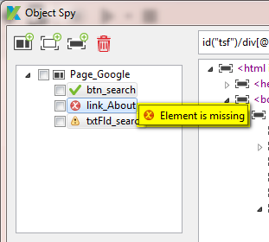

* + For those objects that can still be found but some of its properties have already been changed since the last time it was captured:

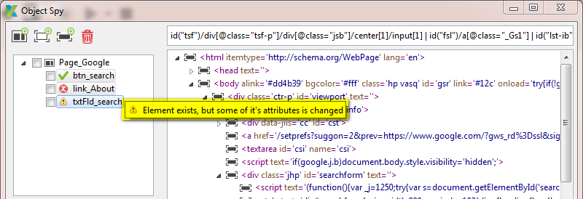

#### For a mobile application

TBD

#### For a desktop application

TBD

# Test Data

In order to support you to design your tests with data driven approach, Katalon Studio also provides you functionalities to manage test data. Test data in Katalon Studio is managed via “data file” objects. Refer to the subsequence sections for how to manage an object of this type.

## Create a data file

You can create a data file by using either one of the following methods:

* Method 1: Using menu bar:
  + Click anywhere in the Tests Explorer view.
  + Select *File → New → Test Data* from the menu.

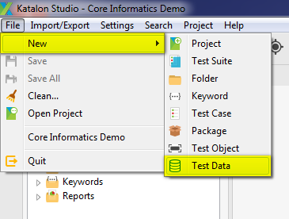

* Method 2: Using toolbar:
  + Click anywhere in the Tests Explorer view.
  + Click on the “New Test Data” button on the toolbar.

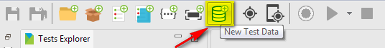

* Method 3: Use the context menu:
  + In the Tests Explorer view, right click on either the “Data Files” folder or any sub-folder under “Data Files” folder.
  + A context menu will be displayed.
  + Select *New → Test Data* from the above context menu.

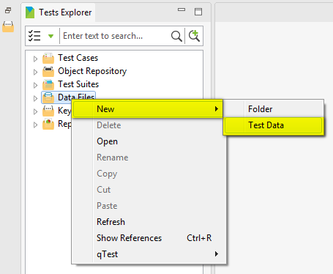

A popup which looks like the following will be displayed asking you to provide the name for the new data file:

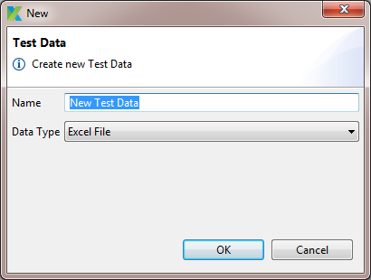

Then:

* Provide the name for the new data file,
* Select the appropriate data type from the “Data Type” dropdown. The following options currently supported by Katalon Studio:

|  |  |
| --- | --- |
| **Data Type** | **Description** |
| Excel File | The test data is loaded from an Excel file. |
| CSV File | The test data is loaded from a CSV file. |
| Internal Data | The test data will be defined internally inside your test project. |

* Press the “OK” button.

A new data file object is created and displayed under either the “Data Files” folder or the folder specified above depending on the each case. Refer to the subsequence sections for further instructions in each case.

### Create test data from an Excel file

If you are creating test data from an excel file, your newly created data file will be displayed in a Data File Editor which will looks like the following:

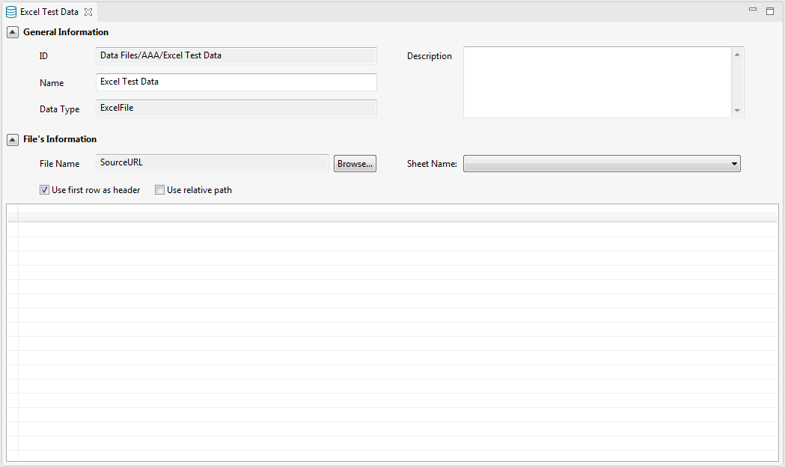

Then continue following the steps instructed in “Manage data for an Excel data file” section to load and map the real test data from the external Excel file into the current data file object:

### Create test data from a CSV file

If you are creating test data from a CSV file, your newly created data file will be displayed in a Data File Editor which will looks like the following:

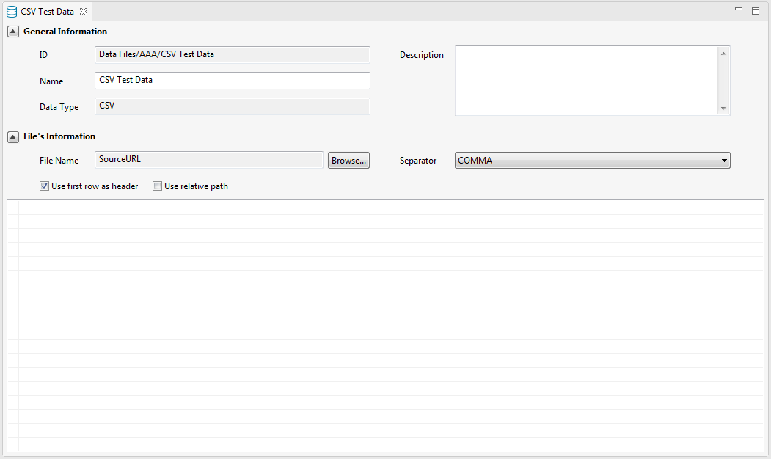

Then continue following the steps instructed in “Manage data for a CSV data file” section below to load and map the real test data from the external CSV file into the current data file object:

### Create internal test data

If you are creating test data internally in Katalon Studio which then will be saved internally in your test project, your newly created data file will be displayed in a Data File Editor which will looks like the following:

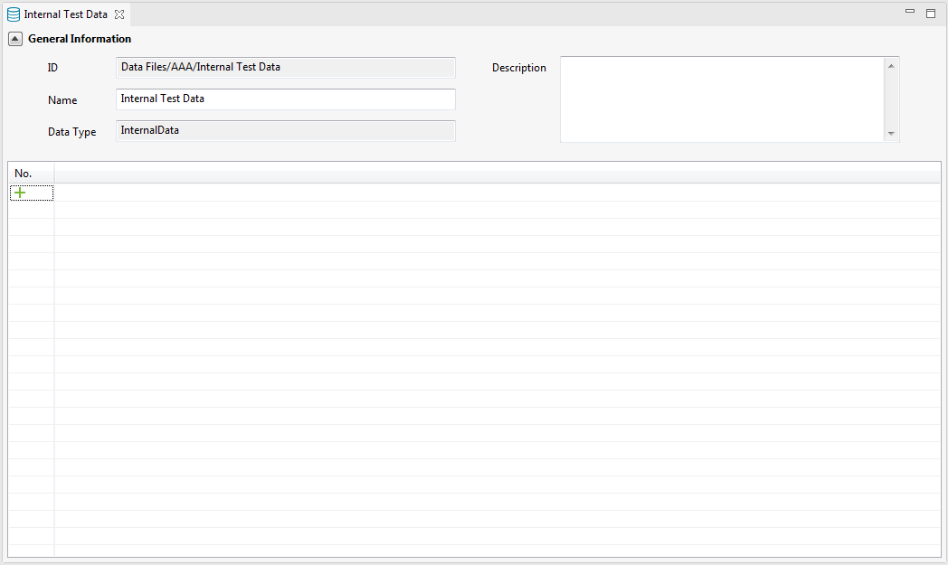

Then you can add rows and columns, and key in the needed data for the current data file object. Follow the instruction in the “Manage data for an internal data file” section for more details.

## Delete a data file

Follow the steps below in order to delete a data file object:

* In the Tests Explorer view, under “Data Files” folder, right click on the data file object that you want to delete.
* A context menu will be displayed.
* Select *Delete* from the above context menu.

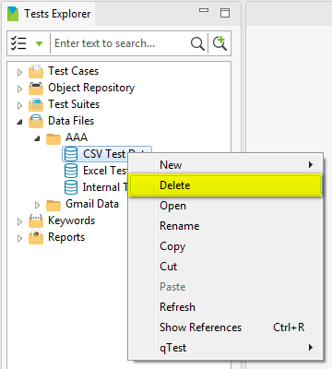

* A popup which looks similar to the following will be displayed asking for your confirmation to delete the selected data file object:

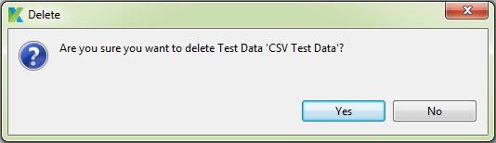

* Press on the “Yes” button to agree to delete the test object:
  + The selected data file object will be deleted immediately from your test project.
  + If that data file object is being used anywhere in your test project (e.g.: it is being used in one of your test case), then Katalon Studio will also remove such reference.

## Rename a data file

Follow the steps below in order to rename a data file object:

* In the Tests Explorer view, under “Data Files” folder, right click on the data file object that you want to rename.
* A context menu will be displayed.
* Select *Rename* from the above context menu.

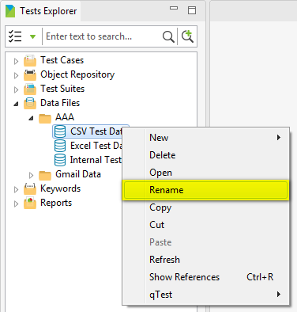

* A popup which looks like the following will be displayed asking you to provide the new name for the data file object:

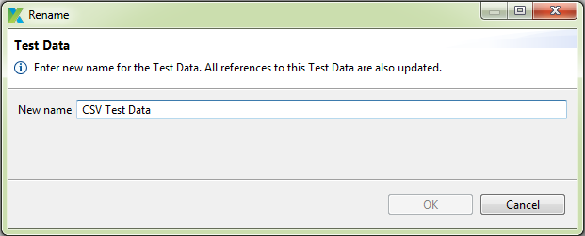

* Once you provide a valid new name for the data file object, the “OK” button will be enabled. Simply press on the “OK” button, the selected data file object will be renamed and all references to this data file object in your test project will also be updated accordingly.

## Copy a data file

A data file object can only be copied and pasted under “Data Files” folder. That is, a copied data file object can only be pasted under “Data Files” folder, but not into any other default folders.

Follow the steps below in order to copy a data file object:

* In the Tests Explorer view, under “Data Files” folder, right click on the data file object that you want to copy.
* A context menu will be displayed.
* Select *Copy* from the above context menu.

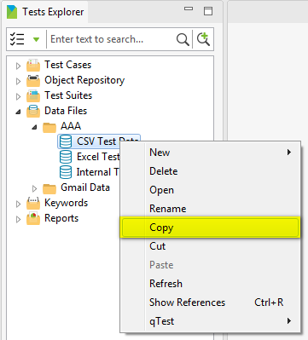

* Select the destination where you want to paste the copied data file object. Right click on it and select *Paste* from the context menu which has just been displayed.

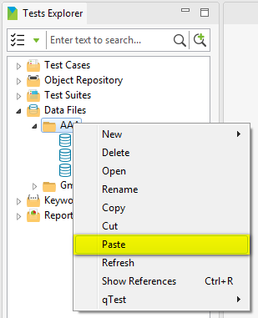

A copied version of the specified data file object will be pasted at the destination.

Notice that:

* The name of the copied version will follow the below rule:

copiedDataFileObjectName = sourceDataFileObjectName + “- Copy”

* If there’s already an existing data file object with the same name as the name of the copied version at the destination, the name of the copied version will be automatically renamed by appending “(1)” at the end.

## Move a data file

A data file object can only be moved under “Data Files” folder, but not into any other default folders.

Follow the steps below in order to move a data file object:

* In the Tests Explorer view, under “Data Files” folder, right click on the data file object that you want to move.
* A context menu will be displayed.
* Select *Cut* from the above context menu.

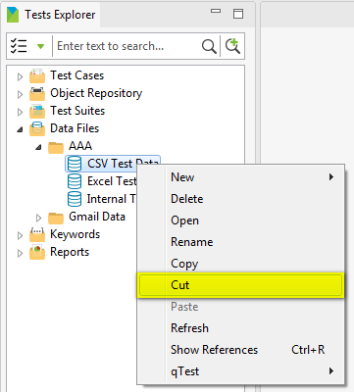

* Select the destination where you want to paste the data file object. Right click on it and select *Paste* from the context menu which has just been displayed.

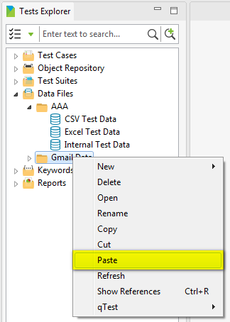

The specified data file object will be moved to the destination.

Notice that if there’s already an existing data file object with the same name as the name of the being-pasted data file object at the destination, the name of the being-pasted data file object will be automatically renamed by appending “(1)” at the end in this case.

## Edit a data file

In order to edit a data file object, simply follow the steps below:

* In the Tests Explorer view, under “Data Files” folder, double click on the data file object that you want to edit.
* A tab containing the Data File Editor will be open to display the detailed information of the selected data file object.
* Modify the data of the data file object.
* Save your modification. You can save your modification by using either one of the following methods:
  + Method 1: Press Ctrl + S
  + Method 2: Select *File → Save* or *File → Save All* from the menu.



* + Method 3: Click on the “Save” or “Save All” button on the toolbar.



## Manage data in a data file

### For an Excel data file

Follow the steps below to load and map the real test data from the external Excel file into an Excel data file object:

* Specify the source Excel file containing the real test data by using the “Browse” function, as illustrated below:



* Once an Excel file is selected, its data will be loaded into the preview section area, as illustrated below:

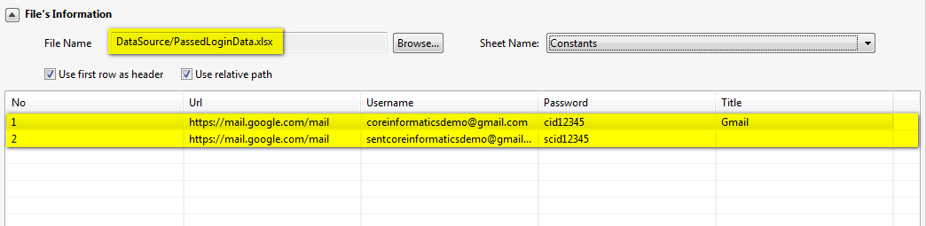

* If there are several sheets containing in the selected Excel file:
  + The data of the first sheet will be loaded into the preview section by default.
  + You can select another sheet name from the “Sheet Name” dropdown to preview its data, as illustrated below:

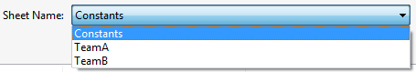

* + Once another sheet is selected, its data will be loaded into the preview section accordingly.

### For a CSV data file

Follow the steps below to load and map the real test data from the external CSV file into a CSV data file object:

* Specify the source CSV file containing the real test data by using the “Browse” function, as illustrated below:



* Once an CSV file is selected, its data will be loaded into the preview section area, as illustrated below:

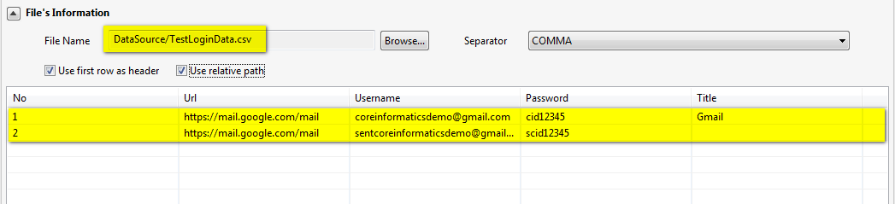

* Notice that you need to specify the correct separator that should be used to parse the data from the selected CSV file. This separator must be the same as the one used in the selected CSV file in order for the data to be correctly parsed. In order to do this, select among the available options displayed in the “Separator” dropdown, as illustrated below:

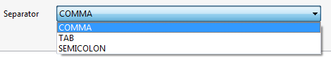

### For an internal data file

Here’s the list of activities you can perform to manage your internal data file object:

* Add a row
* Insert a row
* Delete a row
* Add a column
* Insert a column
* Delete a column
* Rename a column
* Edit data in a cell

#### Add a row

You can add new row into the data grid by using the  button displayed under the column “No.”, as illustrated below:

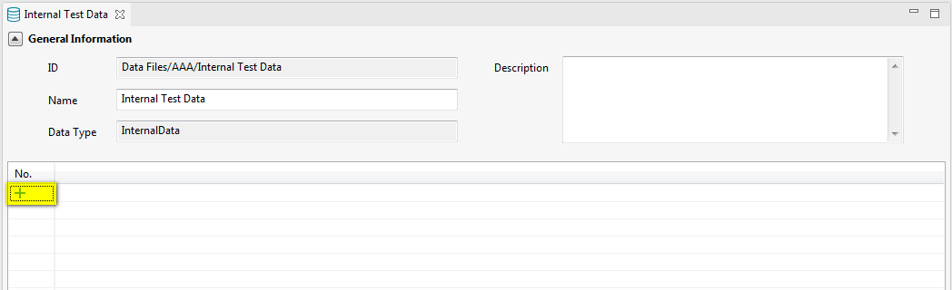

The new row will be appended in the data grid.

#### Insert a row

You can insert a row into a data grid by using the “Insert row” function in the context menu. Simply follow the steps below:

* Right click anywhere or on any row in the data grid. A context menu will be displayed as below:
  + If no row has been added into the data grid yet:

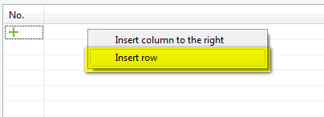

* + If some row has already been added in the data grid:

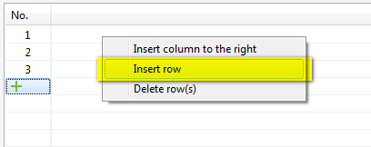

* Select the “Insert row” item in the context menu above.
* The new row will be inserted before the currently selected row or appended into the data grid in case no row is selected.

#### Delete a row

You can delete a row by following the steps below:

* In the data grid, select the row(s) that you want to delete. Right click on the selected row(s). A context menu will be displayed as below:

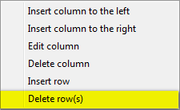

* Select the “Delete row(s)” item in the context menu above.
* The selected row(s) will be deleted from the data grid.

#### Add a column

You can add new column into the data grid by using the  button displayed ???, as illustrated below:

TBD: Need a screenshot here

The new column will be appended to the right in the data grid.

#### Insert column

You can insert a column into a data grid by using the “Insert column …” function in the context menu. Simply follow the steps below:

* Right click anywhere or on any row in the data grid. A context menu will be displayed as below:
  + If no column has been added into the data grid yet:

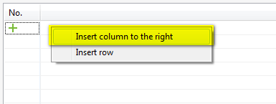

* + If some column has already been added in the data grid:

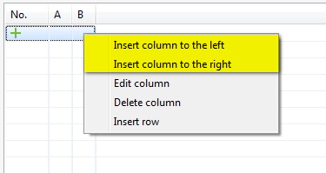

* Select the “Insert column …” item in the context menu above. A popup which looks like the following will be displayed:

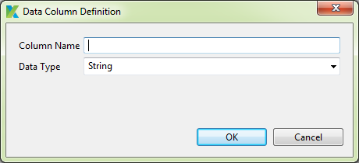

* Key in the name for the to-be-added column and press the “OK” button.
* The new column will be inserted accordingly in the data grid.

#### Delete a column

You can delete a column by following the steps below:

* In the data grid, right click on anywhere in the column that you want to delete. A context menu will be displayed as below:

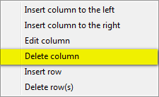

* Select the “Delete column” item in the context menu above.
* The selected column will be deleted from the data grid.

#### Rename a column

You can rename a column by following the steps below:

* In the data grid, right click on anywhere in the column that you want to rename. A context menu will be displayed as below:

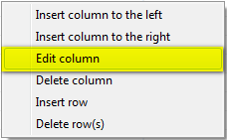

* Select the “Edit column” item in the context menu above. A popup which looks like the following will be displayed:

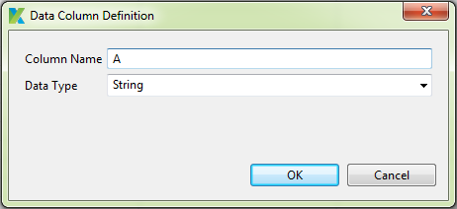

* Key in the new name for the column and press the “OK” button.
* The selected column will be renamed in the data grid.

#### Edit data in a cell

You can edit the data in a cell in the data grid by following the steps below:

* In the data grid, click on any cell that you want to edit its data. The cell will be changed to editable mode to allow you to key in the value, as illustrated below:

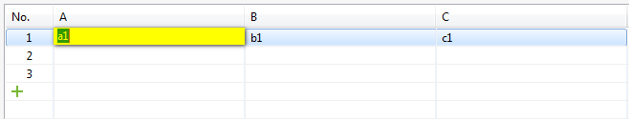

* Just key in the value of the cell and click anywhere in the data grid outside this cell.

# Test Suite

## Create a test suite

You can create a test suite by using either one of the following methods:

* Method 1: Using menu bar:
  + Click anywhere in the Tests Explorer view.
  + Select *File → New → Test Suite* from the menu.

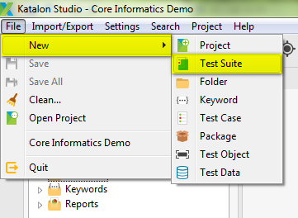

* Method 2: Using toolbar:
  + Click anywhere in the Tests Explorer view.
  + Click on the “New Test Suite” button on the toolbar.

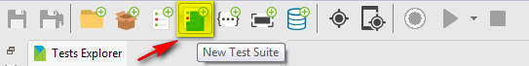

* Method 3: Use the context menu:
  + In the Tests Explorer view, right click on either the “Test Suites” folder or any sub-folder under “Test Suites” folder.
  + A context menu will be displayed.
  + Select *New → Test Suite* from the above context menu.

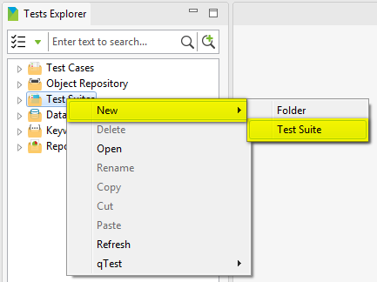

A popup which looks like the following will be displayed asking you to provide the name for the new test suite:

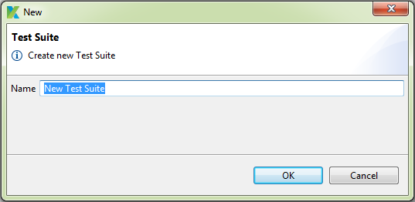

Provide the name for the new test suite, then press “OK” button. A new test suite is created and displayed under either the “Test Suites” folder or the folder specified above depending on the each case.

## Delete a test suite

Follow the steps below in order to delete a test suite:

* In the Tests Explorer view, under “Test Suites” folder, right click on the test suite that you want to delete.
* A context menu will be displayed.
* Select *Delete* from the above context menu.

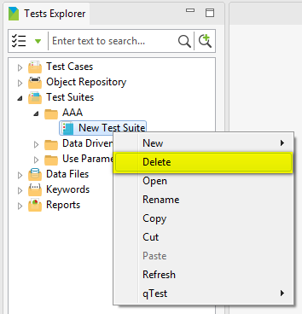

* A popup which looks similar to the following will be displayed asking for your confirmation to delete the selected test suite:

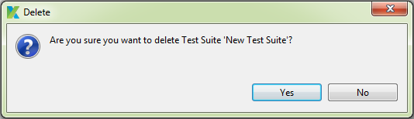

* Press on the “Yes” button to agree to delete the test suite. The selected test suite will be deleted immediately from your test project.

## Rename a test suite

Follow the steps below in order to rename a test suite:

* In the Tests Explorer view, under “Test Suites” folder, right click on the test suite that you want to rename.
* A context menu will be displayed.
* Select *Rename* from the above context menu.

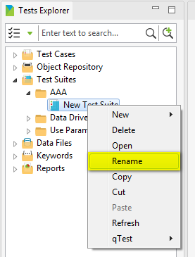

* A popup which looks like the following will be displayed asking you to provide the new name for the test suite:

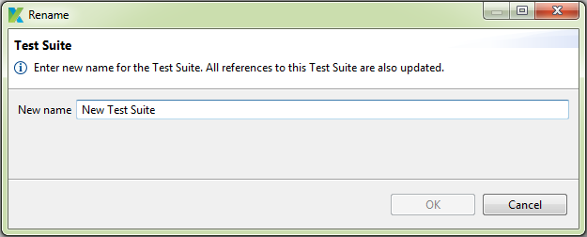

* Once you provide a valid new name for the test suite, the “OK” button will be enabled. Simply press on the “OK” button, the selected test suite will be renamed and all references to this test suite in your test project will also be updated accordingly.

## Copy a test suite

A test suite can only be copied and pasted under “Test Suites” folder. That is, a copied test suite can only be pasted under “Test Suites” folder, but not into any other default folders.

Follow the steps below in order to copy a test case:

* In the Tests Explorer view, under “Test Suites” folder, right click on the test suite that you want to copy.
* A context menu will be displayed.
* Select *Copy* from the above context menu.

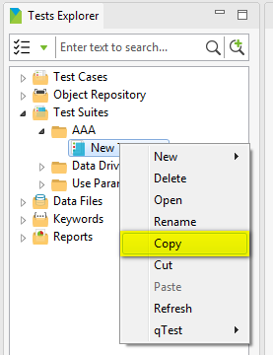

* Select the destination where you want to paste the copied test suite. Right click on it and select *Paste* from the context menu which has just been displayed.

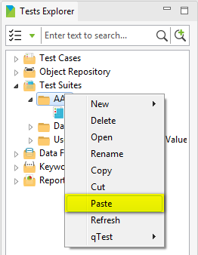

A copied version of the specified test suite will be pasted at the destination.

Notice that:

* The name of the copied version will follow the below rule:

copiedTestSuiteName = sourceTestSuiteName + “- Copy”

* If there’s already an existing test suite with the same name as the name of the copied version at the destination, the name of the copied version will be automatically renamed by appending “(1)” at the end.

## Move a test suite

A test suite can only be moved under “Test Suites” folder, but not into any other default folders.

Follow the steps below in order to move a test suite:

* In the Tests Explorer view, under “Test Suites” folder, right click on the test suite that you want to move.
* A context menu will be displayed.
* Select *Cut* from the above context menu.

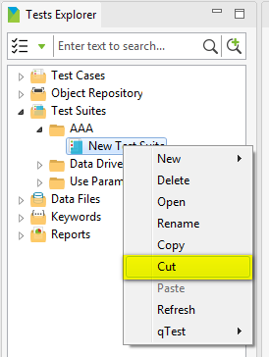

* Select the destination where you want to paste the test suite. Right click on it and select *Paste* from the context menu which has just been displayed.

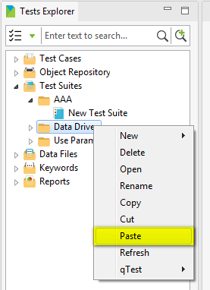

The specified test suite will be moved to the destination.

Notice that if there’s already an existing test suite with the same name as the name of the being-pasted test suite at the destination, the name of the being-pasted test suite will be automatically renamed by appending “(1)” at the end in this case.

## Edit a test suite

In order to edit a test suite, simply follow the steps below:

* In the Tests Explorer view, under “Test Suites” folder, double click on the test suite that you want to edit.
* A tab containing the Test Suite Editor will be open to display the detailed information of the selected test suite.
* Modify the data of the test suite.
* Save your modification. You can save your modification by using either one of the following methods:
  + Method 1: Press Ctrl + S
  + Method 2: Select *File → Save* or *File → Save All* from the menu.



* + Method 3: Click on the “Save” or “Save All” button on the toolbar.



## Manage execution information

You can also view/manage further information needed to be taken into account in a test suite execution, as below:

|  |  |
| --- | --- |
| **Execution Param/Info** | **Description** |
| Page load timeout | This param is to define the timeout period allowed to wait for a page to be loaded. You can choose among the following options:   * Use default – With this option, the default value defined will be used. Refer to ??? section for how to set up this default value that should be used in Katalon Studio. * User define – With this option, you have to key in the timeout (in seconds) that would be used when the current test suite is executed. |
| Re-run | This param is to define the maximum number of retries that a failed test case would be re-executed until it is successfully passed. |
| Mail Recipients | This param is to define the list of recipients who would receive the execution report of this test suite once the test suite finishes its execution.    Notice that there’s also another list of recipients who will be receiving all the reports from Katalon by default. Refer to ??? section for where and how to set up such list of recipients. |
| Last run | This info is to show the date time when the test suite was last executed. You can also quickly open the execution report of this last execution time by clicking on the “Last run” hyperlink. |

## Manage test case set

Basically a test suite will contain a list of test cases that are intended for testing an application under test to show that it has some specified set of behaviors. Therefore, knowing how to manage this list of test cases in a test suite will boost your progress in designing test suite.

Here’s the list of activities you can perform to manage test case set:

* Add a test case into a test suite
* Delete a test case from a test suite
* Re-sequence the test cases

### Add a test case into a test suite

Using the Test Suite Editor, you can add a test case into a test suite by following the steps below:

* Click on the “Add” button in the toolbar above the test case grid, as illustrated below:

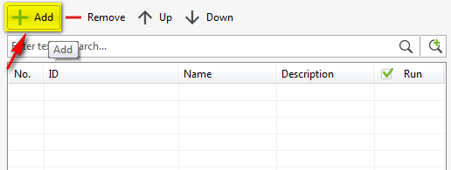

* A popup which looks like the following will be displayed.



* Search and select the test case(s) that you would like to use and press the “OK” button.
* The selected test case(s) will be displayed in the test case grid in the Test Suite Editor, as illustrated below:

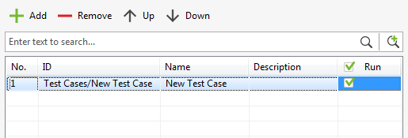

* Notice that the checkbox at the end of the newly added test case row is checked by default. This means that the test case will be executed when the test suite is executed. Otherwise, the test case execution will be ignored when the test suite is executed. You can toggle the test case execution on/off by checking/unchecking this checkbox.

Save your modification.

Done! You have already successfully added a test case into your test suite.

### Delete a test case from a test suite

Using the Test Suite Editor, you can remove a test case from a test suite by following the steps below:

* In the test case grid, select the test case(s) that you want to remove from the test suite.
* Then click on the “Remove” button in the toolbar above the test case gird, as illustrated below:

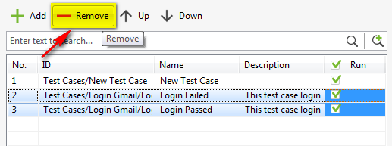

* The selected test case(s) will be removed from your test suite.

Save your modification.

Done! You have already successfully removed a test case from your test suite.

### Re-sequence the test cases

Using the Test Suite Editor, you can re-sequence a test case by using either one of the following methods:

* Method 1: Using “Move up” and “Move down” buttons in the toolbar of the test case grid in the Test Suite Editor
  + Select the test case that you would like to re-sequence.
  + Click on the “Move up” button if you want to move the selected test case up:

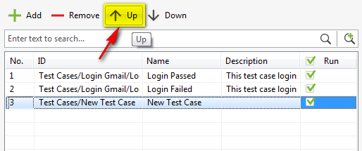

* + Click on the “Move down” button if you want to move the selected test case down:

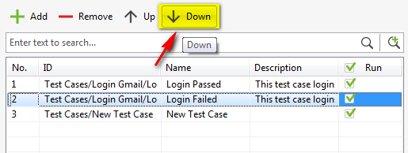

* Method 2: Drag and drop the test case up/down in the test case grid
  + Click on the test case(s) that you would like to re-sequence.
  + Hold the left mouse down while dragging the mouse up/down to the destination in the test case grid.
  + Release the mouse to drop the test case(s) at the destination.

Save your modification.

Done! You have already successfully re-sequenced a test case in your test suite.

## Manage test data

As you might know that Katalon Studio does provide you the ability to define test data that can later be iteratively used in your tests when executing them. Refer to the “Test Data” section for more detailed information about this functionality. In this section you will be instructed for how to design your test using data driven approach, i.e. how to drive your test execution using predefined test data.

Here’s the list of activities you can perform to manage test data used in a test case execution:

* Add test data to be used in a test case execution
* Delete test data from being used in a test case execution
* Manage test data execution specification
* Re-sequence the test data used in a test case execution
* Map data (???)

### Add test data to be used in a test case execution

Using the Test Suite Editor, you can add a predefined test data file object which will be used later in a test case execution by following the steps below:

* In the test case grid, select the test case that you want to manage test data used during its execution.
* Then click on arrow next to the “Add” button in the toolbar above the test data grid, as illustrated below:

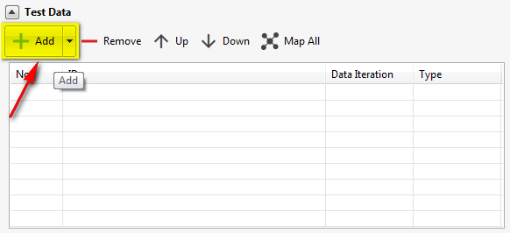

* A dropdown menu will be displayed to show the available options for your selection:

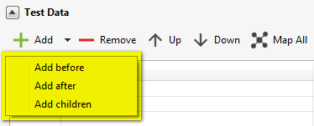

* Select one of the available options in the dropdown menu above depending on your need. A popup which looks like the following will be displayed.

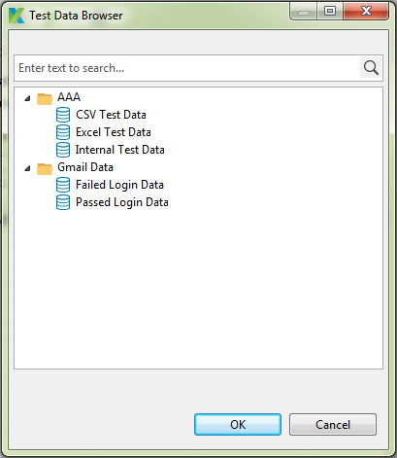

* Search and select the test data file object(s) that you would like to use and press the “OK” button.
* The selected test data file object will be displayed in the test data grid in the Test Suite Editor:
  + If you have chosen “Add before” or “Add after” option previously, the selected test data file object(s) will be added before/after the currently selected row in the test data grid respectively, as illustrated below:

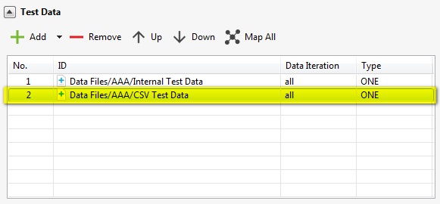

* If you have chosen “Add children” option, the selected test data file object(s) will be added as a child row(s)/node(s) of the currently selected row in the test data grid, as illustrated below. Notice that the purpose of this functionality is only to allow you to easily manage your test data used in a test case execution. It brings no effect on the data usage during your test case execution. Thus there’s no restriction on the depth of the parent/child tree that you can specify here.

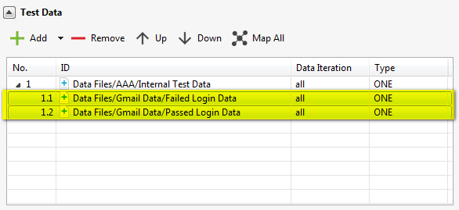

Save your modification.

Done! You have already successfully added a test data file object that would be used in a test case execution in your test suite.

### Delete test data from being used in a test case execution

Using the Test Suite Editor, you can remove a test data file object from being used in a test case execution in your test suite by following the steps below:

* In the test case grid, select the test case that you want to manage test data used during its execution.
* In the test data grid, select the test data file object(s) that you want to remove from the selected test case.
* Then click on the “Remove” button in the toolbar above the test data gird, as illustrated below:

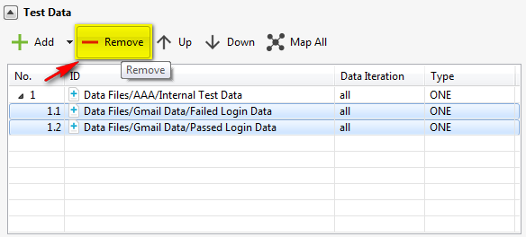

* The selected test data file object(s) will be removed from the selected test case.

Save your modification.

Done! You have already successfully removed a test data from the selected test case.

### Manage test data execution specification

After specifying a test data file object to be used during a test case execution, you should further manage the execution specification of this test data. This means that you can perform the following:

* Change the test data file object used
* Specify the data range used
* Manage test data relationship
* Manage variable binding

Refer to the subsequence sections for more information.

#### Change test data file object used

In order to change the test data file object that should be used for a test case execution, simply follow the steps below:

* In the test case grid, select the test case that you want to manage test data used during its execution.
* In the test data grid, click on the cell under the “ID” column of the test data row that you want to change its associated test data file object. The cell will be changed to edit mode as illustrated below:

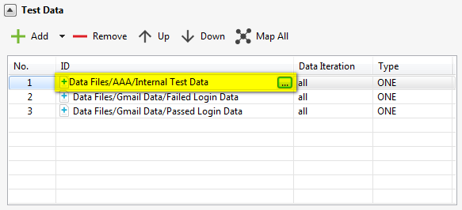

* Click on the  button at the end of the above cell. A popup which looks like the following will be displayed.

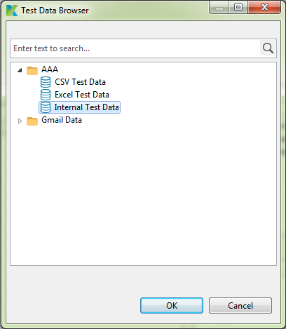

* Notice that the test data file object which is currently specified in the test data row is selected by default in the above popup. Search and select the test data file object(s) that you would like to use and press the “OK” button. The previously chosen test data file object in the test data row will be replaced by the new one.

Save your modification.

Done! You have already successfully changed the test data file object used in the selected test case.

#### Specify the data range used

In order to specify which data range from the test data file object that should be used for a test case execution, simply follow the steps below:

* In the test case grid, select the test case that you want to manage test data used during its execution.
* In the test data grid, click on the cell under the “Data Iteration” column of the test data row that you want to specify the data range used. The cell will be changed to edit mode as illustrated below:

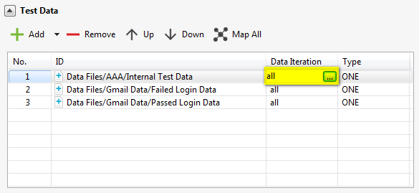

* Click on the  button at the end of the above cell. A popup which looks like the following will be displayed.

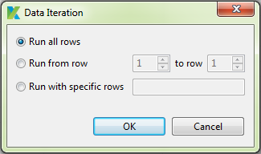

* Choose among the options available on the above popup to specify the data range that should be used in test case execution. The following options are supported in Katalon Studio:

|  |  |
| --- | --- |
| **Data Iteration** | **Description** |
| Run all rows | This is to specify that all the data rows in the test data file object will be used in the test case execution. |
| Run from row … to row … | This is to specify that the data range from which row to which row in the test data file object will be used in the test case execution. |
| Run with specific rows | This is to specify that the data rows which are specified here will be used in the test case execution.  With this option, you can identify the specific data rows using the either one of the following syntaxes:   * rowNum, rowNum, rowNum * E.g.: 1,2,3 -> to use the three data rows (row 1, row 2, row 3) * rowNum-rowNum, rowNum * E.g.: 1-3,6 -> to use the four data rows (row 1, row 2, row 3, row 6) |

* Press the “OK” button.

Save your modification.

Done! You have already successfully specified the data range used in the test data file object for the selected test case.

#### Manage test data relationship

If you are specifying multiple test data file objects that will be used in a test case execution, then you can further define the relationship among them. That is to define how all the data sets are combined together to become the final data set used in the test case execution. There are two types of relationship supported in Katalon Studio:

|  |  |
| --- | --- |
| **Relationship Type** | **Description** |
| One | This means that each data element in the data set should be used at least once during the test case execution. |
| Many | This means that each data element in the data set should be used at least more than once during the test case execution. |

Therefore, we can have the following combinations among data sets:

|  |  |
| --- | --- |
| **Relationships** | **Example** |
| One – One | Imagine there are two data sets as below:  ONE ONE a1 b1 a2 b2  a3  Then the final data set used for test case execution includes the following data:   * a1 b1 * a2 b2 |
| Many – Many | Imagine there are two data sets as below:  MANY MANY a1 b1  a2  a3 b2  Then the final data set used for test case execution includes the following data:   * a1 b1 * a1 b2 * a2 b1 * a2 b2 * a3 b1 * a3 b2 |
| One – Many | Imagine there are two data sets as below:  ONE MANY a1 b1  a2  a3  a4 b2    Then the final data set used for test case execution includes the following data:   * a1 b1 * a2 b1 * a3 b1 * a4 b1 * a1 b2 * a2 b2 * a3 b2 * a4 b2 |
| Imagine there are three data sets as below:  ONE ONE MANY a1 b1 c1  a2 b2 c2 a3    Then the final data set used for test case execution includes the following data:   * a1 b1 c1 * a1 b1 c2 * a2 b2 c1 * a2 b2 c2 |

Notice that each test data file object will have relationship type “ONE” by default after being added into the test suite. In order to change this relationship type, simply follow the steps below:

* In the test case grid, select the test case that you want to manage test data used during its execution.
* In the test data grid, click on the cell under the “Type” column of the test data row that you want to change its relationship type. The value in this cell will be toggled between ONE and MANY.

Save your modification.

Done! You have already successfully managed the relationship among test data file objects used in the selected test case.

#### Manage variable binding

If there’s any local variable defined in your test case and this test case is used in your test suite, then Katalon Studio provides you the ability to manage variable binding for your test case execution. That is to specify which value would be used for which variable during the test case execution.

In order to manage variable binding for a test case in a test suite, simply follow the steps below:

* Suppose we’ve got the following test case whose local variables are defined as below:

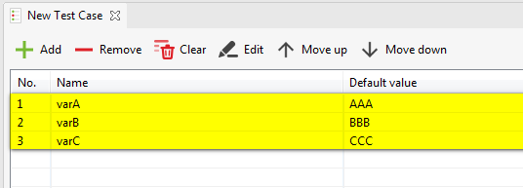

* Using the Test Suite Editor, in the test case grid, select the test case that you want to manage test data used during its execution. Let’s select the test case in the example above.
* All the local variables defined in your corresponding test case will be loaded into the variable grid as illustrated below:

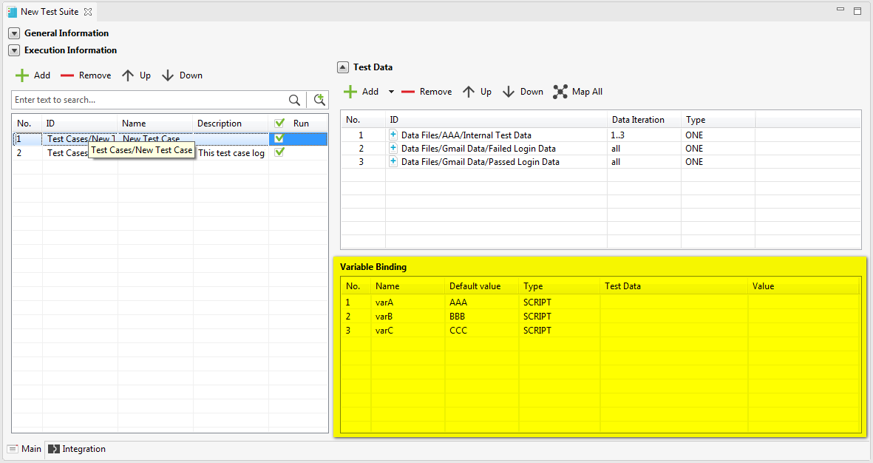

* You can bind the data to a variable using one of the following sources:
  + From scripting value
  + From test data file object
* Perform data binding for each of the variables.
* Save your modification. Done! You have already successfully performed variable binding for the selected test case.

##### Variable bound from scripting value

In order to bind data to a variable from a scripting value, simply follow the steps below:

* In the variable grid, click on the cell under the “Type” column. The cell will be changed to edit mode and a dropdown containing available options is displayed, as illustrated below:

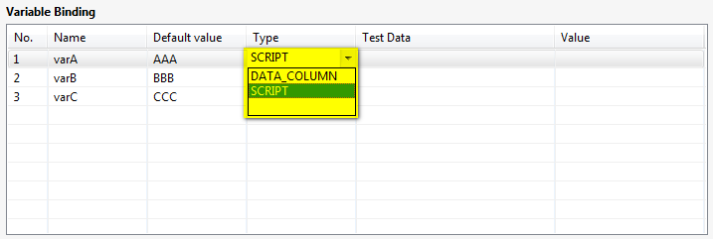

* Select the “Script” item from the above dropdown.
* Click on the cell under the “Value” column. This cell will be changed to edit mode. Key in the value that you would like to use into this cell. This value will then be used for the corresponding variable during test case execution.

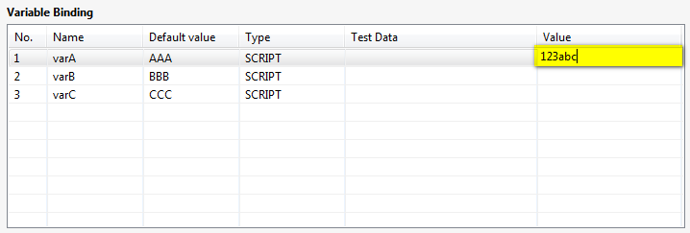

##### Variable bound from test data file object

In order to bind data to a variable from a test data file object, simply follow the steps below:

* In the variable grid, click on the cell under the “Type” column. The cell will be changed to edit mode and a dropdown containing available options is displayed, as illustrated below:



* Select the “Data column” item from the above dropdown.
* Click on the cell under the “Test Data” column. This cell will be changed to edit mode, as illustrated below:

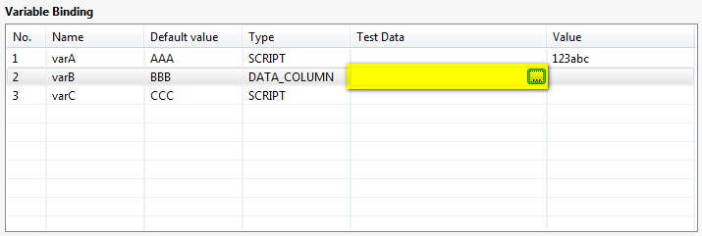

* Click on the  button at the end of the above cell. A popup which looks like the following will be displayed:

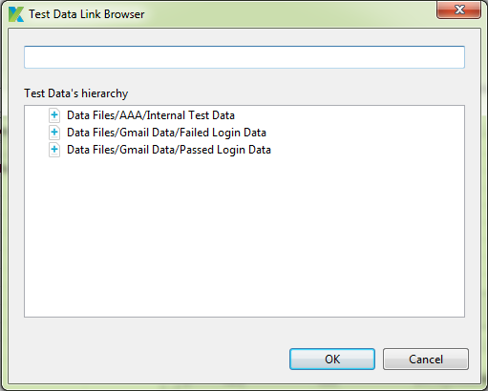

* In this popup, all the test data file objects specified to be used for the selected test case (which is added and displayed in the test data grid) will be displayed. Select the test data file object that you would like to use to bind data for the current variable.
* Click on the cell under the “Value” column, a dropdown containing all the column headers defined in the selected test data file object will be displayed, as illustrated below:

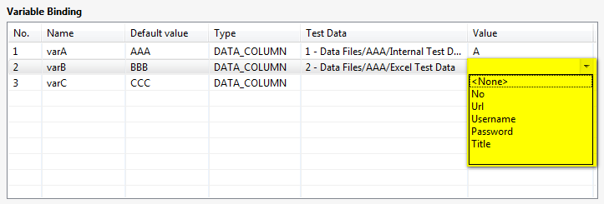

* Select the column header where corresponding data should be found for variable binding. The value under this column in the selected test data file object will then be used for the corresponding variable during test case execution.

### Re-sequence the test data used in a test case execution

Using the Test Suite Editor, you can re-sequence a test data file object used in a test case execution by using either one of the following methods:

* Method 1: Using “Move up” and “Move down” buttons in the toolbar of the test data grid in the Test Suite Editor
  + Select the test data that you would like to re-sequence.
  + Click on the “Move up” button if you want to move the selected test data up:

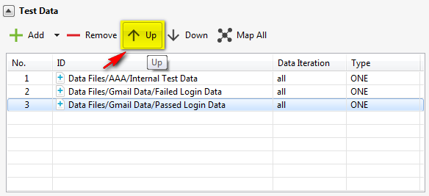

* + Click on the “Move down” button if you want to move the selected test data down:

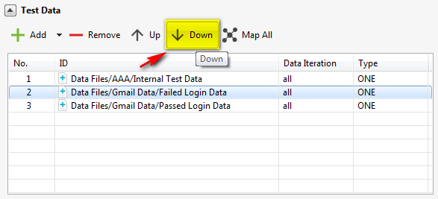

* Method 2: Drag and drop the test data up/down in the test data grid
  + Click on the test data that you would like to re-sequence.
  + Hold the left mouse down while dragging the mouse up/down to the destination in the test data grid.
  + Release the mouse to drop the test data at the destination.

Save your modification.

Done! You have already successfully re-sequenced a test data in the selected test case.

## Execute a test suite

Executing a test suite is more or less the same as executing a test case. Refer to “Execute a test case” section for more details.

Here’s the Job Progress view when a test suite is being executed:

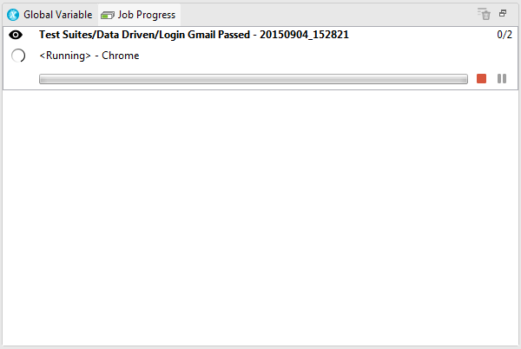

And here’s the Log Viewer view when a test suite is being executed:

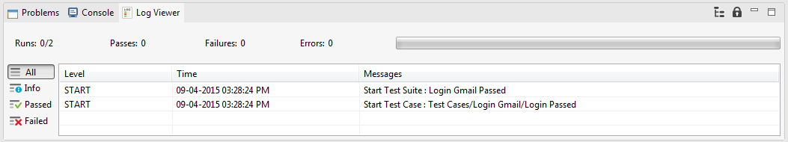

## View execution history report

Once a test suite finishes its execution, a report will be automatically generated and stored in the “Reports” folder. These reports are called execution history report. In fact, a dedicated folder structure will be created under the “Report” folder to store all the execution history reports of each test suite.

For example, we’ve got the following test suite with its own folder structure:

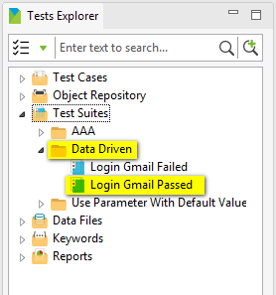

Then, all the execution history reports of the “Login Gmail Passed” test suite will be stored in the folder “Data Driven \ Login Gmail Passed” under the “Reports” folder as illustrated below:

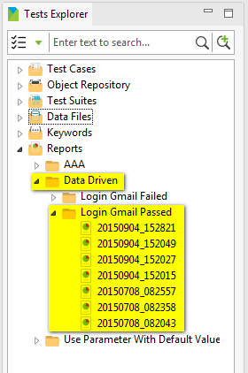

Notice that the report will be named following the naming convention below:

YYYYMMDD_HHmmss

Where “YYYYMMDD_HHmmss” in fact is the date time when the test suite starts its execution.

# Keyword

There are two types of keywords supported in Katalon Studio:

|  |  |
| --- | --- |
| **Keyword Type** | **Description** |
| Built-in keyword | A keyword of this type is a keyword which is predefined and embedded in Katalon Studio. |
| Custom keyword | A keyword of this type is a keyword which is defined by the end users for their own need. |

Refer to the subsequence sections for more information.

## Built-in keywords

Refer to “**Keywords Explanation.pdf**” for the detailed guideline for how to use each keyword of this type.

## Custom keywords

When you are designing your test case, there might be cases that none of the current built-in keywords supported in Katalon Studio can help you to achieve your target/need. For example, there’s a special action that can be performed on your application under test, or there’s a special command that you want to perform on a specific environment and/or context … In such cases, Katalon Studio does provide you the ability to create custom keywords for your own need. Therefore, knowing how to work with custom keywords will boost your progress in designing your test project. Refer to the subsequence sections for more information.

### Manage package

A package is just a mechanism which Katalon Studio provides you to group your custom keywords into different categories. Refer to the subsequence sections for how to manage a package in Katalon Studio.

#### Create a package

You can create a package by using either one of the following methods:

* Method 1: Using menu bar:
  + Click anywhere in the Tests Explorer view.
  + Select *File → New → Package* from the menu.

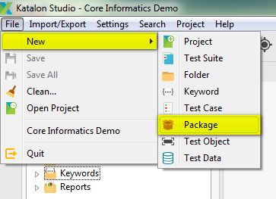

* Method 2: Using toolbar:
  + Click anywhere in the Tests Explorer view.
  + Click on the “New Package for Keyword” button on the toolbar.

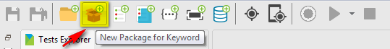

* Method 3: Use the context menu:
  + In the Tests Explorer view, right click on either the “Keywords” folder or any package under “Keywords” folder.
  + A context menu will be displayed.
  + Select *New → Package* from the above context menu.

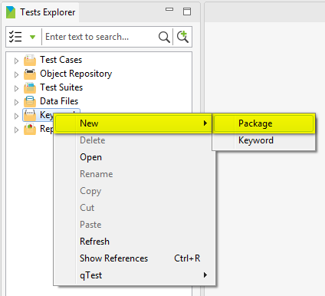

A popup which looks like the following will be displayed asking you to provide the name for the new package:

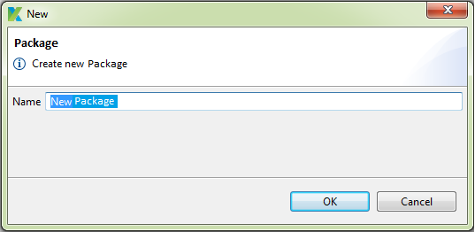

Provide the name for the new package, then press “OK” button. A new package is created and displayed under the “Keywords” folder.

#### Delete a package

Follow the steps below in order to delete a package:

* In the Tests Explorer view, under “Keywords” folder, right click on the package that you want to delete.
* A context menu will be displayed.
* Select *Delete* from the above context menu.

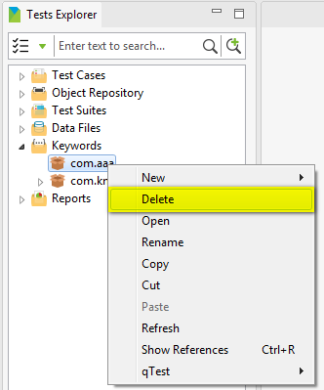

* A popup which looks similar to the following will be displayed asking for your confirmation to delete the selected package:

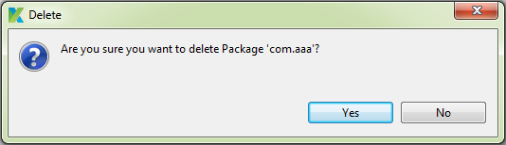

* Press on the “Yes” button to agree to delete the package.
  + The selected package will be deleted immediately from your test project.
  + If any keyword belonging to this package is currently being used anywhere in your test project (e.g.: it is being used in one of your test case), then Katalon Studio will also remove such reference.

#### Rename a package

Follow the steps below in order to rename a package:

* In the Tests Explorer view, under “Keywords” folder, right click on the package that you want to rename.
* A context menu will be displayed.
* Select *Rename* from the above context menu.

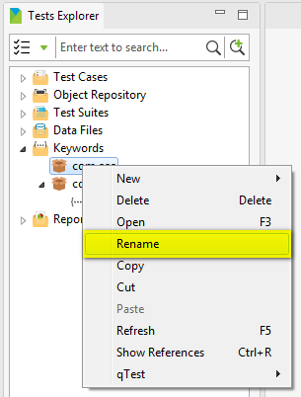

* A popup which looks like the following will be displayed asking you to provide the new name for the package:

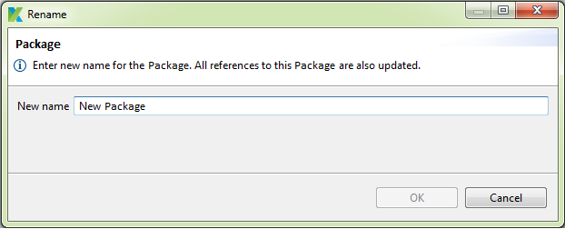

* Once you provide a valid new name for the package, the “OK” button will be enabled. Simply press on the “OK” button, the selected package will be renamed and all references to this package in your test project will also be updated accordingly.

#### Copy a package

This feature is under implementation.

#### Move a package

This feature is under implementation.

### Manage custom keyword

#### Create a custom keyword class

You can create a custom keyword class by using either one of the following methods:

* Method 1: Using menu bar:
  + Click anywhere in the Tests Explorer view.
  + Select *File → New → Keyword* from the menu.

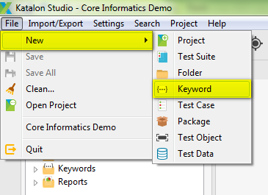

* Method 2: Using toolbar:
  + Click anywhere in the Tests Explorer view.
  + Click on the “New Keyword” button on the toolbar.

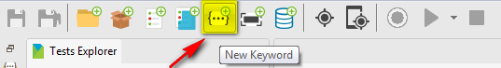

* Method 3: Use the context menu:
  + In the Tests Explorer view, right click on either the “Keywords” folder or any package under “Keywords” folder.
  + A context menu will be displayed.
  + Select *New → Keyword* from the above context menu.

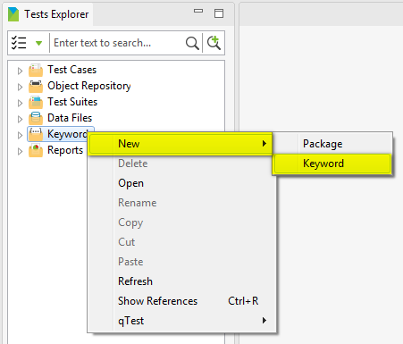

A popup which looks like the following will be displayed asking you to provide the name for the new custom keyword clas:

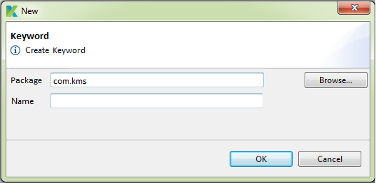

You can specify the destination package where the new custom keyword class should be belonging to by using the “Browse” button. Press on this button, a popup which looks like the following will be displayed:

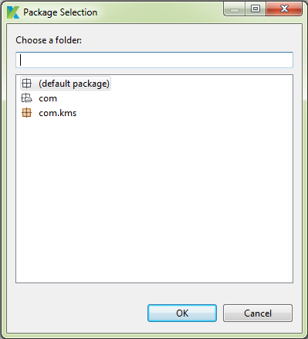

Search and select the interested package. Then press on the “OK” button in the above popup.

Then provide the name for the new custom keyword class, then press “OK” button. A new custom keyword class is created and displayed under the respective package in the “Keywords” folder.

#### Delete a custom keyword class

Follow the steps below in order to delete a custom keyword class:

* In the Tests Explorer view, under “Keywords” folder, right click on the custom keyword class that you want to delete.
* A context menu will be displayed.
* Select *Delete* from the above context menu.

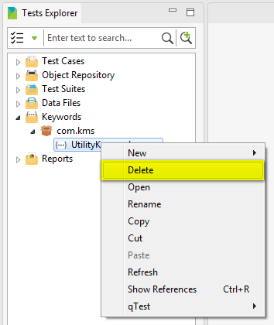

* A popup which looks similar to the following will be displayed asking for your confirmation to delete the selected custom keyword class:

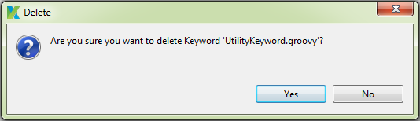

* Press on the “Yes” button to agree to delete the custom keyword.
  + The selected custom keyword class will be deleted immediately from your test project.
  + If that custom keyword class is being used anywhere in your test project (e.g.: it is being used in one of your test case), then Katalon Studio will also remove such reference.

#### Rename a custom keyword class

Follow the steps below in order to rename a custom keyword class:

* In the Tests Explorer view, under “Keywords” folder, right click on the custom keyword class that you want to rename.
* A context menu will be displayed.
* Select *Rename* from the above context menu.

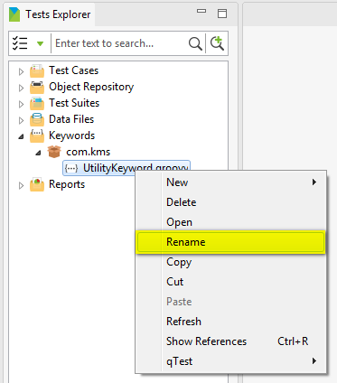

* A popup which looks like the following will be displayed asking you to provide the new name for the custom keyword class:

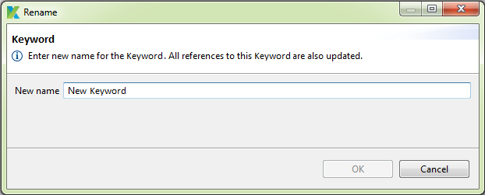

* Once you provide a valid new name for the custom keyword class, the “OK” button will be enabled. Simply press on the “OK” button, the selected custom keyword class will be renamed and all references to this custom keyword class in your test project will also be updated accordingly.

#### Copy a custom keyword class

This feature is under implementation.

#### Move a custom keyword class

This feature is under implementation.

#### Edit a custom keyword class

In order to edit a custom keyword class, simply follow the steps below:

* In the Tests Explorer view, under “Keywords” folder, double click on the custom keyword class that you want to edit.
* A tab containing the Keyword Editor will be open to display the detailed information of the selected custom keyword class.
* Modify the data of the custom keyword class.
* Save your modification. You can save your modification by using either one of the following methods:
  + Method 1: Press Ctrl + S
  + Method 2: Select *File → Save* or *File → Save All* from the menu.



* + Method 3: Click on the “Save” or “Save All” button on the toolbar.



#### Define a custom keyword

You can define a custom keyword using either Groovy or Java. Refer to the subsequence sections for the guidelines for how to define a custom keyword in each of the above languages.

##### Define a custom keyword using Groovy

Follow the steps below in order to define a custom keyword:

* Import the package “*com.kms.katalon.core.annotation.Keyword*” into your keyword class.
* Define the following block of code in your keyword class to define one custom keyword:

@Keyword

**def** keywordName(paramters …) {

}

Where:

* + @Keyword is the annotation to denote that the block of code right under it is a definition for a keyword.
  + keywordName is the name that you would like to use for your custom keyword.
  + parameters is the list of parameters that would be used in the custom keyword.
* See the following for an example custom keyword:

@Keyword

**def** executeCommand(String cmd) {

("cmd /c " + cmd).*execute*()

}

* zzz

##### Define a custom keyword using Java

TBD

#### Use a custom keyword

Once you define a custom keyword, you can then use it in your test case. When you choose which custom keyword to be used in your test case, you are in fact adding a test step using the chosen custom keyword. Thus, refer to the following sections for more detailed instructions on how to add and edit a test step:

* Test Case > Manage test step > Add a test step
* Test Case > Manage test step > Edi a test step

In this section, you will be given brief instruction for how to use your custom keyword in your test case.

##### Use a custom keyword in a test case via Manual mode

Using the Test Case Editor in Manual mode, follow the steps below in order to use a custom keyword in your test case:

* In the Test Case Editor, click on the down arrow next to the “Add” button, as illustrated below:



* A dropdown menu will be displayed to show the available groups of keywords for your selection:



* Select the “Custom Keyword” item in the context menu above. A test step will be added and displayed as a new row in the test step grid:

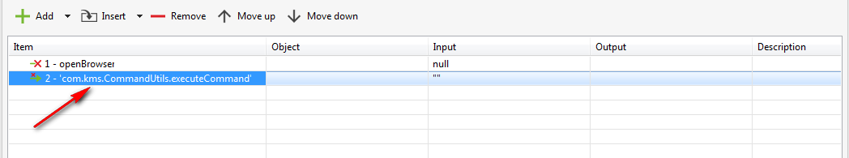

* Double click on the cell in the “Item” column of the newly added test step, it will be changed to edit mode. That is, a dropdown containing a list of available custom keywords, as illustrated below:

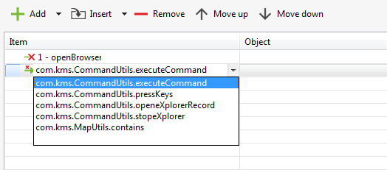

* Select the interested custom keyword.

##### Use a custom keyword in a test case via Scripting mode

Using the Test Case Editor in Scripting mode, follow the steps below in order to use a custom keyword in your test case:

* Key in “CustomKeywords”
* Key in “.”
* The “Content Assist” function will be invoked. Content assist is the functionality in Katalon Studio which allows the tester to get context-sensitive code completion in a test case editor upon user request. That is, a combo box containing all the custom keywords defined in your test project will be displayed as below:

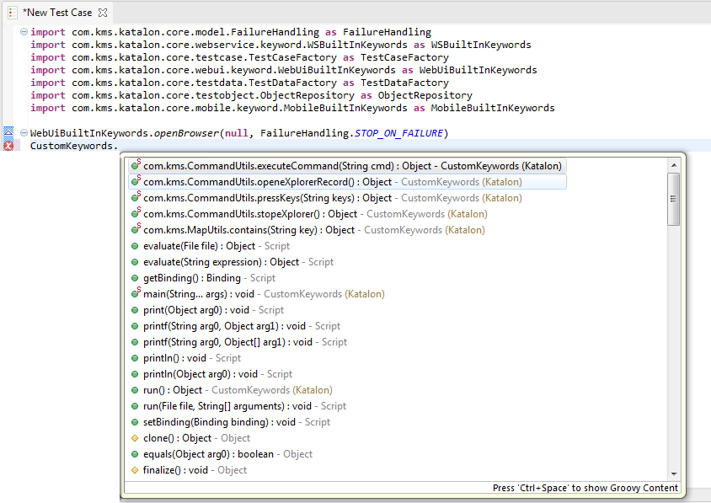

* Choose the custom keyword that suites your need.
* Then provide all parameters as required for the selected custom keyword.

# Reports

TBD

# Console Mode Execution

From the previous sections, you already know how to execute test case/suite using Katalon Studio’s controls. However, there are cases when you want to execute your test case/suite without having to open Katalon Studio and load your test project there. To support such need, Katalon does provide you the ability to execute test case/suite from command line. Follow the steps below for how to do this.

* Remember to register mailing lists that should be receiving all the reports from Katalon by default. Refer to ??? section for where and how to set up such list of recipients.
* Open the command line and navigate to the folder containing katalon.exe file, for example:

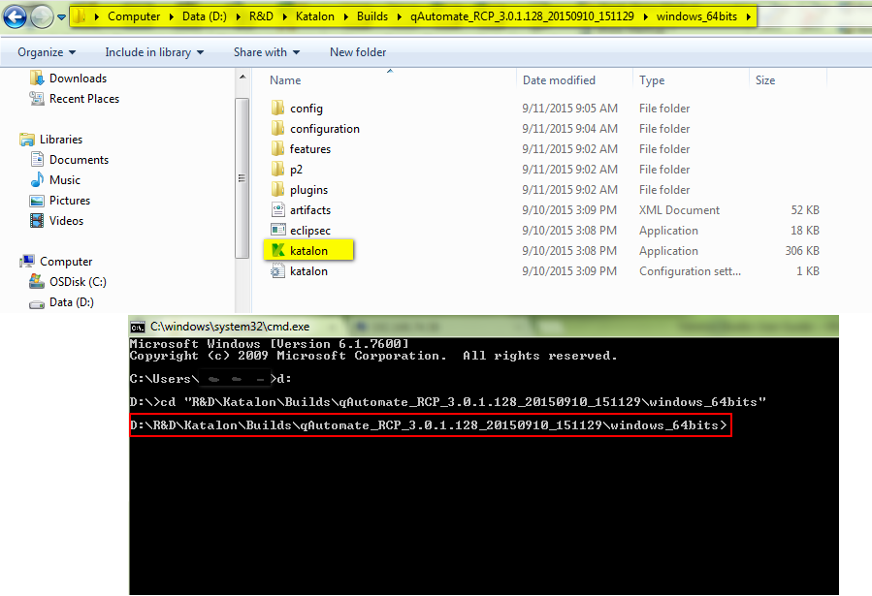

* Enter the Katalon commands that you would like to use.
  + The execution command is “katalon”.
  + Key in the options needed.
  + See the example below for how to execute test suite using Katalon command

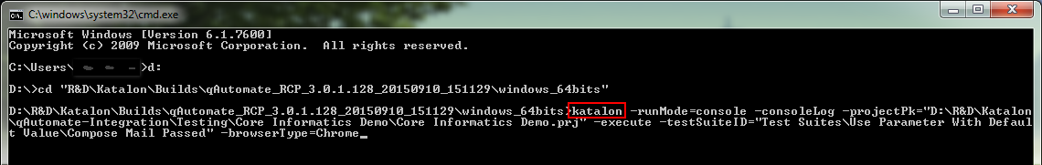

* Press Enter.

Here’s the list of options supported for “katalon” command:

|  |  |  |
| --- | --- | --- |
| **Katalon Command Line Option** | **Description** | **Mandatory?** |
| -runMode=console | Enable console mode. | Y |
| -consoleLog | Display log in the console. | N |
| -noExit | Keep the console open after the execution is completed. | N |
| -summaryReport | Send summary report for a batch run. | N |
| -statusDelay=<seconds> | System will update execution status of the test suite after the delay period (in seconds) specified. | N |
| -projectPk=<path> | Specify the project location (include .prj file). The absolute path must be used in this case. | Y |
| -execute | Indicate that katalon will execute the following test suite. | Y |
| -testSuiteID=<path> | Specify the test suite file (without extension .ts). The relative path (root being project folder) must be used in this case. | Y |
| -browserType=<browser> | Specify the browser type used for test suite execution.  The following browsers are supported in Katalon:   * Firefox * Chrome * IE * Safari | Y |
| -reportFolder=<path> | Specify the destination folder for saving report files. Can use absolute path or relative path (root being project folder). | N |
| -reportFileName=<name> | Specify the name for report files (.html, .csv, .log). If not provide, system uses the name "report" (report.html, report.csv, report.log). This option is only taken into account when being used with “-reportFolder” option. | N |

And here are some examples:

* Use default report folder and report name

katalon -runMode=console -summaryReport -projectPk="…" -execute -testSuiteID="…" -browserType=Firefox

* Specify report folder using absolute path, NOT specify report name (system use name "report" for report files of all test suites)

katalon -runMode=console -projectPk="…" -execute -testSuiteID="…" -browserType=Firefox -reportFolder="D:\Report_Folder\FirefoxRun"

* Specify report folder using relative path, specify report name (system uses this name for report files of all test suites)

katalon -runMode=console -reportFileName="index" -projectPk="…" -execute -testSuiteID="…" -browserType=Firefox -reportFolder="Reports\ FirefoxRun"

# API Testing

Katalon Studio also does support you to do API testing. The APIs which are currently supported for being tested in Katalon Studio are as following:

* RESTful request
* SOAP request

Refer to the subsequence sections for more details.

## How to test a Web Service request?

Follow the steps below for how to test a Web Service request:

* Create a Web Service Request object. Refer to “Create a Web Service Request object” section for detailed instruction.
* After a Web Service Request object is created, you need to input more information to the request to make it workable later for sending this type of request. Refer to “Edit a Web Service Request object” section for more information.
* In order to have a good logical structure for the test cases, each API test should be considered as a separated test case in Katalon.
* Then simply use those keywords provided in the “Web Service Keyword” package in your test case to design your test:
  + You can use a keyword provided in the “Web Service Keyword” package in your test case by either one of the following methods:
    - Method 1: Adding/inserting a test step and select the “Web Service Keyword” package from the list.

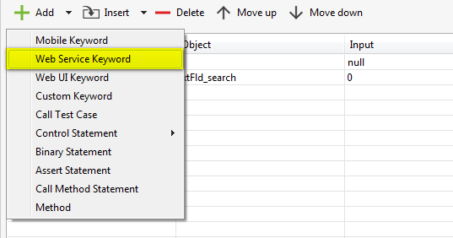

* + - Method 2: Using “Keywords Browser View”, select the interested keyword in the “Web Service Keyword” package, then drag and drop it into the Test Case editor.

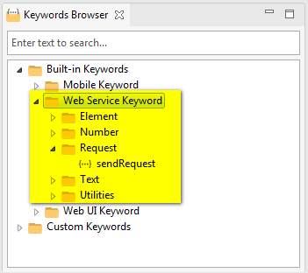

* + To send a Web Service request using your created Web Service Request object, you need to use “sendRequest” keyword, with the input is your created request, as illustrated below:
  + To verify response messages from a request, you can use those “verify” actions depending on your need:
* Zzzz

## Create a Web Service Request object

Notice that Katalon Studio has already provided you some built-in keywords that can be used for API testing. You can take a look at them in the Keywords Browser View as below:



Therefore, in order to use Web Service keywords to perform API testing, you need to create a Web Service Request object which then can later be used in those built-in Web Service keywords.

You can create a Web Service Request object by using either one of the following methods:

* Method 1: Using menu bar:
  + Click anywhere in the Tests Explorer view.
  + Select *File → New → Web Service Request* from the menu.



* Method 2: Using toolbar:
  + Click anywhere in the Tests Explorer view.
  + Click on the “New Web Service Request” button on the toolbar.



* Method 3: Use the context menu:
  + In the Tests Explorer view, right click on either the “Object Repository” folder or any sub-folder under “Object Repository” folder.
  + A context menu will be displayed.
  + Select *New → Web Service Request* from the above context menu.



A popup which looks like the following will be displayed asking you to provide the name for the new Web Service Request object:

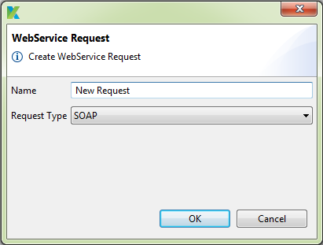

Provide the name for the new Web Service Request object. Select the request type. Then press “OK” button. A new Web Service Request object is created and displayed under either the “Object Repository” folder or the folder specified above depending on the each case.

## Edit a Web Service Request object

How to insert a property?

How to delete a property?

### Edit a RESTful request object

The following attributes of a RESTful request are supported in Katalon Studio:

|  |  |
| --- | --- |
| **Attribute** | **Description** |
| HTTP Header | … |
| HTTP Body | The information that you want to transmit in this RESTful request object. |
| URL | The URL registered for the RESTful web service. |
| Request method | The HTTP method that you want to use in this RESTful request object.  The following HTTP methods are currently supported in Katalon Studio:   * GET * POST * PUT * DELETE |
| Parameters | The parameters that you want to pass along with this RESTful request object. |

See the following for an example of a RESTful request object:

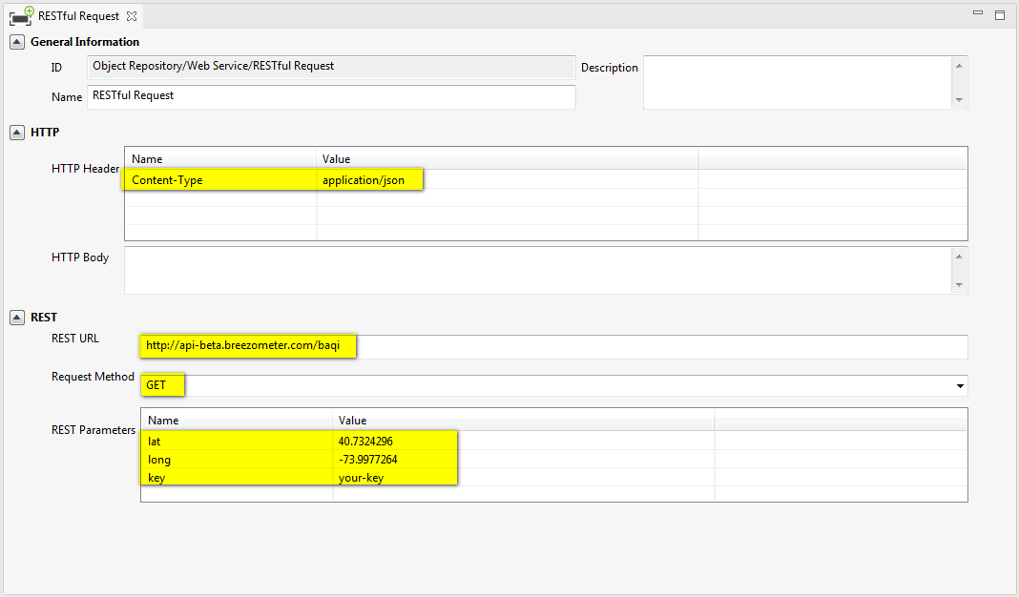

### Edit a SOAP request object

The following attributes of a SOAP request are supported in Katalon Studio:

|  |  |
| --- | --- |
| **Attribute** | **Description** |
| HTTP Header | … |
| HTTP Body | The information that you want to transmit in this SOAP request object. |
| URL | The WSDL address registered for the SOAP web service. |
| Request method | The HTTP method that you want to use in this SOAP request object.  The following HTTP methods are currently supported in Katalon Studio:   * SOAP * POST * GET |
| Service Function | The function/method of the SOAP web service that you want to use in this SOAP request. |
| Parameters | The parameters that you want to pass along with this SOAP request object. |
| SOAP Header | The optional SOAP Header element contains application-specific information (like authentication, payment, etc) that you want to use in this SOAP request. |
| SOAP Body | The actual SOAP message that you want to transmit in this SOAP request. |

See the following for an example of a SOAP request object:

* Let’s use the following SOAP web service as an example:
* zzz